


Serve a range of wine products
D1.HBS.CL5.15
Trainee Manual


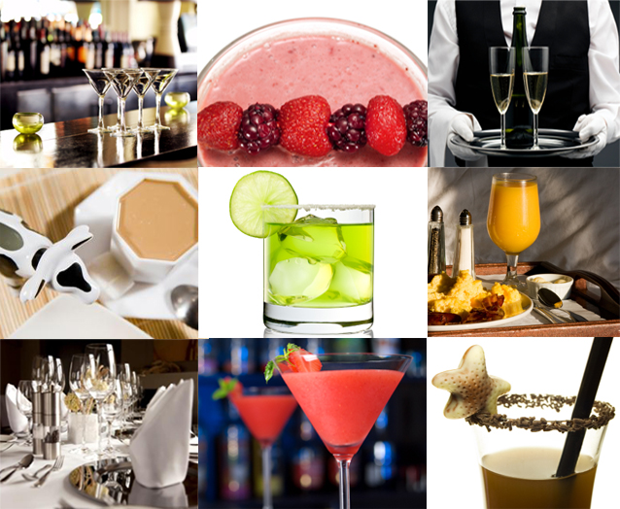



Serve a range of wine products

D1.HBS.CL5.15

Trainee Manual




Project Base
William Angliss Institute of TAFE
555 La Trobe Street
Melbourne 3000 Victoria
Telephone: | (03) 9606 2111
Facsimile: | (03) 9670 1330
Acknowledgements
Project Director: | Wayne Crosbie
Chief Writer: | Alan Hickman
Subject Writer: | Nick Hyland
Project Manager: | Alan Maguire
Editor: | Jim Irwin
DTP/Production: | Daniel Chee, Mai Vu, Kaly Quach

The Association of Southeast Asian Nations (ASEAN) was established on 8 August 1967. The Member States of the Association are Brunei Darussalam, Cambodia, Indonesia, Lao PDR, Malaysia, Myanmar, Philippines, Singapore, Thailand and Viet Nam.
The ASEAN Secretariat is based in Jakarta, Indonesia.
General Information on ASEAN appears online at the ASEAN Website: www.asean.org.
All text is produced by William Angliss Institute of TAFE for the ASEAN Project on “Toolbox Development for Front Office, Food and Beverage Services and Food Production Divisions”.
This publication is supported by the Australian Government’s aid program through the ASEAN-Australia Development Cooperation Program Phase II (AADCP II).
Copyright: Association of Southeast Asian Nations (ASEAN) 2013.
All rights reserved.
Disclaimer
Every effort has been made to ensure that this publication is free from errors or omissions. However, you should conduct your own enquiries and seek professional advice before relying on any fact, statement or matter contained in this book. The ASEAN Secretariat and William Angliss Institute of TAFE are not responsible for any injury, loss or damage as a result of material included or omitted from this course. Information in this module is current at the time of publication. Time of publication is indicated in the date stamp at the bottom of each page.
Some images appearing in this resource have been purchased from stock photography suppliers Shutterstock and iStockphoto and other third party copyright owners and as such are non-transferable and non-exclusive. Clip arts, font images and illustrations used are from the Microsoft Office Clip Art and Media Library. Some images have been provided by and are the property of William Angliss Institute.
Additional images have been sourced from Flickr and SXC and are used under Creative Commons licence: http://creativecommons.org/licenses/by/2.0/deed.en

File name: TM_Serve_a_range_of_wine_products_refined





Table of Contents
Introduction to trainee manual 1
Unit descriptor 3
Assessment matrix 5
Glossary 9
Element 1: Develop wine knowledge 23
Element 2: Store and retrieve wines 53
Element 3: Undertake sensory appraisal of wines 67
Element 4: Provide advice to patrons 93
Element 5: Serve wines 107
Element 6: Maintain wine knowledge 123
Presentation of written work 135
Recommended reading 137
Trainee evaluation sheet 139
Trainee self-assessment checklist 141

Introduction to trainee manual

To the Trainee
Congratulations on joining this course. This Trainee Manual is one part of a ‘toolbox’ which is a resource provided to trainees, trainers and assessors to help you become competent in various areas of your work.
The ‘toolbox’ consists of three elements:
- A Trainee Manual for you to read and study at home or in class
- A Trainer Guide with Power Point slides to help your Trainer explain the content of the training material and provide class activities to help with practice
- An Assessment Manual which provides your Assessor with oral and written questions and other assessment tasks to establish whether or not you have achieved competency.
The first thing you may notice is that this training program and the information you find in the Trainee Manual seems different to the textbooks you have used previously. This is because the method of instruction and examination is different. The method used is called Competency based training (CBT) and Competency based assessment (CBA). CBT and CBA is the training and assessment system chosen by ASEAN (Association of South-East Asian Nations) to train people to work in the tourism and hospitality industry throughout all the ASEAN member states.
What is the CBT and CBA system and why has it been adopted by ASEAN?
CBT is a way of training that concentrates on what a worker can do or is required to do at work. The aim is of the training is to enable trainees to perform tasks and duties at a standard expected by employers. CBT seeks to develop the skills, knowledge and attitudes (or recognise the ones the trainee already possesses) to achieve the required competency standard. ASEAN has adopted the CBT/CBA training system as it is able to produce the type of worker that industry is looking for and this therefore increases trainees’ chances of obtaining employment.
CBA involves collecting evidence and making a judgement of the extent to which a worker can perform his/her duties at the required competency standard. Where a trainee can already demonstrate a degree of competency, either due to prior training or work experience, a process of ‘Recognition of Prior Learning’ (RPL) is available to trainees to recognise this. Please speak to your trainer about RPL if you think this applies to you.
What is a competency standard?
Competency standards are descriptions of the skills and knowledge required to perform a task or activity at the level of a required standard.
242 competency standards for the tourism and hospitality industries throughout the ASEAN region have been developed to cover all the knowledge, skills and attitudes required to work in the following occupational areas:
- Housekeeping
- Food Production
- Food and Beverage Service
- Front Office
- Travel Agencies
- Tour Operations.
All of these competency standards are available for you to look at. In fact you will find a summary of each one at the beginning of each Trainee Manual under the heading ‘Unit Descriptor’. The unit descriptor describes the content of the unit you will be studying in the Trainee Manual and provides a table of contents which are divided up into ‘Elements’ and ‘Performance Criteria”. An element is a description of one aspect of what has to be achieved in the workplace. The ‘Performance Criteria’ below each element details the level of performance that needs to be demonstrated to be declared competent.
There are other components of the competency standard:
- Unit Title: statement about what is to be done in the workplace
- Unit Number: unique number identifying the particular competency
- Nominal hours: number of classroom or practical hours usually needed to complete the competency. We call them ‘nominal’ hours because they can vary e.g. sometimes it will take an individual less time to complete a unit of competency because he/she has prior knowledge or work experience in that area.
The final heading you will see before you start reading the Trainee Manual is the ‘Assessment Matrix’. Competency based assessment requires trainees to be assessed in at least 2 – 3 different ways, one of which must be practical. This section outlines three ways assessment can be carried out and includes work projects, written questions and oral questions. The matrix is designed to show you which performance criteria will be assessed and how they will be assessed. Your trainer and/or assessor may also use other assessment methods including ‘Observation Checklist’ and ‘Third Party Statement’. An observation checklist is a way of recording how you perform at work and a third party statement is a statement by a supervisor or employer about the degree of competence they believe you have achieved. This can be based on observing your workplace performance, inspecting your work or gaining feedback from fellow workers.
Your trainer and/or assessor may use other methods to assess you such as:
- Journals
- Oral presentations
- Role plays
- Log books
- Group projects
- Practical demonstrations.
Remember your trainer is there to help you succeed and become competent. Please feel free to ask him or her for more explanation of what you have just read and of what is expected from you and best wishes for your future studies and future career in tourism and hospitality.

Unit descriptor
Serve a range of wine products
This unit deals with the skills and knowledge required to Serve a range of wine products in a range of settings within the hotel and travel industries workplace context.
Unit Code:
D1.HBS.CL5.15
Nominal Hours:
90

Element 1: Develop wine knowledge
Performance Criteria
1.1 Identify and differentiate between wine styles
1.2 Identify and differentiate between the major grape varieties used in wine production
1.3 Identify major wine producing countries and the wines they produce
1.4 Identify the steps in basic wine production
1.5 Describe variations in grape growing and wine production techniques
1.6 Interpret wine labels to identify and make assessment of wine contained within bottles

Element 2: Store and retrieve wines
Performance Criteria
2.1 Develop in-house wine storage facilities
2.2 Create floor wine displays and self-service stands
2.3 Store wines in established wine storage facilities
2.4 Retrieve wines for service/sale

Element 3: Undertake sensory appraisal of wines
Performance Criteria
3.1 Create the conditions for wine tasting and appraisal
3.2 Evaluate wines by sight, taste and smell
3.3 Identify wines by style and grape variety
3.4 Determine wine quality and characteristics
3.5 Identify wine faults

Element 4: Provide advice to patrons
Performance Criteria
4.1 Present wine list/lists to patrons
4.2 Identify patron preferences and food that has been ordered
4.3 Recommend suitable wine and food combinations to meet identified needs and preferences
4.4 Explain choice of recommended wine and food combinations
4.5 Inform patrons of relevant wine production countries, grape varieties, wine production techniques and associated wine industry information, trends and details
4.6 Interpret wine medals and wine judging methodologies

Element 5: Serve wines
Performance Criteria
5.1 Present and serve red table wines
5.2 Present and serve white table wines
5.3 Present and serve sparkling wines
5.4 Present and serve fortified wines
5.5 Serve house wines
5.6 Respond to patron complaints about wine

Element 6: Maintain wine knowledge
Performance Criteria
6.1 Implement formal and informal research to update knowledge about wine
6.2 Identify emerging trends in the consumption of wine and changes in patron preferences
6.3 Share updated wine knowledge with others

Assessment matrix
Showing mapping of Performance Criteria against Work Projects, Written Questions and Oral Questions
The Assessment Matrix indicates three of the most common assessment activities your Assessor may use to assess your understanding of the content of this manual and your performance - Work Projects, Written Questions and Oral Questions. It also indicates where you can find the subject content related to these assessment activities in the Trainee Manual (i.e. under which element or performance criteria). As explained in the Introduction, however, the assessors are free to choose which assessment activities are most suitable to best capture evidence of competency as they deem appropriate for individual students.
 |  |  | Work Projects | Written Questions | Oral Questions
Element 1: Develop wine knowledge
1.1 | Identify and differentiate between wine styles |  | 1.1 | 1 | 1
1.2 | Identify and differentiate between the major grape varieties used in wine production |  | 1.2 | 2 | 2
1.3 | Identify major wine producing countries and the wines they produce |  | 1.3 | 3 | 3
1.4 | Identify the steps in basic wine production |  | 1.4 | 4 | 4
1.5 | Describe variations in grape growing and wine production techniques |  | 1.5 | 5 | 5
1.6 | Interpret wine labels to identify and make assessment of wine contained within bottles |  | 1.6 | 6 | 6
Element 2: Store and retrieve wines
2.1 |  | Develop in-house wine storage facilities | 2.1 | 7 | 7
2.2 |  | Create floor wine displays and self-service stands | 2.2 | 8 | 8
2.3 |  | Store wines in established wine storage facilities | 2.3 | 9 | 9
2.4 |  | Retrieve wines for service/sale | 2.4 | 10 | 10
Element 3: Undertake sensory appraisal of wines
3.1 | Create the conditions for wine tasting and appraisal |  | 3.1 | 11 | 11
3.2 | Evaluate wines by sight, taste and smell |  | 3.2 | 12 | 12
3.3 | Identify wines by style and grape variety |  | 3.3 | 13 | 13
3.4 | Determine wine quality and characteristics |  | 3.4 | 14 | 14
3.5 | Identify wine faults |  | 3.5 | 15 | 15
Element 4: Provide advice to patrons
4.1 |  | Present wine list/lists to patrons | 4.1 | 16 | 16
4.2 |  | Identify patron preferences and food that has been ordered | 4.2 | 17 | 17
4.3 |  | Recommend suitable wine and food combinations to meet identified needs and preferences | 4.3 | 18 | 18
4.4 |  | Explain choice of recommended wine and food combinations | 4.4 | 19 | 19
4.5 |  | Inform patrons of relevant wine production countries, grape varieties, wine production techniques and associated wine industry information, trends and details | 4.5 | 20 | 20
4.6 |  | Interpret wine medals and wine judging methodologies | 4.6 | 21 | 21
Element 5: Serve wines
5.1 | Present and serve red table wines |  | 5.1 | 22 | 22
5.2 | Present and serve white table wines |  | 5.2 | 23 | 23
5.3 | Present and serve sparkling wines |  | 5.3 | 24 | 24
5.4 | Present and serve fortified wines |  | 5.4 | 25 | 25
5.5 | Serve house wines |  | 5.5 | 26 | 26
5.6 | Respond to patron complaints about wine |  | 5.6 | 27 | 27
Element 6: Maintain wine knowledge
6.1 |  | Implement formal and informal research to update knowledge about wine | 6.1 | 28 | 28
6.2 |  | Identify emerging trends in the consumption of wine and changes in patron preferences | 6.2 | 29 | 29
6.3 |  | Share updated wine knowledge with others | 6.3 | 30 | 30

Glossary
A
Acetic Acid
Present in small amounts in all wines. In excess causes sharp vinegary aroma and taste
Acidity
General term for the fresh, tart or sour taste produced by the natural organic acids present in wine; it contributes flavour and freshness to wine when it is in proper balance
Alcohol
Common name for ethanol
Antioxidants
Phenolic compounds present in grape colour and tannin that provide protection to the human body
Appearance
Refers to clarity of a wine; wines should usually be free of cloudy and suspended particles when evaluated in a glass
Appellation
French system for designating and controlling the regions and geographical based names, not just of wines, but also of spirits and certain food products
Aroma
Smells associated with young wines and sometimes varietal characteristics
Aspect
The direction in which a slope faces, relevant to vineyard sites, especially important in cool climates
Astringency
Tactile, bitter sensation that makes the mouth pucker. Wines with high levels of astringency may be described as course, harsh, and rough or having too much tannin

B
Bag-in-Box
Alternate wine package comprised of a collapsible laminated bag inside a strong carton box with handle. Wine is drawn from a tap specially designed to minimise the ingress of oxygen and preserve wine left in the bag
Balance
Pleasant harmony of the elements and components of a wine; a balanced wine is one whose components of sugar, fruit, tannin, acid, alcohol, wood and extract are evident, but do not mask or dominate each other
Blends
A wine deliberately made from more than one grape variety rather than a single varietal, to obtain uniform quality and style from year to year
Blind Tasting
Form of wine tasting in which the taster attempts to evaluate and/or identify wines without knowing their identity. Most professional tastings are conducted blind
Body
Tasting term for the perceived ‘weight’- the sensation of fullness, resulting from density or viscosity - of a wine on the palate; wines at either end of the scale are described as full bodied and light bodied
Bottle Ageing
The process of deliberately maturing a wine after bottling whether for a few weeks or as a conscious effort on the part of the bottler to allow the wine to settle or mature
Bouquet
Complex aromatic compounds which result from wines of extended bottle age
Bud
Name given to a small part of the vine shoot which rests between the leaf stalk or petiole and the shoot stem
Bud Burst (Bud Break)
A stage of annual vine development during which small shoots emerge from vine buds in the spring
Bulk Wine
Wine that is ready to drink but has not been put into smaller containers such as bottles

C
Cane
The stem of a mature grapevine shoot after the bark becomes tan-coloured at veraison and starts its overwintering form
Canopy
The part of the vine above the ground, which includes stems, leaves and fruit
Charmat (Tank Method)
Consistent, cheap, labour saving method of making sparkling wine in bulk; the second fermentation takes place in the vat, not the bottle
Climate
Long term weather pattern of an area
Cold Settle
Natural clarification of white grape juice after pressing and before the commencement of fermentation
Cover Crop
A crop of plants other than vines established in the vineyard, typically between the rows, generally for the benefit of the vineyard soil
Cultured Yeasts
Laboratory-bred strains of natural yeast

D
Decanting
An optional process when serving wine, involving pouring wine out of its bottle into another container called a decanter
Degree Days
Unit of measure in heat summation calculation, equal to the difference of one degree between the mean outdoor temperature on a certain day and a reference temperature
Destemming
The winemaking process of removing the stems, or stalks, from clusters of grape berries
Dormancy
The normal state of vines during winter, between leaf fall and bud burst
Dosage
The final addition to a sparkling wine which may top up a bottle in the case of champagne method wines, and also determines the sweetness, or residual sugar, of the finished wine
Dry
Adjective often used to describe wines in which there is no perceptible sweetness
Dynamisation
Energising through dilution in water which is stirred to create a vortex
E
Elevation
The height either above sea level or above some local base altitude, such as that of a valley floor

F
Fermentation
As applicable to wine, fermentation is the process of converting sugar to ethanol and carbon dioxide affected by the anaerobic metabolism of yeast
Ferrongenous
Associated with or containing iron
Fertility
Viticultural term for the fruitfulness of buds or shoots, and also of vineyard soils
Filtration
Sieving process to remove suspended particles; less gentle clarification than fining
Fining
Wine making process whereby a range of special materials (fining agents) are added to the wine, with the aim of removing small particles for clarification and stabilisation of the wine
Flavour
Most of what is described as flavour in wine is actually aroma. Flavour is used to describe the overall sensory impression of both aroma and the taste components
Flavour Profiling
The use of a sensory panel of trained experts to describe the aroma and flavour attributes of a set of wines
Flowering
The sequence of events including the opening of individual flowers, with the petals being shed, pollen being liberated, and ovules becoming fertilised; fertilisation leads to subsequent development of flowers into berries, or fruit set
Free-run
Juice which runs out of the vat under the natural weight of the fruit; widely considered to be of better quality than press juice
Frost
The ice crystals formed by freezing of water vapour on objects which have cooled below 0 degrees C or 32 degrees F
Fruit Driven
A tasting term used to convey the fact that a wine has a dominance of grape derived fruit flavour. For a wine to merit this description, the dominance of fruit overrides flavours in the wine that originate from other processes or treatments which the wine has undergone
Fruit Set
The transition of vine flowers into grape berries, where only fertilised flowers grow into berries from which wine is made
Full Bodied
Description of a wine that is high in alcohol and viscosity
G
Geographical Indication (GI)
A Geographical Indication (GI) is an official description of an Australian wine zone, region or sub-region. It takes the form of a textual description (i.e. a list of grid references, map coordinates, roads and natural landmarks which can be traced to outline the regional boundary) along with a map. Its main purpose is to protect the use of the regional name under international law, limiting its use to describe wines produced from wine grape fruit grown within that GI
Green
Tasting term for a wine made from grapes that did not reach full ripeness
Green Harvest
Viticultural practice to selectively remove some bunches from the vine, in an attempt to concentrate flavour and colour of remaining crop. Also referred to as crop or bunch thinning
Growth Cycle
The annual cycle of a vine’s development, which begins at bud break in the spring, and concludes at leaf fall in the autumn
H
Hang Time
American expression for the growing season, or total period between flowering and harvest
Hard
Tasting term applied to wine that is high in astringent tannins and apparently lacking in fruit
Harvest
Both the process of picking ripe grapes from the vine and transferring them to the winery
Herbaceous
Tasting term for the leafy or grassy aroma of crushed green leaves or freshly cut grass
Humidity
Moisture content of the atmosphere that can have considerable implications both for vine growth and for the storage of barrels and wine

L
Latitude
Angular distance north or south of the equator; measured in degrees and minutes
Leaf fall
The process which occurs naturally in autumn, marking the start of the harvest cycle
Lees
Sediment comprising dead yeast cells, grape seeds, pulp, stem and skin fragments that settle at the bottom of the container in the wine making process. Red wine is racked off this sediment. Some whites are left on their lees to add flavour and complexity
Lifted
Tasting term for a wine with a high but not excessive level of volatile acidity
Lignify
To turn into wood or become woody through the formation and deposit of lignin in cell walls
Lignin
A complex polymer, the chief non-carbohydrate constituent of wood that binds to cellulose fibres and hardens and strengthens the cell walls of plants
Long
Tasting term referring to the persistence of wine impact on the palate, a wine that is long is usually considered of high quality

M
Maceration
Refers to period during which wine remains in contact with the grape skins. Alcohol acts as a solvent, extracting colour, tannin and aroma from the skins
Macro-climate (Regional Climate)
A climate broadly representing an area or region on a scale of tens to hundreds of kilometres
Malic Acid
Component of wine which accounts for green and sour taste of wine made from unripe grapes
Malolactic Fermentation
Conversion by bacteria (not yeast) of malic acid, naturally present in new wine, into lactic acid and carbon dioxide. This process softens wine and reduces overall acidity
Mature
Tasting term for a fine wine that seems to have enjoyed sufficient ageing for it to have reached the peak of its potential
Meso-climate
A term of climatic scale between Macro-climate and the very small scale Micro-climate; the usual scale for a meso-climate is in tens or hundreds of metres, such as the size of a particular vineyard
Micro-climate
The climate within a defined and usually very restricted space or position; in viticulture it might be at specified positions between rows of vines, or distances above the ground
Mouthfeel (Texture)
Non-specific tasting term, used particularly for red wines, to indicate those textural attributes, such as smoothness, that produce tactile sensations on the surface of the oral cavity
Must
Freshly crushed grape juice (with or without skins) from the crushing and de-stemming of the grapes at the start of the winemaking process, prior to fermentation

N
New World
A collective term describing the wine producing countries outside of the traditional wine growing areas of Europe and North Africa. These include Argentina, Australia, Chile, New Zealand, South Africa, and the USA
Node
The part of a plant’s stem at which a leaf is attached
Non-vintage (NV)
A blended wine, particularly champagne or sparkling wine, which may contain the produce of several different vintages
Nose
Used as a synonym for the smell, aroma, or bouquet of a wine
O
Old World
A collective term describing European and other Mediterranean countries with a longer tradition (4th Century) of viticulture and winemaking (France, Italy, Portugal, and Spain)
Oxidation
Chemical reaction of wine to oxygen in the air; if a wine is described as being oxidised, it has gone stale and flat from excessive contact with air

P
Palate
Sense of taste in the mouth
Petiole
The stalk of a plant’s leaf which supports the leaf blade
Phenols
Group of closely related substances called anthocyanins, flavones and leucoanthocyanins which congregate in the skins and pips of the grape. Phenolic is used mainly to describe coarse or heavy white wines which, while having much lower levels of phenols than do red wines, are more susceptible to being flawed by excessive phenolic content
Photosynthesis
A biochemical reaction which combines water and atmospheric carbon dioxide using the energy of the sun to form sugars in plants, including vines
Phylloxera
A small aphid-like insect that attacks the roots of grapevines resulting in death of the vines
Press
Equipment used to separate juice or wine from skins and pips
Pruning
Cutting off unwanted vegetative parts in the forms of canes, during winter
Pumping Over
Wine-making operation involving the circulation of fermenting red wine with the grape skins

R
Racking
The winemaking operation of removing clear wine from the settled sediment or lees in the bottom of the container
Reduction
Indicates smells in wine resulting from sulphur combined with hydrogen not oxygen
Region (Geographical Indication)
Reference to the delimitation of wine areas, controlled by Appellation or Geographical Indication, to establish a distinctive identity for the wine produced from within the area
Regional Climate (Macro-climate)
A climate broadly representing an area or region on a scale of tens to hundreds of square kilometres
Regionality
The concept that the location of a vineyard plays an important part in shaping the character of the wine produced from it. Some wines will refer to the region on the label
Residual Sugar (RS)
Natural grape sugar left after fermentation which is usually stopped artificially to retain sweetness in a wine
Reverse Osmosis
Concentration of wine or grape juice by removal of water molecules through a special filter; the wine or juice to be concentrated passes through the filter, leaving the water behind
Riddling
Winemaking process that involves dislodging the deposit left in a bottle after a second fermentation has taken place inside it and shaking it into the neck of the inverted bottle. An integral stage in the traditional champagne method of making sparkling wines

S
Screw Cap
Alternative bottle closure (to cork) which is fitted to the outside of the wine bottle, providing an air tight seal between the wine and the outside environment; the screw cap consists of a piece of wadding that is compressed onto the lip of the bottle and held in place by the metal lined screw cap
Sediment
The solid material which settles to the bottom of any wine container
Senesce
To reach later maturity; grow old
Shoot
New growth in a plant that develops from a bud and consists of a stem with leaves; collectively the shoots and the leaves of a vine form its canopy
Short
Tasting term for a wine whose impact on the palate is not persistent; the opposite of long
Single Vineyard
Special designated area within a specific vineyard site, where the grapes are used to produce wines with unique characteristics
Site Selection
The process of selecting vineyard location based on factors that will influence the vineyard’s yield, quality of the wine produced, and therefore the vineyard’s long term profitability
Soil Structure
The physical structure of soils, governed by bonding of the primary particles into larger aggregates
Sommelier
Specialist wine waiter, who ensures that any wine ordered is served correctly and, ideally, advises on the individual characteristics of every wine on the list and on food and wine matching
Spur
A viticultural term for a shortened grape vine cane or stub formed by pruning the cane to between one and four nodes (usually two); spurs are used to provide the next season’s fruiting shoots
T
Tank Method (Charmat)
Alternative name for a bulk sparkling wine making process which involves provoking a second fermentation in wine stored in a pressure tank
Tannins
A compound naturally found in grapes and therefore wine. The tannins in grapes are predominantly in the skins and seeds of each berry and also the stems. Tannins are believed to be responsible for the sensation of astringency
Tasting
The act of consciously assessing a wine’s quality, character, or identity
Tartaric Acid
The most important grape (and wine) acid; cold stabilisation causes the acid to be precipitated out in crystal form. It may be added to wine lacking in acidity
Texture (Mouthfeel)
Non-specific tasting term, used particularly for red wines, to indicate those textural attributes, such as smoothness, that produce tactile sensations on the surface of the oral cavity
Transfer Method
Sparkling wine making process involving providing a second fermentation in bottle and then transferring its contents into a tank where the wine is separated from the deposit
Trellis
Support structure for the vine framework. Can be in the form of a stake driven beside the vine, to which the trunk or shoots are tied. Most commonly a series of posts installed along a row, with wire spanning between, which supports the vines and foliage

V
v/v
v/v (volume per volume) refers to the known number of parts by volume of solute in one hundred of the same parts by volume of solution. E.g.10ml of ethanol dissolved in 100ml of solution is expressed as 10% v/v
Variety
Vine or grape variety refers to the distinct type of vine and/or fruit produced
Varietal
Wine made completely or predominantly from a single grape variety. Most New World wines feature varietal labels - the name of the wine is the name of the grape (e.g. Shiraz)
Veraison
The intermediate stage of grape berry development which marks the beginning of ripening when the grapes change from the hard, green state to their softened and coloured form
Vine Age
Easily observable by the width of the vine’s trunk, it is widely considered a factor affecting wine quality, with widespread consensus that, in general, older vines make better wine
Viniculture
Theory, art, and science of making wine
Vintage Year
The year in which a wine was produced and the characteristics of that year; a vintage dated wine carries the year in which the grapes were picked
Viticulture
Theory, science, and study of the production of grapes
Volatile Acidity
Derives from acetic acid, caused by bacteria spoiling a wine exposed to air; a small amount enhances bouquet and flavour
W
Wild Yeasts
Naturally occurring yeast which can be seen as the ‘bloom’ on skins of ripe grapes
Y
Yeast
Brings about fermentation of grape juice to wine by secreting the enzyme zymase, which converts sugar to ethyl alcohol and carbon dioxide
Yield
The measure of how much fruit a vineyard produces, usually calculated as the weight of fresh grapes per unit land area, for example tonnes/ha or tons/acre

Element 1:
Develop wine knowledge

1.1 Identify and differentiate between wine styles

Introduction
Wine is a common beverage found on most menus around the world, in a wide variety of food and beverage establishments, ranging from cheap eateries, international bars through to fine dining establishments.
Whilst is it a common beverage, many people do not understand the complexities of wine, the different types available and which ones to select in a given dining situation.
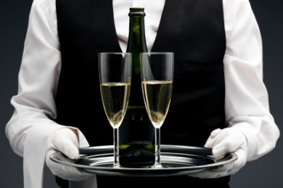
In fact the mere mention of wine can scare people as it may be a new concept to them.
Whilst the world of wine can be seem complex and hard to understand in the eyes of many consumers, it is in fact easy to gain a basic understanding of what wines are about and how they can be enjoyed.
Whilst customers are not expected to have a thorough understanding of wine, most food and beverage servers should have as a minimum, a sound understanding of the basics.
This is essential when helping to guide and assist customers in trying to select a wine that they may enjoy.
This manual will explore the ‘world of wine’ to demystify its complexity.
Wine production, popularity and enjoyment is on the rise in all corners of the globe and the more people who can enjoy wine, the more beneficial it will be for all hospitality organisations, for wine makers and more importantly, the customers themselves.
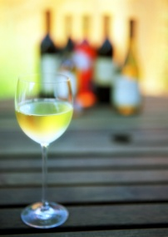
Definition of wine
Wine is defined as the naturally produced beverage made from the fermented juice of grapes.
Wine is a major aspect of beverage service and is routinely served to complement a lunch or evening meal.
Wine knowledge will be covered in more detail throughout this manual.
Wine styles
In addition to ‘red’ or white’ table wine, wine can be further categorised as follows:
- Varietal or generic table wines
- Sparkling wine
- Fortified wine
- Rice wine.
Varietal wines
‘Varietal’ wines are wines made from one grape variety. The name of this grape appears on the label of the bottle.
The different types of varietal wines will be explained in the next section.
Generic wines
‘Generic’ is the term used to describe wines are made to a style, usually naming a European location as its origin, such as Hock, Moselle, Claret and Burgundy.
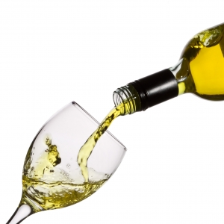
Generic white wines
Generic white wines include:
- Chablis – a very dry, flinty wine
- Hock – a very dry white wine
- Moselle – a popular and pleasantly semi-sweet wine, less sweet than Sauternes
- Riesling – drier than Moselle. Often described as fruity and has its fruitiness confused with sweetness
- Sauternes – produced from fully ripe grapes, a very sweet wine
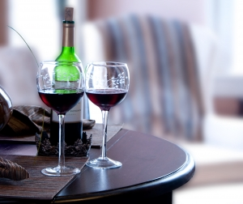
- White Burgundy – a fairly dry white with full flavour.
Generic red wines
Generic red wines include:
- Burgundy – a soft and fruity red wine
- Claret – a dry red with more astringency than burgundy.
When most wine industries started, most if not all of its wines were generic wines.
Today there is a tendency for the cask or house wines to be generic and the premium bottled wines to be varietal. That said, there are many types of varietal and blended cask wine.
Blended wines
Blended wines, as the name suggests are made from two or more grape varieties.
This may be done by a wine maker to create a unique taste to:
- Mask a deficiency in one grape - such as lack of colour, lack of flavour
- Because of economic necessity - some grape varieties are cheaper than others.
A blended wine is not to be seen as inferior to a straight varietal wine. It is just different.
Cask wines
Many venues will use cask wine for their house wines. House wines are wines that are served by the glass or the carafe.
Glass sizes vary between 160 mls – 200 mls in size, and carafes are available in 500 mls, 1 litre and 2 litre.
Casks are available in a wide variety of varietal and generic options. Common sizes are 2 litres and 4 litres with some larger sizes including 10 litres and 20 litres.
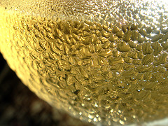
Premium wine by the glass
Some properties feature a system that allows premium quality wines to be sold by the glass.
These systems use nitrogen to dispense the wine thereby avoiding the oxidising problems involved when wine bottles are opened.
Sparkling wines
The word ‘Champagne’ is now legally reserved for sparkling wine produced from the Champagne region in France. Where produced in other parts of the world, it is correctly now known as ‘sparkling wine’.
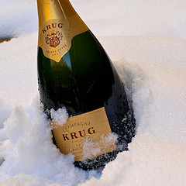
Sparkling wines may be made using one of four options, each producing vastly different quality products.
Styles of champagne
Non-vintage (N.V.)
This is the most common style and is made from base of two to three wines every year to enable consistency of product.
The end product cannot be legally identified as coming from a specified year, hence the term N.V.
Vintage
This is a rarer and more expensive wine made solely from wine of the one nominated year.
It is usually a better quality champagne.
Vintage champagne not made every year. It depends on grape quality and the season.
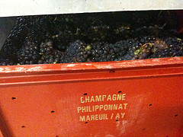
Rosé
This style may be made from leaving the grape juice in contact with the red or black grapes for a period so the wine can pick up some colour from the skins or some red wine may be added to the white base wine prior to the second fermentation.
Crémant
‘Crémant’ means ‘creaming’.
The wine is a gently sparkling wine, giving the impression of creaminess, preferred by many especially with desserts.
Blanc de blancs
This wine is made exclusively from white grapes.
Blanc de Noirs
This wine is made only from red grapes.

Degrees of sweetness/dryness
Sugar levels vary between brands so a brut in one brand may well not be as dry as a brut in another.
The following is a general guide to sweetness/dryness:
- Driest Extra brut
- Brut
- Extra dry
- Sec
- Demi-sec
- Sweetest Doux.
Champagne should be chilled before serving, and served at 7.5°C in champagne flute glasses.
Champagne bottle sizes
Champagne comes in half bottles (375ml) and full bottles (750ml). Some are also available in 200 ml bottles, as well as a range of larger bottles each with their own name:
- Magnum – equivalent to 2 bottles
- Jeroboam – equivalent to 4 bottles
- Rehoboam – equivalent to 6 bottles
- Methuselah – equivalent to 8 bottles
- Salmanazar – equivalent to 12 bottles
- Balthazar – equivalent to 16 bottles
- Nebuchadnezzar – equivalent to 20 bottles.
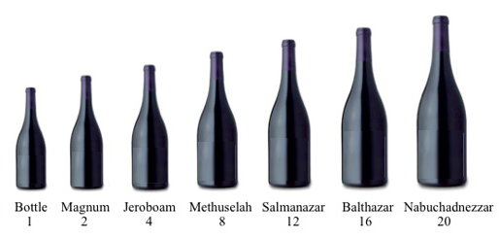

Champagne and sparkling wine websites
- http://www.champagne.com/en_indx.html
- http://www.moet.com/
- http://www.veuve-clicquot.com/
- http://www.wineaustralia.com/Australia/Default.aspx?tabid=807
- http://www.winediva.com.au/.
Fortified wines
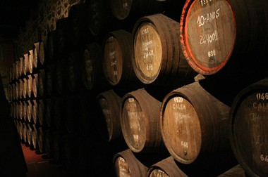
Fortified wines are base wines which are strengthened or ‘fortified’ by the addition of grape spirit or brandy.
The addition of the grape spirit stops fermentation, increases alcoholic strength, adds sweetness, imparts keeping qualities, and in the case of port provides the brandy character.
Most fortified wines must by law be between 17 – 22% alc/vol.
The standard industry size serve for a fortified wine is 60 mls.
Fortified wines include:
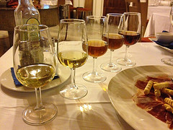
Sherries
Served as an aperitif, sherries are available in:
- Dry – which is often kept under refrigeration and served chilled
- Medium
- Sweet
- Cream.
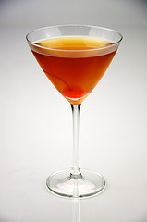
You can tell the difference between a dry sherry and a sweet sherry that are on a drinks tray because the sweet sherry is darker in colour.
Vermouth
Vermouth is a white wine that has been infused with various herbs, spices, flowers, fruits etc. This normally depends on the manufacturer.
It is available in red (rosso) often referred to as Italian, or white (bianco) which is also referred to as French. It is used (or mixed) as a pre-dinner drink.
Visit http://cocktails.about.com/od/liqueurscordials/g/dry_vermouth.htm for more information.
Ports
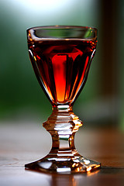
White port is produced in the same way as red, with the same difference in production as the difference in production of red and white table wines. The time on skins is either far less, or non-existent.
The final product in white port is usually much sweeter than the red port, even where the labels read ‘dry’ or even ‘extra dry’.
Ruby port
Ruby port is amongst the simplest and most inexpensive due to the fact that it is aged in bulk vats, not smaller barrels, and bottled young (after 2 – 3 years) after blending. It retains a deep ruby colour and a ‘fiery’ taste. Mulberry flavours are often traditionally associated with ruby wine.
Tawny port
Tawny port gets its name from the tawny colour that port gets from its wood ageing or the use in tawny of a lighter base wine, or the blending of a red port with a white one.
Vintage port
Vintage port is a port that is simple to make being made blended wines from the one vintage, yet is the most expensive in part due to the fact that only the very best grapes are used. Not every year will be a year when a ‘vintage’ can be declared.
Despite being a fortified wine, vintage port has a limited shelf life. After opening it should be consumed within 2 – 3 days.
Liqueur port
Liqueur port is produced when after some time tawny ports become so concentrated or liquored through evaporation through casks that their very nature has changed. The evaporation reduces the liquid volume but concentrates the sugar, colour and flavour present and results in a port of liqueur-like character.
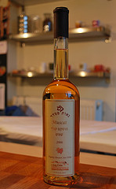
Alternatively, and more cheaply, a sweet white wine can be added to the tawny before bottling producing a nutty vanilla flavour.
Muscat
The name can refer to either grapes, or to the wine they make.
Muscat is a red dessert wine with a rich raisin taste and smoky characteristic.
The Liqueur Muscat is made in the same way as the natural liqueur port.
Tokay
This is a simplified version of the Hungarian original wine ‘Tokaj’.
Tokay is similar to muscat in terms of production method, and produced from Muscadelle grapes. It is matured in oak barrels, up to 2,000 litres in size in the Solera system, and blended before bottling.
Rice wine
Rice wine is an alcoholic beverage made from rice. Unlike European wine, which is made by fermentation of naturally sweet grapes and other fruit, rice wine is made from the fermentation of rice starch converted to sugars. This process is akin to that used to produce beer. However, beer production employs a mashing process to convert starch to sugars, whereas rice wine uses the different amylolytic process.
Sake is often referred to in English-speaking countries as "rice wine"; however, this usage is a misnomer. Sake is produced by means of a brewing process similar to that which is used for beer. Thus, sake would be more accurately referred to as "rice beer" rather than as "rice wine".
Rice wine typically has a higher alcohol content, 18%–25% ABV, than grape wine (9%–16%), which in turn has higher alcohol content than beer (usually 4%–6%).
Rice wine is much used in Chinese and other Asian cuisines.
Alcoholic beverages distilled from rice were formerly exclusive to East Asian and Southeast Asian countries. Later, knowledge of the distillation process reached India and parts of South Asia through trade.
Some types of rice wine are:
- Ang Jiu - Chinese red rice wine, popular among the Foo Chow Chinese (Malaysia, China)
- Ara - Bhutanese rice, millet, or maize wine
- Brem - Balinese rice wine
- Cheongju - Korean rice wine
- Choujiu - A milky glutinous rice wine popular in Xi'an, China
- Gamju - A milky, sweet rice wine from Korea
- Huangjiu - A Chinese fermented rice wine, literally "yellow wine" or "yellow liquor", with colours varying from clear to brown or brownish red
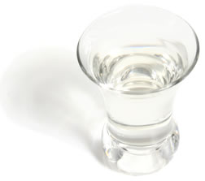
- Kulapo - A reddish rice wine with strong odour and alcohol content from the Philippines
- Lao-Lao - A clear rice wine from Laos
- Lihing - Kadazan rice wine (Sabah, Malaysian Borneo)
- Makgeolli - a milky traditional rice wine indigenous to Korea
- Mijiu - a clear, sweet Chinese rice wine/liqueur made from fermented glutinous rice
- Pangasi - Rice wine from Mindanao in the Philippines
- Raksi - Tibetan and Nepali rice wine
- Sato - A rice wine originating in the Isan region of Thailand
- Shaoxing - A rice wine from Shaoxing, Zhejiang province, China, probably the best known rice wine
- Sonti - Indian rice wine
- Tapuy - Clear rice wine from the Mountain Province in the Philippines
- Tapai - Kadazandusun rice wine (Sabah, Malaysian Borneo)
- Tuak - Dayak rice wine (Sarawak, Malaysian Borneo)
- Thi - Kayan rice wine, served in a clay-pot with a straw to sip (Kayah State, Myanmar).
As can be seen in this section there are a number of wine styles that are available throughout the world.

1.2 Identify and differentiate between the major grape varieties used in wine production

Introduction
As mentioned, ‘varietal’ wines are wines made from one grape variety. The name of this grape appears on the label of the bottle.
Where a wine claims that the wine is made from a certain grape variety, the wine must be made from a minimum 85% of that stated variety.
Where a wine claims to be made from grapes of a certain year, then 85% of the wine must be from that specified year.
Where a wine claims that the wine comes from a nominated region, then 85% of the wine must come from that stated area.
Grapes – Berries and Varieties
The following article ‘Grapes – Berries and Varieties’ is taken from the Australian Wine and Brandy Corporation website at
http://www.wineaustralia.com/australia/Default. aspx?tabid=796
There are many factors that influence the character of a finished wine and every one of these has its own unique role to play, however the most significant influence on the character of a wine is the actual berry or grape variety used.
Defining Properties
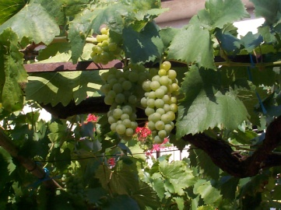
Grape variety refers to the type of grape, whereas the word varietal refers to the wine made from those grapes. The structure of the grape berry can be broken down into three major components; the flesh, the skin and the seeds.
Flesh: The flesh and juice of the berry is the main component of a finished wine. Acidity and sugar are both present in the flesh of the grape and are extracted into the juice, where fermentation in the winemaking process results in the alteration of the acid structure of the liquid and sugar being converted into alcohol.
Skin: The skin comprises approximately 5-10% of mature berry weight with the flesh and juice making up the major component. Tannins are found in the grape skins along with the colouring pigments, anthocyanins, both of which are important to the texture and colour of a wine. The skin is also the main source of what becomes the flavour compound in wine.
Seeds: Grape seeds vary in size and number per berry and generally the more seeds there are, the larger the berry. The seeds are of little importance in the winemaking process, however if they are crushed, bitter tannins will be released.
Range and Scope
The known range of grape varieties grown around the world is vast and new varieties are constantly being isolated and catalogued. Within each grape variety there are then a range of different clones that add a further level of difference to the equation.
Flavour and Texture
The distinguishing characters in a wine derived from the grape variety are described as varietal character. These include aspects of the wine’s aroma, flavour and texture or mouthfeel. Flavours are just that, and those derived from the primary fruit character of the grape plus those that are added through the process of winemaking and maturation, are not distinguished from one another.
The mouthfeel of the wine is similarly described as one set of properties. The notion of viscosity and descriptions of the weight of the wine (i.e. light through to heavy) are all used to describe the mouthfeel of a wine.
Varietal types
Varietal white wines
White grape varieties include:
- Chardonnay – a full-flavoured dry white wine
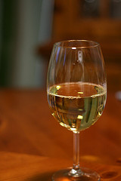
- Chenin Blanc – a pleasant fruity ‘drink now’ wine with a refreshing acid finish
- Riesling – a delicate wine with fruit character and a trace of sugar that varies hugely depending on the region in which it is grown.
- Sauvignon Blanc – a dry white wine with distinct varietal flavour such as melon, pineapple, tropical fruit
- Semillon – a dry, crisp white wine with grassy flavours
- Traminer – a fresh and fruity wine with a spicy smell and taste.
The common bottle size for most white wines is 750 mls.
Varietal red wines
Red grape varieties include:
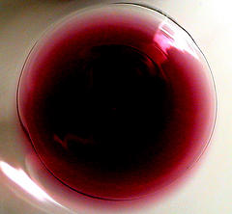
- Cabernet Sauvignon – an aromatic red with berry, mint, capsicum and blackcurrant highlights
- Malbec – a fruity, soft wine
- Merlot – another fruity and aromatic red reminiscent of plums, pumpkins and fruitcake
- Pinot Noir – a lighter style red, thin in taste and colour, berry flavours
- Shiraz – also used to be called ‘Hermitage’ this grape produces fine full-flavoured reds that vary greatly from region to region. They are often blended and have peppery characteristics.
The characteristics of these grape varietals will be described in more detail in Section 3 of this manual.

1.3 Identify major wine producing countries and the wines they produce

Introduction
Many countries around the world produce wine, whether as identified above, or in their own format and styles. So what are the major wine producing countries?
Major wine growing countries
Top 10 wine producing countries (2011)
Rank | Country | Wine production (in Hecto Litres)
1 | France | 46,500,000
2 | Italy | 44,010,000
3 | Spain | 42,800,000
4 | United States | 20,800,000
5 | Argentina | 13,230,000
6 | China | 11,600,000
7 | Australia | 10,200,000
8 | South Africa | 8,850,000
9 | Germany | 8,190,000
10 | Portugal | 7,340,000
Source:http://www.seriousrankings.com/top-10-wine-producing-countries/
Date: 10/26/2011
Wine growing regions
This section will explore some of the most famous regions for producing wine around the world.
Given that most wines on an international wine list will feature wines from these regions, but having a basic understanding of these regions and the wines produced within them, will not only help you to identify and differentiate wines, but again can be invaluable information for customers.
France
France is arguably the most important wine producing country in the world.
It is a country that many countries and wine regions have sought to emulate or better when establishing and developing their own wine industries. Whilst it is fair to say that their contribution to the vast body of knowledge on wine making has been enormous, individuals from many other countries journey to France to teach them.
It may not be that France has lost its position of authority and dominance through a drop in its standards or practices, but more that other countries have caught up with it, passed it and are now forging their own identities.

Some French regions are as follows:
Champagne
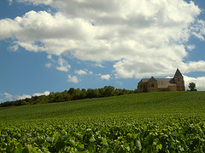
France is very famous for its Champagne and yet French Champagne is now responsible for a decreasing amount of the sparkling wine sold today. Many countries produce sparkling wine that is the equivalent of champagne.
Main grape varieties used include Chardonnay (white), Pinot Noir (black) and Pinot Meunier (black and also called Gris Meunier and Meunier).
Noted producers include Krug, Bollinger, Moet & Chandon, Pol Roger, Piper-Heidsieck, Mumm, and Pommery.
Some of these companies have built and invested in wineries overseas to make sparkling wine outside of France, keeping their established name well in view of the consumers.
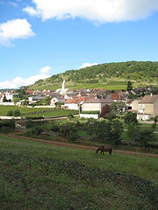
Champagne wines are the only French wines not to carry an appellation on the label, but only grapes grown in the geographically defined region of Champagne can be called Champagne.
Burgundy (Bourgogne)
The Burgundy region is located in east central France.
It is best known for medium-bodied dry red with a soft finish using Pinot Noir, hence our use of the generic term Burgundy.
The region also produces a light to medium bodied red from Gamay grapes centring on the region of Beaujolais.
Burgundy also produces a fine full-bodied dry white using Chardonnay.
Bordeaux
Bordeaux is one of the largest French cities and is located on the Garonne River.
Bordeaux wine is any wine produced in the Bordeaux region of France.
It produces a large variety of wines, ranging from value for money table wines through to expensive versions, made by over 8,500 producers.
Types of wine produced include:
- Red wine (claret) – majority of wine produced in the region
- Sweet white wine
- Dry white wines
- Rose
- Sparkling wines.
Sauterne
This is a region within the Graves district of Bordeaux.
Produces full-bodied sweet white wines and gave us our generic wine term.
Main grape varieties used are Semillon and Sauvignon Blanc.
Loire Valley
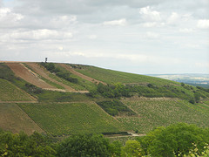
The area produces light bodied dry white and dry red, and sparkling wines.
Main grape varieties are Chenin Blanc, Sauvignon Blanc and Cabernet Franc.
Well known names include:
- Sancerre – a hilltop on the left bank of the Loire river, making predominantly white with some red and rosé
- Anjou – where rosé is the main wine produced
- Saumur – a town making Saumur Moussex (moussex means foamy, frothy, sparkling) a sparkling wine from Sauvignon Blanc and Chardonnay. Also produces Saumur Rouge and Saumur Blanc, and a rosé called Cabernet de Saumur.
Alsace
A region on France’s eastern border, it is separated from Germany by the Rhine, and from the rest of France by the Vosges mountains.
Alsace is the only region where the wines are sold under a varietal label. All the other wines are labelled by region, château, town and buyers are assumed to know the style, quality of what they are buying.
Grapes grown include Riesling, Sylvaner, Gewurztraminer, Pinot Gris, Muscat, Pinot Blanc, Pinot Noir and many more lesser-known varieties.
Produces light-bodied dry whites using the Riesling and Gewurztraminer grape varieties
Italy
Tuscany
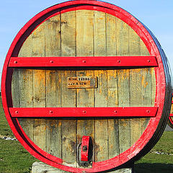
Tuscany is found in the north central area of Italy and whilst a major wine producer is also a famous tourist attraction region in its own right.
Types of wine produced in Tuscany include:
- Famous Sangiovese reds
- Chianti
- Brunello di Montalcino
- Vino Nobile di Montepulciano
- Vernaccia di San Gimignano.
Chianti
A geographical region between the towns of Florence and Siena in the district of Tuscany in central Italy
Main grape varieties are Sangiovese (red), Canaiolo (red), Trebbiano (white) and Malvasia (white).
Albana di Romagna
This is the principal white wine zone in Italy, made in Romagna in central-northern Italy, and made from the Albana grape.
The Albana di Romagna wines come in three styles – ‘secco’ (dry), ‘amabile’ (medium-dry) and ‘dolce’ (sweet).
It is thought that the future of this zone/wine lies in the making of sweet, dessert wines.
United States of America
Napa Valley
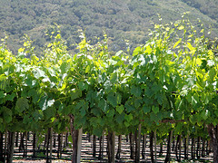
The state of California on the Pacific coast is ‘the Wine State’ and leads the union’s production, turning out more than 90% of its wine.
It is known in the USA and in a growing number of overseas countries simply as ‘the Valley’ and is responsible for most of the wine fame that California enjoys.
There are about 200 wineries in the Napa Valley.
The main grape varieties are Chardonnay and Cabernet Sauvignon.
California is planted mainly to Chardonnay, Colombard, Cabernet Sauvignon, Zinfandel, Gewurztraminer, Merlot, Pinot Blanc, Pinot Noir, Riesling and Sauvignon Blanc.
Washington
This is the second-placed wine state behind California. Whilst it is way behind in terms of quantity, there are many who believe the quality of the product is not all that far behind.
Popular grapes are Chardonnay, Semillon, Gewurztraminer, Chenin Blanc, Muller-Thurgau and Cabernet Sauvignon.
Pinot Noir is popular in the west of the state but does not grow well and hence is rare in the east. Many wineries prefer barrel fermentation of their wines and encourage malo-lactic fermentation.
The wines are predominantly varietal.
Australia
Due to its climatic diversity, Australia produces a wide variety of wines in all corners of the country and is a popular region from which international wine lists are developed.
The information identified in relation to Australian wine is derived in part from http://www.wineaustralia.com/australia.
Hunter Valley
The Hunter Valley is located in New South Wales and is a warm to hot climate region.
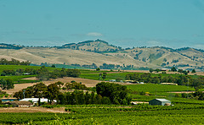
Semillon is regarded as the great wine of the Hunter. That said, it is also famous for producing Chardonnay, Shiraz and Cabernet.
Barossa Valley
The Barossa Valley located in South Australia and is one of the best wine-known producing regions on the Australian mainland with a rapidly-growing international reputation.
It is one of Australia's oldest wine regions and a producer of high quality wines.
Due to its hot climate Shiraz is a familiar variety of wine to the region. Other grape varieties grown in the Barossa include Grenache, Cabernet Sauvignon, Riesling, Chardonnay and Semillon.

Yarra Valley
The Yarra Valley is Victoria’s oldest wine region, has over 3,600 hectares under vine and crushes around 19,000 tonnes of grapes annually.
As it is a cooler climate it produces primarily Chardonnay and Pinot Noir.
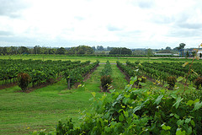
Margaret River
Located approximately three hours drive south of Perth, the vibrant Margaret River region enjoys a growing reputation as one of the most popular destinations in Australia thanks to its exceptional range of restaurants, accommodation and tourist activities.
Initially regarded as a producer of powerful yet elegant Cabernet Sauvignon, the region has also forged a great reputation for its white wines, notably Chardonnay and Semillon Sauvignon Blanc blends. However, it is capable of producing all the classic varietal wines.
Germany
Germany is a famous wine producing country with a wide variety of wines coming from over 2,600 ‘Einzellagen’ (meaning ‘individual sites’) which are officially registered as producers of grapes.
Popular white wine varieties include Riesling and Muller-Thurgau (accounting for 45% of plantings.
Popular red wine varieties include Spatburgunder, Portugieser and Dornfelder.
Rheinhessen
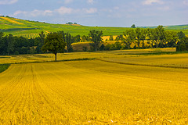
A big and varied region with a well known grosslage in the region called Niersteiner Rehbach and a nearby einzellage called Nackenheimer Rothenberg, which is renowned for its whites.
The area accounts for about a third of Germany’s wine exports, so there’s a fair chance you’ll come into contact with its name.
It also produces half of the nation’s famous Liebfraumilch a medium dry white wine made from Riesling grapes – principal producers being Blue Nun and Black Tower.
As with most areas the wines from here are in part, estate-bottled whilst some goes to the bulk market.
It is an area that experts believe has its wines under-valued in terms of what return the wine-makers receive for their product, being a much poorer cousin to Rheingau for wines of similar quality.
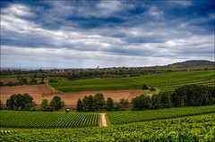
Rheingau
This is the most successful wine-growing region.
Most of the region lies on the right bank of the Rhine with the rest of the vineyards being located at Hochheim (hence ‘Hock’) on the banks of the Mann, just before it joins the Rhine.
The area mainly produces whites which are on the dry side but there is an emerging trend towards reds from Pinot Noir (or Spatburgunder as the Germans call the variety).
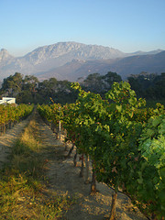
South Africa
Cape Winelands
The Cape Winelands are a region in the south of South Africa. The winelands boast some of the most majestic scenery in South Africa. It is situated to the north-east of Cape Town and offers a beautiful landscape of wine hills and mountains.
It is an area ideal for growing a wide range of noble vine varieties such as Sauvignon Blanc, Chardonnay, Cabernet Sauvignon, Shiraz and Pinot Noir.
New Zealand
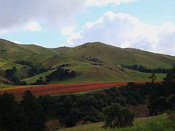
Marlborough
Marlborough is a region on the north-east coast of the South Island of New Zealand. Marlborough is famous for high sunshine hours, New Zealand's largest wine growing area and the Marlborough Sounds.
The main varieties of grape grown are Sauvignon Blanc, Chardonnay and Pinot Noir.

1.4 Identify the steps in basic wine production

Introduction
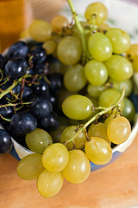
Whilst it is not essential for all wine servers to have an in-depth understanding of the wine production process, it is certainly an advantage. Not only does it show your commitment to your chosen profession, but the information learnt can help identify a suitable wine for a customer and to be able to provide further information that may be of interest to the customer.
The following article ‘Grape to Glass’ is taken from the Australian Wine and Brandy Corporation website at http://www.wineaustralia.com/australia/Default.aspx?tabid=803 (accessed 10/5/09).
Wine is a popular modern beverage and it has been produced for centuries in many parts of the world. Today the grape vine is cultivated for wine production in more locations and conditions than at any other time in history.
The variables involved in its production are numerous and have now been researched and refined to a very high level. But despite the march of science, there are some universal principles that are the same today as they were centuries ago.
General production of wine
Selecting and collecting grapes
Following harvest, grapes are taken to the winery where they are de-stemmed, crushed and pressed.
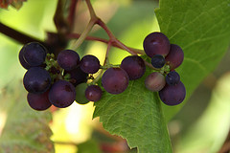
Depending on the style of wine to be made, different techniques are employed to manage the amount of contact between grape skins, flesh and juice.
Generally speaking, skin contact is essential for red wine making and the grape juice is fermented with the skins and then pressed to separate the skins from the wine; whereas only few white wines benefit from a period of skin contact before fermentation.
Fermentation
Every wine relies on the basic act of fermentation which involves the conversion of sugar, released from the grape juice in the form of glucose and fructose, to alcohol. Yeast is the agent of fermentation and these tiny creatures process the natural grape sugars, producing aroma and flavour compounds, alcohol, gas (carbon dioxide) and heat.
Two types of yeast are vital for fermentation as they are resistant to alcohol, allowing all sugar to be processed, producing dry finished wine. These two strains are:
- Saccharomyces cerevisiae
- Saccharomyces bayanus.

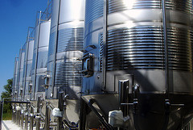
Some winemakers select specific dried yeasts while others prefer to rely on naturally occurring yeasts found on grape skins and winery surfaces for fermentation. Generally speaking, selected dried yeasts in packet form allow winemakers to match certain yeasts with certain grape varieties in order to pursue a desired wine style.
Yeasts found on grape skins and in wineries are variously referred to as ambient yeast, natural yeast or indigenous yeast.
Although the simple act of fermentation is the same, the choice of yeast, ambient or selected, can have a significant impact on the character of the finished wine.
The control of heat produced during fermentation through temperature-controlled tanks is one of the most significant advances of modern winemaking, enabling the winemaker to have a more regulated environment within which to direct the duration and intensity of fermentation.
The size and type of fermentation vessel is also important as it determines the volume to surface area ratio of the fermenting wine and the accommodating tank or barrel, and therefore the influence it may have on the finished wine such as tannin development, imparting oak influence, rate of colour extraction etc.
Sizes range from small buckets to large tanks holding millions of litres and fermentation vessels can be variously made of oak, concrete stone glass, clay synthetics (plastics), or stainless steel.
‘Cleaning’ wine
Following the fermentation process, when all the sugar has been converted to alcohol, the yeast cells die out. These dead yeast cells, or lees, are separated from the liquid in a process known as racking. As mentioned earlier, red wines also need to be separated from the skins following fermentation by pressing.
Depending on the style of wine being produced, the winemaker may choose a short or long period of time before the wine is racked as there are ongoing chemical changes during this time.
Maturing and Bottling
Once fermentation is finished wines are prepared for bottling. Some wines are bottled very soon after fermentation and others are matured for a period of time, usually in oak barrels. With commercial supply pressures, wines made in industrial quantities often use fining agents and filtration to ensure the finished wine is clear before bottling.
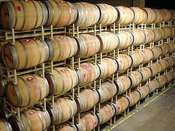
Wine made in an artisanal manner, with the benefit of time, care and attention can naturally settle clear, and is often bottled without fining or filtration.
Once the wine is clear, winemakers need to make sure the wine is in a stable condition prior to bottling. Various processes are available to stabilise a wine ensuring that yeast activity will not continue in the bottle and ensuring that undesirable changes do not occur. Dissolved gases are checked and adjusted, as are sulphur levels.
Bottling is an important part of the winemaking process and precision is the key. A lot of hard work and careful winemaking can all be compromised at the point of bottling. Immediately before bottling most wines are subjected to a thorough laboratory analysis to ensure it is ready.
Once in bottle the winemaking process has finished but each wine continues to change and evolve. This process is known as bottle-aging. This is the final frontier for researchers as the processes that occur in bottle are incredibly complex.
Summary
Primary fermentation is the conversion by yeast of the sugar in the juice to alcohol and carbon dioxide. This basic winemaking process is surrounded by many variables that steer the outcome of the finished wine before, during and after the yeast converts sugar to alcohol and grapes to wine. These variables include the duration and temperature of the fermentation, the type and size of the fermentation vessel and in w hat vessel the finished wine is stored prior to bottling.
To date we have looked at the general production process of wine, but how does it differ depending on the type of wine that is being produced? We will explore the different production methods in this section.
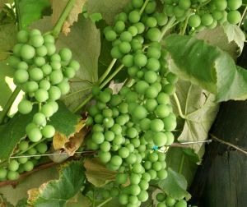
Making white wine
White wine can be made from red or white grapes because grape juice is clear. Wine picks up its colour from contact with the skins, so a white wine made from red grapes would spend virtually no time in contact with the red skins.
The process for making of both white and red table wine is very similar.
The basic procedure for producing white table wine is:
- Grapes are harvested
- Grapes are crushed at the winery – to release free-run juice
- Pressing occurs – to remove all available juice without splitting the pips and stalks
- Sulphur dioxide is added – to prevent yeasts that are naturally occurring on the grapes from starting an unwanted and unpredictable natural fermentation process
- The juice (called ‘must’ at this stage) is chilled – and allowed to settle
- Must is filtered – through a centrifuge to remove large particles not wanted in the final product
- A commercially prepared yeast is added to the must – to start a fermentation process that is predictable and stable
- Fermentation occurs under refrigeration – to control the heat generated during the fermentation process
- Fermentation is stopped when the wine has reached the required level of dryness or sweetness – or as the wine maker’s scientific and taste-testing observations indicate
- Yeast protein, skins and other residue are allowed to settle out – and the wine is pumped out to undergo a ‘fining’ (filtering) process to remove the unwanted matter generated during the fermentation process
- The wine is aged, sometimes in wood but often in large stainless steel tanks
- It is then bottled, may be bottle aged and is then sold.
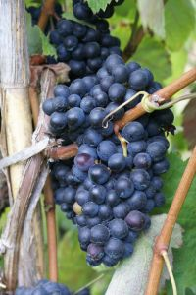
Making red wine
Red wine can only be made from red wine grapes.
The main difference between the production of red and white table wines is that in red wine production, the grape juice is allowed to spend time in contact with the grape skins to pick up colour and tannins which play critical roles in the ageing of the wine.
The basics are:
- Grapes are harvested
- Grapes are crushed – and juice stays in contact with skins
- Winemaker determines how long juice stays on the skins
- Grapes pressed to extract all the juice and other juice may be added – many red table wines are ‘blends’ of different grape varieties
- Fermentation occurs
- Wine is fined, filtered and stored in wood
- Bottled for age and then sale.
Making sparkling wine
Naturally carbonated wine
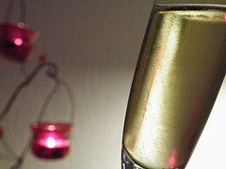
The traditional way of producing sparkling wine is using the French method known as ‘méthode champenoise’, whereby bubbles naturally occur in the bottle as a result the fermentation process.
Many sparkling wines are made using this process and highly regarded around the world as outstanding of the champagne style even thought they are not by strict definition ‘champagne’.
This method is also called ‘méthode traditionelle’, or ‘méthode classique’.
Carbonated or Injection method
This is the cheapest and quickest method and the one producing the lowest quality sparkling wine.
The base wine is placed in a closed tank and chilled. Carbon dioxide is pumped in under pressure and absorbed into wine. Cola and lemonade is made in the same way.
This method produces wine with comparatively large bubbles that disappear quickly in the glass. The label on this wine states ‘Carbonated wine’.
Cuvee close, Charmat, Bulk or Tank method
The base wine is pumped into stainless steel tanks, where yeast and sugar is added to start a second fermentation. The first fermentation has happened to get the initial base wine. It is this second fermentation that puts the bubbles in the wine.
The wine is allowed to settle, filtered and transferred to another tank, still under pressure – where it receives a dose of sweetener or liqueur for the desired level of sweetness.
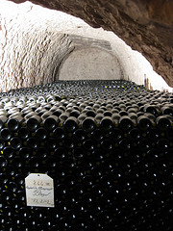
Transfer method
This represents a compromise between the Charmat method and the best, most expensive and most time-consuming method – méthode champenoise.
The secondary fermentation takes place in the bottle in the méthode champenoise way, and wines are also aged for a short while in the bottle.
The wine is transferred under pressure from bottles, after the secondary fermentation to tanks where it is allowed to settle and is filtered. A sweetener is added while the wine is still under pressure and then it is bottled for sale.
The label will state ‘fermented in the bottle’.

1.5 Describe variations in grape growing and wine production techniques

Introduction
Whilst there are quite general styles and varietals of wine, it is not expected that all producers follow the same rules when making them. Whilst there are some general production methods and techniques that are commonly used around the world, like in any business, wine makers will look for different ways to make wine, whether to make the process more profitable, to take into consideration local conditions or to produce different tastes, to name but as few.
This Section will explore some areas of wine production in which variations may exist.
Viticulture
The remainder of the notes in this section are taken from various Australian Wine and Brandy Corporation web pages: http://www.wineaustralia.com/australia/Default.aspx.
Acknowledgements shown on the website for this article from AWBC: Patrick Iland & Peter Gago Australian Wine: Styles & Tastes, Patrick Iland Wine Promotions, Adelaide 2002.
The basic functioning of the vine is very simple and, like most fruit bearing plants, the pattern of growth revolves around the reproductive cycle. The growing cycle repeats on an annual basis and, whilst each part of the vine depends on the other, the focus shifts from different parts of the plant as it moves through different stages of the season.
The Big Picture - The Constant Gardener
The vine is divided in to 3 basic areas and functions:
- The root zone
- The canopy
- The fruit zone.
The root zone will sustain and feed the plant, the canopy area acts as the ‘engine’ for the vine and the primary agent for photosynthesis, and the fruit zone delivers the ultimate benefit: reproductive growth and grapes.
Balance and Influence
Just as balance in wine is the ultimate goal of high quality production, so too is the goal of balance in the vineyard. The ultimate aim of viticulture is to produce the most ideal grapes for vinification and whilst the specific techniques and practices can be very precisely applied and managed, there are many variables affecting the vine that are out of human control.
The influence of climate is crucial in deciding the quality of the wine produced each season. Solar radiation, heat energy, air movement and rainfall are highly variable and the job of the viticulturalist is to manage the vineyard, interpret the climatic conditions of each season and respond accordingly.
Much of the work in viticulture involves steering the vineyard and preparing each vine to move through the many stages of the season. The process is best described as one of aiming at the target of harvest and it is one that begins way back from the start of the cycle at pruning.
Each grape variety is unique and the techniques best suited to one grape variety are likely to be very different from the next, just as they are different depending on the age of the vineyard. As vines mature, the focus of viticulture changes.
Training for Yield
In the early years of establishing the vineyard, the focus is on getting the vine set up on the trellising system (or shaping the vine in the case of goblet vines) and also on the formation of the roots. Generally roots are encouraged to grow down into the soil and provide the vine with a stable and reliable source of nutrient. It is also a goal to avoid the uptake of surface moisture by discouraging lateral root growth near the surface of the vine.
The crop level or yield is a crucial determinant of wine quality. This is either measured in the amount of grapes or must be produced by an area of land. It is a popular misconception that the lower the yield, the better the wine. Like so many aspects of wine production, the notion of a balanced vine, producing an ideal amount of fruit is the key. Too much fruit or too little can both reduce the quality of the wine produced.
The Canopy as an Engine
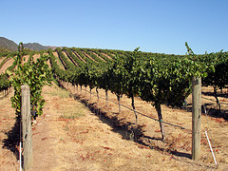
The canopy or vegetative area of the vine is often referred to as the engine of the vine. The photosynthesis conducted in the leaves facilitates the growth of the plant throughout the season. It is important to manage the canopy of each vine in order to produce the highest quality fruit.
There are many techniques that can be employed but, once again, there is an act of balancing the canopy and matching the canopy area to the amount of fruit carried by each vine. This is referred to as the leaf to fruit ratio.
Once bunches are formed, the focus shifts to the fruiting zone as the grapes are nurtured towards the eventual goal of harvest. The exposure of bunches is an important factor in determining fruit quality. Depending on the climate, it will be necessary to expose the fruit to the sun or to shade it. The flow of air around the ripening bunches is also of key importance as the grapes need to be well ventilated. If moisture is allowed to accumulate in the fruiting zone, the pressure of various fungal outbreaks can compromise fruit quality and that of the finished wine.
Growing Cycle
The vine growth cycle is a pattern repeated every year in every vineyard. This module explains the key events in this yearly cycle and how these milestones impact the stages that follow and sometimes even the following year’s growth cycle. While the time to pick the fruit is often regarded as one of the most crucial decisions, harvest is merely the final action of the yearly growing season that is determined by pruning and other vine management decisions.
A Life in the Year of a Vine
In mapping out the annual growth cycle of the grape vine, the logical point to start in the season is immediately following the climax of harvest. The vineyards are momentarily left quiet as the focus shifts to the winery.
As the weather cools, fermentations are finished and all the wine is safely into barrel, leaves age (senesce) on the vine and eventually drop to the ground, leaving the shoots to wood (lignify). Pruning occurs throughout the cold winter months and there are various techniques from which to choose.
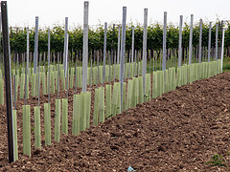
Roots, Shoots and Leaves
It is important to prune each vineyard specifically to establish the right amount and quality of wood for the coming year. Pruning removes the woody growth of the season past and sets the vine up for the coming cycle to begin. Even at this stage the yield is being established as the number of shoots are set in the pruning phase.
New Beginnings
As winter fades and the weather starts to warm, the rising temperature triggers the growth of new foliage from wood that has been laid down at pruning. This stage is known as bud burst or bud break. Small buds swell out and the first tiny leaves unfurl. Green shoots start to sprout and the season is underway.
The shoots grow rapidly in the early stages, encouraged by the availability of winter moisture and the increased solar energy. After a period of approximately two months (depending on grape variety, site and climatic conditions) shoot growth slows and flowering occurs.
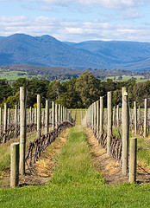
Fruitful Flowering
Tiny clusters of small flowers burst from the cluster and it is at this time that weather patterns are crucial in determining the quantity and quality of the coming harvest. Fine mild weather will promote an even and healthy setting of fruit (referred to as fruit set) however high winds, excessive rain, or hail can potentially reduce the fruit set and cause uneven formation of bunches.
Following the completion of fruit set, green bunches of grapes are now formed and the fruit moves through a period of growth and development. The warm weather causes sugar to accumulate in the berries as they move through the season towards ripeness.
Weather throughout the ripening period shapes the character of the grapes and the development of flavour and aroma compounds. Essential components like sugar development, acidity and tannin development are plotted.
As the vines move through this period of berry development, a calculation of yield is made. Although at pruning the number of shoots per vine was established, the number of bunches per shoot now needs to be checked. Drilling down even further, the number of berries per bunch can be assessed as well as average berry weight, allowing the calculation of an average bunch weight.
From Green Harvests to Ripe Promise
There are crucial decisions to be made at this point, as just prior to veraison, there is an opportunity to reduce the yield. This process is known as green harvesting, as excessive bunches of green berries are removed and dropped to the ground. The aim here is to ensure that each vine has the right balance of canopy and fruit load, ensuring it will carry the remaining bunches to optimum maturity in time for harvest.
As ripening reaches its zenith, grapes and juice are tested. Winemakers prepare the winery for the arrival of the first fruit to be picked. When the crop approaches its peak, fruit is monitored weekly, sometimes daily and the crucial decision to pick the fruit is eventually made. One season ends and another begins.
Site Selection
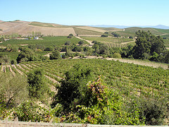
The key influences of soil composition, temperature through the various stages of the season, rainfall, wind exposure, topography and orientation all play a major role in determining the most outstanding sites for the production of high quality wine.
The ability to express the character and conditions of vineyard site in the finished wine is one of the most sought after attributes. The distinctive expression of each wine is therefore ultimately reliant on the conditions of site.
Matching Site and Wine
When selecting a site for the production of any style or quality of wine, the most important starting point is to understand the goal of the finished wine. Not all sites are created equal and it is important to understand the specific idiosyncrasies of each grape variety when choosing a site upon which to grow it.
There are however universal principals that apply to the selection of a site for the production of high quality grapes, the most important ingredient in the production of top quality wine. Whilst all grape varieties follow the same cycle of growth and fruit production, there are distinct differences when you drill down further layers.
Variety and Site Compatibility
Varieties behave differently throughout the growing season and ripening period (typically about 100 days). Accordingly you will find variances in flowering time and growth cycle among different types of grape. These factors are key considerations in site selection, as this in turn must be able to support the ripening grape to the desired level of maturity.
Key Concerns
Frost exposure is another key concern in the selection of the right site, particularly if a cool climate is ideal for the style of wine to be made. Spring frosts are usually of the biggest concern and occur most significantly when warm weather early in the season triggers a premature or early bud burst.
New shoots and young leaves are highly prone to damage by frost or very low temperature and although secondary shoot growth can occur if the damage is early in the season, these have significantly lower crop potential than the primary shoots.
From the Ground up
Topography can have a significant effect on the potential for frost as can wind exposure. Typically vineyards planted on valley floors in cool to cold climates are at the greatest risk of frost whilst sites on sloping terrain allow the cold air to ‘drain’ away and thereby reduce the risk of frost. Reliable air circulation through the site is another key to avoiding unnecessary frost damage and in some sites that are highly frost prone large automatically activated fans are often used to combat frost.
Composition and Rainfall
Soil composition, also referred to as soil structure, is a key consideration of selecting the correct site. Properties like pH, moisture retention, friability, depth of topsoil and mineral and nutrient availability are all of key consideration. It is important to understand that different grape varieties are compatible with different soil types and so they must be carefully matched with each other.
Rainfall is another key factor and it is important to remember that too much or too little can be detrimental to fruit quality and ultimately limit the potential of the site. Generally sites that receive significant rainfall close to or during the harvest period are unsuitable for the production of high quality wine.
Age and Orientation
It is also important to note that younger vines, particularly saplings, require more water than older vines. Irrigation is an essential aspect of viticulture in arid conditions and is particularly important in keeping the vine functioning during the fruit bearing stage of the season. Careful water management is critical to producing high quality fruit and efficient water use is essential.

Orientation in regards to the trajectory of the sun is a variable to consider for each grape variety, particularly with regard to the accumulation of tannins and phenolic compounds in the grape skins. Generally in cool climates there is desirability for greater sun exposure to achieve adequate ripeness in the fruit and in warmer climates grapes may need protection from the stronger energy of the sun.
Climate
Across the vineyards of the world there is a startling range of climates under which grapes are grown for the production of wine. The properties of climate have a pronounced effect on the process of wine production, and climate therefore sets the parameters for the selection of grape variety.
Climate (and weather) is made up of several factors: temperature, rainfall, humidity, evaporation, wind, sunshine and frost. If one was to focus on a single factor of paramount importance, it would be temperature, as this most closely regulates the production of aroma and flavour compounds in grapes.

Climate - A Question of Scale
To make an analysis of climate and in order to draw conclusions about site suitability for viticulture, or decisions of vineyard management, climate is broken into three categories of scale: macro, meso, and micro.
From Macro to Micro
The largest is macro-climate and this refers to a large area of land. It covers many square kilometres and often equates to an entire sub-region or even a whole region. This is useful in determining climatic explanations of regional character.
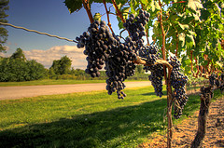
Meso-climate is smaller and more localised. It breaks down topographic elements and can often be equated to a particular vineyard or section of vineyard. To use the example of a simple hillside, the top of the hill, the sloped section and the bottom of the hill will all be described in terms of their own separate meso-climates. Similarly, the western face of a hill will have a meso-climate distinct from the eastern face. Meso-climate is particularly useful in describing the climatic influence on the character of wines made from single vineyard plots or vineyard character.
The final, smallest scale is that of micro-climate. This is an often-misused term and frequently applied to descriptions of the meso-climate scale. Micro-climate in a vineyard sense is the area surrounding the vine, its canopy and its fruit. Differences can be made between the inner and outer canopy as two distinctly different micro-climates. This scale is particularly useful when discussing specific viticultural and vine management techniques.
The Defining Influence
The impact of climate on the character of wine grapes and ultimately, the finished wine cannot be overstated. The dual notions of vintage character and vintage variation are entirely related to the effect of climate. Whilst generalisations about climate are arrived at through a process of averaging and plotting variables, each year presents a unique set of challenges and conditions against which responses are made in the vineyard and winery.
The very best vineyards are those that have an affinity between the desired wine, the quality and character of grapes required to make that wine and grape variety. This balance is increasingly harder to define as weather patterns are becoming more irregular or atypical.
Beyond Temperature
The effects of other climatic elements should also be considered:
Sunshine: provides energy for photosynthesis and light for the initiation of colour and flavour development.
Humidity and Evaporation: sites that have high evaporation rates and low relative humidity have higher transpiration rates (evaporation of water off the leave surface) and may therefore require irrigation.

Rainfall: no water, no growth, no comment!
Wind: may be beneficial in terms of drying out vines and thereby preventing the onset of disease through damp conditions. Conversely it may also restrict vine growth and for this reason wind breaks are sometimes required.
Different wine production methods
So far in this section we have explored different impacts that can impact the production of wine.
There are other impacts that can influence the production of wine, imparted by the wine maker themselves.
These include, but certainly not limited to, techniques such as:
- Maceration - To macerate is to soften by soaking, and maceration is the process by which the red wine receives its red colour
- Cold fermentation – used to help control temperatures, especially in hot climates, during the fermentation process
- Barrel fermentation - Barrel fermentation is the process of letting grape juice sit in a large wooden barrel (usually oak), during which time yeast turns the sugar in the grapes into alcohol and the juice is converted into wine
- Use of oak – adds flavour, smoothness and vanilla, buttery characteristics in wine. This is achieved through contact with oak either in barrels or in ‘chips or shavings’
- Ageing – wine is left to mature leading to smoother, deeper and more complex characteristics
- Malolactic fermentation – a process which tends to create a rounder, fuller feel in the mouth when drinking
- Reduced alcohol wines – an alternative to attract different market segments
- Various viticulture techniques
- Alternative methods for the production of sparkling wines, including - Méthode Champenoise, transfer method, bulk method, injection method. These have been mentioned in the previous section.
As can be seen there are many different influences that are caused by the environment, soil, climate and the winemaker themselves, which results in a wonderful and ever-changing wine industry.

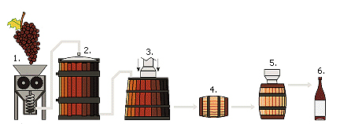
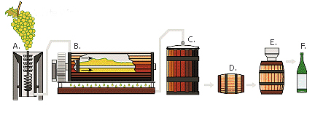
1.6 Interpret wine labels to identify and make assessment of wine contained within bottles

Introduction
The easiest way to gain an immediate understanding about a wine is to simply pick up and look at the bottle.
Naturally the impact of different marketing techniques such as use of pictures, colour, layout and font will help draw people towards certain wines, depending on what they find appealing, the information actually written on the bottle, is a great influence on what wine a customer may find suitable.
Information on label
There are a number of pieces of information that can be found on a wine bottle, including:
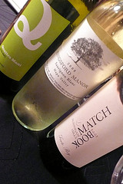
- Vineyard – name of the wine producer. This indicates expected wine quality and guarantee of consistency
- Grape variety - tells you the most about the body and complexity of the wine. For example, Cabernet Sauvignon is full-bodied, intense, and tannic. As mentioned, the characteristics of different grape varieties will be explained later in this manual
- Region – where the wine was produced. It helps to identify the expected style, intensity, and flavour
- Country – again, notes where the wine has been produced
- Vintage - or the year the wine is produced. This helps to reveal the best time to drink the wine
- Alcohol content - implies the body and sweetness of a bottle of wine. Above 14% wines are full-bodied and more tannic. Sweeter and lighter wines generally have alcoholic level below 11%. Sugar from grapes is transformed into alcohol during the fermentation process.
Work Projects
It is a requirement of this Unit you complete Work Projects as advised by your Trainer. You must submit documentation, suitable evidence or other relevant proof of completion of the project to your Trainer by the agreed date.
1.1 To fulfil the requirements of this Work Project you are asked to identify different wine styles, providing examples of each.
1.2. To fulfil the requirements of this Work Project you are asked to identify different wine varietals, providing examples of each.
1.3. To fulfil the requirements of this Work Project you are asked to identify major wine producing countries, famous regions within these countries and the wines produces in each.
1.4. To fulfil the requirements of this Work Project you are asked to identify the steps in basic wine production.
1.5 To fulfil the requirements of this Work Project you are asked to identify variations in grape growing and wine production techniques.
1.6 To fulfil the requirements of this Work Project you are asked to identify different information found on wine bottle labels.

Summary

Develop wine knowledge
Identify and differentiate between wine styles
Definition of wine
Wine styles
Varietal wines
Generic wines
Sparkling wines
Fortified wines
Rice wine.
Identify and differentiate between the major grape varieties used in wine production
Grapes – Berries and Varieties
Varietal types.
Identify major wine producing countries and the wines they produce
Major wine growing countries
Wine growing regions.
Identify the steps in basic wine production
General production of wine
Making white wine
Making red wine
Making sparkling wine.
Describe variations in grape growing and wine production techniques
Viticulture
Growing Cycle
Site Selection
Climate
Different wine production methods.
Interpret wine labels to identify and make assessment of wine contained within bottles
Information on label.

Element 2:
Store and retrieve wines

2.1 Develop in-house wine storage facilities

Introduction
Many hospitality organisations will carry large quantities of wine at one time as most wines come in boxes containing a dozen bottles. Given that most organisations will have a wine list containing a minimum of 10 different wines; it is easy to see how the amount of bottles on stock can quickly add up.
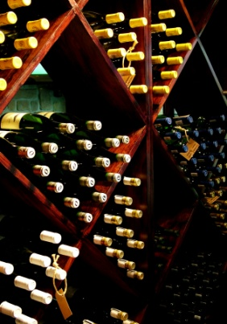
In addition, these bottles may be in storage for a considerable time before they are sold.
In the event of a wine retail shop, the amount of wine kept in stock will greatly increase, with a range of 50-100 wines a common occurrence.
Wine, like other food and beverage items needs to be kept in a storage area that will protect it from the elements. In the case of wine, heat and light can have detrimental effects on the condition of wine.
Wine is normally stored in conditions that are cool, dark, and humid and in still conditions.
This section will explore how to prepare storage areas to successfully store wine.
In Section 2.3 of this manual, the steps for correctly storing wine will also be discussed.
Elements of wine storage
Quite simply wine storage facilities should include:
- Storage facilities for red, white, sparkling and fortified wines
- Create appropriate storage conditions for each wine classification, including suitable space, temperatures and humidity
- Facilities to allow the cellaring of vintage wines for future use
- Consideration of a system to store wines according to type, vintage, style, maker or country.
Requirements for establishing optimal storage facilities
Following are essentials for the correct storage of wine:
- Need for dark storage conditions - out of sunlight and fluorescent lights as light will adversely affect both the taste and aroma of the wine
- Need for a cool environment – the optimal temperature for a wine storage facility should be around 12.2°C and certainly no warmer than 24°C
- Need for a consistent temperature – as any changes should take place slowly. Constant temperature changes prematurely ages wine due to breathing. Temperatures should not undertake changes of more than 1.6°C per day. Many places may have some temperature control mechanisms including refrigeration
- Need for a correct humidity – the optimal humidity level should not be above 70%. Adverse humidity will affect the labels/cork causing mould and disintegration of the label. A damaged label whilst some may find it a bonus on a very old wine may make it difficult to offer the wine to the customer for sale
- Need for sufficient stock – there must be sufficient stock to enable that most, if not all wines identified on the wine list, are actually in stock
- Need for easy access – staff must be able to move around the storage area to conduct essential activities such as stocking, stocktaking, stock rotation and retrieval of wines
- Need for easy identification of bottles – it is important that wines can be easily identified. As mentioned, given that most storage areas contain large quantities of wine not only is this important for retrieval but also when undertaking a stock take or determining the need to re-order
- Need for security – it is easy to see that a large amount of money is invested in purchasing wine and therefore it must be kept in a secure location and with minimum access.
Several companies produce commercial and domestic ‘wine safes’ designed to produce and maintain optimum storage conditions for wines.
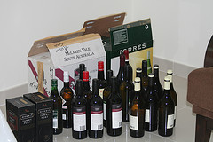
Influences on purchasing wine
This section has explored the requirements that must be considered when developing in-house wine storage facilities, however the process of purchasing wine in which to store in these facilities must also be considered.
Following are ten considerations then purchasing wine.
- Do not write a list of your all time favourite wines - This would be fine if you were the only customer of your restaurant, and if you write this style of list you may well be. The list has to be commercial in the best sense of the word. It is, after all, a business proposition not an audition for “Desert Island Wines”
- Make sure that the wines you have chosen complement your menu - Try not to waste listings on wines that do not fit in with the style and price structure of your restaurant. Wines that show understanding of not only their taste but also knowledge of their combination with food will enhance your profile as a relevant restaurateur. In marketing jargon, cross-marketing and compatibility strengthens your product-service mix and optimises sales opportunities!
- Divide the bottle selling price by 4 to give the by the glass price - The factor 4 is used to yield four glasses (175ml) with a small margin for error or spillage. If perfect pouring is utilised then the profit margin will of course be stronger. Accurate choice of by the glass wines encourages interest, curiosity and trading-up
- Nominate one person to undertake ordering - This will avoid any confusion in the restaurant. There will be one point of contact for restaurant staff and wine companies for both the placing and receiving of orders. This will make stock control easy to monitor and will prove more effective
- Do not buy wines that require protracted cellaring prior to serving - Very few restaurants can afford to cellar wine until it is ready to drink. Wine merchants and wine brokers are better suited to doing that job for you. Cellaring wine ties up funds and clogs up cash flow
- Calculate the average bottle price sold off the list and source wine with this in mind - The average price of wine sold on your list is the most crucial price point you have. When looking to buy new wines, concentrate on packing either side of the average price with interesting wines. Most of the time it is easy to be tempted into buying more expensive wines
- Make sure that house wines and fast movers have rock solid profit margins - The profitability of the entire wine list will hang off the house wines and fast movers. If these wines do not achieve your budgeted profit targets then adjust their selling prices immediately
- Try and convey as much relevant information as possible when listing a wine - The bottles of wine in your cellar will have all the information needed to write your list. If in doubt ask your suppliers which snippets of detail are needed. In general a vintage (unless the wine is a non-vintage style); a title name; a producer; a region and country are all useful. If the wine is a single grape variety, special blend, single vineyard or classed growth then do not leave this information out of the listing as it could make all of the difference to the prospective buyer
- Order little and often - Overstocking the cellar is not efficient when it comes to deliveries, storage, accounting and cash flow. A lean operation exerts as little strain as possible on the bank balance. Regular minimum case orders make a restaurant’s consumption predictable and suppliers are less likely to run out of stock unexpectedly. Regular contact with suppliers guarantees a good rapport and a constant two-way flow of information
- Talk to your suppliers - No need for any explanation here, except to say that this is the most important commandment of all.
Receiving wine
Storage of wine, in the cellar or other area is a rare art form.
The receiving and stacking or racking of wine, in such a way as to maintain the condition of the wine and facilitate ease of location under service pressure, is crucial.
A plan on the wall of the cellar will help staff that who are not familiar with the layout. Remember a wine waiter or barman will not always be available to find the wines. The bottles should be stored in either bin number, wine list order, by region or alphabetically. This will not only ease the hide-and-seek game but will make it easier to re-order wine and check stock.
It is sometimes possible to store wine with your merchant. This will take the form of a paid reserve. It should mean that storage charges are avoided provided the customer removes the wine after a set period of time (which they are not when using a warehousing company).
Watch out for any delivery charges incurred when calling off the stock, as these must be costed in to the selling price. Do not forget to take this paid reserve figure into the stock check at the end of the month. Make sure that the merchant conducts their own check of your stock and that this corresponds to your records.
All venues check their food stores to ensure the optimum storage of food and the same should apply to wines.

2.2 Create floor wine displays and self-service stands

Introduction
In many cases, customers will not be aware of particular wines which they wish to purchase. In these cases they will rely on a number of factors to help entice them in making a decision including:
- Sales skills and promotions - provided by staff
- Promotional displays themselves – provided by visual displays.
All venues should actively promote wines to enhance the combination of food and wine in order to optimise sales and maximise customer enjoyment.
Revenue from wines can never be fully realised unless a distinct effort is made to sell them and actively promoting them in the dining area is a central aspect of achieving this.
This section will explore how wine selling organisations can use these two avenues to help sell wine to customers.
General ways to promote wines
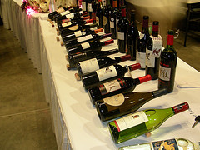
Certain practices will increase wine sales and facilitate wine selection – use them where they exist, and consider initiating them where they don’t.
- Wine displays – this involves the establishment of a significant display in the dining area featuring selected wines perhaps with various wine-related items such as glasses, wine baskets, corkscrews, wine books. The idea is to make an eye-catching display that raises the possibility in the mind of the guest of having a wine with their meal
- Many venues feature high-profile wine stocks that diners can browse, reading the labels, picking up the bottles etc. This relies on the concept of ‘selling by seeing’
- Tent cards - cards placed on individual tables that promote wines. These can be supplied by wineries or produced in-house. They name the wine, give the selling prices for bottle, half bottle, glass, carafe etc, describe it briefly and give tasting notes
- Racks, shelving and bins – many venues locate their wines quite distinctly ‘on display’ in front of customers by placing them around the walls, in shelves or on the floor in bins. This uses the concept known as ‘selling by seeing’ and encourages customers to browse the available wines, pick them up, read the labels, etc
- Chalk boards – these can be used to feature vintage wines and specials of the week or ‘Wine Makers’ suggestions
- Traditional wine lists – these can be divided into various types - sparkling, reds, whites, and fortifieds and may also list dishes from the menu they would go well with

- Winemaker appearances – in this option various winemakers visit the establishment and make some form of presentation intended to promote specified wines. An advertised schedule can be prepared and these appearances can coincide with special menu items designed to demonstrate how certain wines can complement certain dishes
- Tastings – this is an education program of informed tastings conducted by in-house staff or representatives from wineries. Again, a schedule can be developed to inform customers of what is coming up.
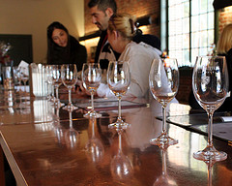
You may for example consider holding:
- A vertical tasting – that is, a tasting of the one wine from a certain region showing how it changes in colour and taste as it develops over time
- Regional tastings – focussing on the wines from various wine growing areas–
- Varietal tastings – showing how the one grape variety can vary in taste etc across a range of wine growing regions.
In Section 3 of this manual, the steps associated with conducting a wine tasting will be explained. Whilst this is aimed at educating service staff, this does not mean it can also be used for educating customers. Educational wine tastings is becoming an ever increasing and popular activity.
- ‘Wine of the Week’ – this is along the lines of a ‘Cellar Master’s Selection’ promotion where a certain wine is featured on the food menu for a week with suggestions as to what foods it complements
- Personal recommendation – you are in an ideal position to sell selected wines. Diners often ask your opinion and this can be the ideal opportunity to, for example, promote local wines or sell wines that management have asked you to push.
Promoting wine at the table
Waiting staff should also be aware that opportunities to promote wine at the table include:
- Suggesting a wine to match the entrees that have been ordered
- Suggesting a wine to accompany the main course
- Suggesting a dessert wine with the desserts
- Offering a second bottle of wine when the first bottle has been emptied.
Steps associated with recommending wine to match the requirements of the customer will be discussed in more detail in Section 4.3 of this manual.

Promoting wines in the wine shop
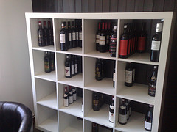
Many of the above techniques used in the dining room can be adjusted for use in a bottle shop environment.
There must be an emphasis on ‘eye appeal’ and on assistance from sales staff.
There are several different techniques that can be used to increase sales including suggestive selling, upselling, features and benefits selling or using the dual positive technique.
Remember that anyone who can sell always sell more if they know what they are talking about so keep thinking how you can combine your product knowledge with these techniques.
Types of selling
Suggestive selling
Suggestive selling is literally selling by suggestion.
Sales are frequently made when staff suggest a product or an option that had not occurred to the customer.
Upselling
Upselling is selling a more expensive line than the customer originally intended to purchase.
Remember to be aware of which lines are your preferred lines, and try to upsell those.
Too frequently sales people are hesitant to suggest the top of the range, but by suggesting the top and the bottom of the range you are improving your customer’s choice.
Upselling can also include multiplying the sale - if a customer buys six bottles of a particular wine, you may increase the sale by suggesting “Did you know that if you take a dozen of that wine there is a further saving of $12.50?”
Upselling works as customers often spend more than intended when they are aware of the options.
Features and benefits selling
This technique works with new products or with customers who don’t know much about the product.
Example: A customer is having a party and wants a wine suitable to drink throughout the meal.
“This Riesling, because of its slight fruity quality (feature) is suitable to drink with all foods and is not too dry for most people (benefit).”
Remember, if someone is unsure of the product they may not appreciate its features (dry, complex, sharp) but may be impressed with its benefits such as it goes well with most food, it’s a good red wine for people who don’t normally drink red wine, etc.
But remember before you can sell the benefits, you must know the features. It’s all part of product knowledge too.

Dual positive selling
This is a technique common in the retail industry.
It means that you give the customer at least two choices (hence ‘dual’), both of which are potential sales, thus being ‘positive’ in nature.
Example: A customer wants an after-dinner drink.
If you said “Do you want a port?” you risk losing a sale because the customer may not like port, and it is very easy, too, to refuse a closed question.
However if you say “Would you like a bottle of port or liqueur?”, or “Would you like a port or a muscat?”, you are offering two options, both of them potential sales, and you stand a better chance of making a sale.
The ABC of sales
When selling in the wine shop, sales can be increased if the concepts underpinning the ‘ABC of Sales’ are remembered and put into practice at appropriate moments.
The ABC of Sales says that sales fall into three different categories – Automatic, Bettered and Created – ABC.
The Automatic sale is where a customer comes into the wine shop and asks for an item: “Can I get a bottle of red, please? We’re having the boss over for dinner tonight, so I better get some wine and show a bit of class?”
You would recognise the ABC opportunity, and make a suggestion to achieve a Bettered sale: “Sounds like an important meal – may I suggest you consider some premium bottled wine? We have some excellent wine Specials this week, and they’re all very well known and well respected names. What are you having to eat?”
Having Bettered the sale which means increasing the original value of the sale, you next move to the Created sale.
“We also have some fine ports available – that might be an excellent way to finish off a business dinner. Do you prefer tawny or vintage? The Hanwood is on Special this week”.
Sales techniques for a wine shop with self selection
Customers who enter a wine shop with self selection are usually prepared to browse, try new products, and are generally more discriminating.
Self selection customers are most likely to make their buying decisions between brands they see displayed on the selling floor, as opposed to coming in with a certain brand in their mind. They want to ‘see what you’ve got’.
This also demands careful attention to shop layout and stock presentation in order to maximise sales.
Because walk-in customers are more discriminating and they have time to browse they may want to know more about the products.
There are no set rules regarding when to approach a customer, and this will greatly depend on the circumstances. By keeping customers under discreet observation you can offer assistance at the appropriate time by reading their body language.

Here are some ideas:
- If a customer is looking around, you should approach them with a greeting and then ask if there is anything in particular the customer is looking for
- By finding out what is required you can capitalise on the customer’s time by making appropriate suggestions and thus multiplying the sales opportunities
- If a customer has inspected several displays and picked up a few bottles, you can either:
- Offer to take the selected wines to the counter while they continue to inspect other lines on display
- Provide a trolley or basket (if available)
- Recommend other lines on display
- Mention there are further reductions if they purchase bulk quantities of the lines selected.
Sales techniques for wine shop with counter service
Unlike self selection every customer comes into direct contact with a salesperson if your wine shop has counter service.
This gives you a wonderful opportunity to use your product knowledge and selling skills.
You will be required to maintain excellent product knowledge, because at the counter you are the link between the customer and a good selection.
The personal nature of the contact gives you the opportunity to increase the number of regular loyal customers if you handle them correctly.
Because customers don’t have access to the bottles, effective counter displays are essential to maximise sales.
Shelf talkers and written material is needed, and must be planned and well maintained.
Lines you hope will result in impulse sales (selected because they return a high gross profit) and those lines that are popular with customers, known as ‘preferred lines’, should be displayed near the cash register.
You must make the most effective use of available space to encourage additional, or impulse, sales.
2.3 Store wines in established wine storage facilities

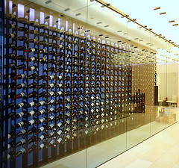
Introduction
In Section 2.1 of this manual, a range of requirements for the establishment of sufficient wine storage facilities where identified.
This section will explore the correct techniques for the storage of wine within these facilities.
Wine storage techniques
Completion of necessary in-house documentation to record wine storage
Like with ordering of any other food and beverage item from a central storage area, wine must also ordered in the correct manner, following organisational requisition policies and procedures.
Storage of red, white, sparkling and fortified wines under correct storage conditions
Bottled wine is frequently stored incorrectly. Too many people store their bottles standing up, which means the cork, where there is one, is no longer in touch with the wine.
This means the cork dries out and shrinks, thereby allowing air into the bottle and into contact with the wine causing the wine to oxidise. This means to turn the wine to vinegar.
Wine, including table wine, sparkling wine and vintage port, should be stored on its side. Many wineries facilitate this by the way they pack their wine. The printing on the carton is right side up, but the bottles of wine are upside down, or horizontal, in a stable environment of around 10°C with around 90% humidity. As mentioned, this environment should be free from light, odours and vibration.
Wine should not be moved when stored, Therefore they must be placed in a manner that reduces handling.
Wine should not be influenced by the vibrations of machinery or other equipment as this also moves the content of wine bottles.
Wines with Stelvin caps do not need to be stored lying down as the seal is air-tight. Some venues will still prefer to lie these wines down because it gives a more traditional look or because existing storage facilities were built to lie bottles down.
Wine should only be stored for their ‘optimal’ time. Not all wines will get better over time.
Opened bottles or flagons of table wines should be consumed within 2–5 days providing they are re-corked. They will start to deteriorate from the day they are opened but will keep for a short while.
Wine should be stored away from strong smelling items, as these smells can permeate through the cork and affect the wine itself. This can include cheeses, dry herbs and spices and strong smelling oils.
Casks that are opened have a much longer keeping life, up to a month.
Fortified wine, because of their high alcohol content, will keep for months.
Ensuring the security and presentation of all products
Due to the very value of the wine itself in most storage areas, there is a need to protect the wines, whether from theft, unauthorised access and adverse conditions.
Allow ease of access
It is essential that staff can obtain bottles quickly without wasting great amounts of time, or moving bottles unnecessarily.
This also includes allowing for ready identification of wines to facilitate quick retrieval of wines by staff and to help when stock-taking.
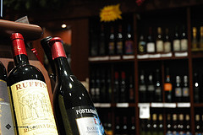
Monitoring wine and bottle conditions during storage
It is important that wine is monitored through the wine storage process.
It is essential that wine is safe, regardless of the storage method. This means that is must be kept in an area that ensures it:
- Is out of light
- Unlikely to be stolen
- Unlikely to be dropped or broken
- Has minimal disruption and handling.
If a certain wine appears to be ‘off’ when opened, it may also affect other wines from the winery or may identify problems with the storage activities and facilities themselves.
It is a wise idea that wine experts, including winemakers and suppliers, are consulted in how to improve storage techniques.

2.4 Retrieve wines for service/sale

Introduction
When retrieving wine from storage areas for immediate sale or to be placed in suitable display cabinets and areas, there are also a number of tips to remember to ensure that the wine in not greatly affected.
Retrieving wines
Some steps associated with retrieving wine include:
- Completion of necessary in-house documentation to track stock movement of wine
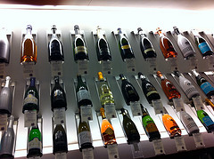
- Ensuring bottles are stored in either bin number, wine list order, by region or alphabetically to ensure easier identification
- Verifying the condition of wines that are retrieved – this will be explained in later Sections
- Retrieval of designated red, white, sparkling and fortified wines to meet customer requests and/or display and other internal requirements
- Minimal movement and handling
- Gradually adjusting temperature - Right before drinking the wine, allow the temperature to rise or fall to the appropriate serving temperature
- The correct serving temperatures of wine are:
- Blush, rose and dry white wines - 8-14ºC
- Sparkling wines and champagne - 6-8ºC
- Light red wine- 13ºC
- Deep red wines - 15-19ºC.

Work Projects
It is a requirement of this Unit you complete Work Projects as advised by your Trainer. You must submit documentation, suitable evidence or other relevant proof of completion of the project to your Trainer by the agreed date.
2.1 To fulfil the requirements of this Work Project you are asked to identify requirements for developing in-house wine storage facilities.
2.2. To fulfil the requirements of this Work Project you are asked to explain ways to promote wine to customers.
2.3. To fulfil the requirements of this Work Project you are asked to identify how to correctly store wines in established wine storage facilities.
2.4. To fulfil the requirements of this Work Project you are asked to identify activities associated with retrieving wines.

Summary

Store and retrieve wines
Develop in-house wine storage facilities
Elements of wine storage
Requirements for establishing optimal storage facilities
Influences on purchasing wine
Receiving wine.
Create floor wine displays and self-service stands
General ways to promote wines
Promoting wine at the table
Promoting wines in the wine shop
Types of selling.
Store wines in established wine storage facilities
Wine storage techniques.
Retrieve wines for service/sale
Retrieving wines.

Element 3:
Undertake sensory appraisal of wines

3.1 Create the conditions for wine tasting and appraisal

Introduction
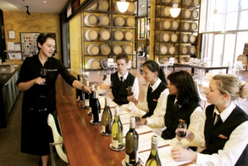
One of the best ways to be able to get a first hand understanding of wine is to undertake a wine tasting activity.
This allows all your senses to be involved in the learning process. Most food and beverage establishments conduct a food tasting on a regular basis, and a priority should also be towards understanding wines.
The purpose of a wine tasting is to enable you to evaluate wine using accepted sensory evaluation techniques.
Creating favourable conditions for wine tasting
In order to achieve consistency in the evaluation of wines it is important prescribed conditions are used every time a certain wine style is tasted.
There can be a wide variety of tasting conditions deemed as acceptable by different venues.
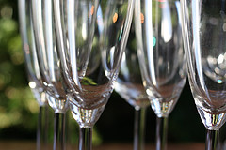
Certainly the stringent conditions that apply at wine shows including white table cloths, standard size and shaped glassware, masked or cleanskin bottles etc do not apply in the vast majority of tasting sessions.
Conditions that should apply include:
- Always conducting the tasting in the same location – perhaps a board room, the cellar or a nominated bar
- Always conducting the tasting at the same time of day – such as mid-morning
- Using the same glasses to taste the wine that are going to be used by customers when they taste the wine on the premises – this may mean using a larger wine glass for tasting red table wines than for tasting white table wines if this is what is normally used when serving those wines. It can also mean using champagne flutes for tasting sparkling wines and port glasses for tasting fortified wines. Note that wine judges use a nominated standard wine glass for evaluating wines. Making sure the temperature of the wine is appropriate for the style being tasted. This can mean tasting the wine at the same temperature as it will be served to customers rather than at a ‘prescribed temperature’ as recommended by wine makers, wine associations or wine experts
- Adherence to workplace Standard Operating Procedures (SOPs) – in addition to the above there can be specific requirements that the venue imposes ion staff when wines are being evaluated.
Temperatures
While many venues will taste wines at the temperature they will be served to customers in the property, the following guidelines have emerged as being ‘optimal’ for the evaluation of wines:
- Whites – 10ºC - 12ºC
- Reds – around 16ºC
- Fortified wines – 14ºC - 18ºC but actual room temperature is mostly used.
It is important the temperatures used stay consistent across all tastings. This means all wines of the one style tasted ‘this time’ must be the same and the same temperature range for the same style of wines must be used ‘next time’ and the time after etc.
The influence of your ‘service temperature’
If your venue serves, for example, their dry Sherries ‘refrigerated’ or chilled it is best to evaluate these Sherries at that temperature. That is, at the temperature they come out of the refrigerator and will be served to customers.
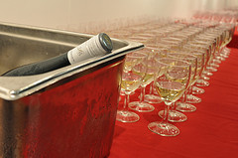
The intention of the tasting, therefore, is to evaluate wines in the same condition and at the same temperature as your customers will be drinking them.
If your venue serves its white wines from a refrigerated unit operating at 3ºC then this is the temperature your evaluations should be conducted at when trying to determine what to include on a wine list.
If your fortified wines are served ‘off the shelf’ at room temperature, then this is how they should be evaluated.
This means when tasting wines to determine whether or not they should be included on a wine list, the wines should be evaluated at venue service temperatures rather than at the temperatures recommended for tasting wines at, say, a wine show. This allows you to evaluate the wines against your specific service ‘reality.
Taste the difference
To gain a better understanding of how temperature affects the evaluation of a wine, try the following experiment:
- Take a white table wine out of the fridge, pour a glass and taste it – record your thoughts
- Allow the wine to stand at room temperature for 15 – 20 minutes and taste it again – record your thoughts
- Compare how the two evaluations differ.

Standard Operating Procedures
The SOPs that can apply in your workplace for the tasting of wines may include:
- Policies identifying those in the workplace who may and may not be involved in wine tasting
- Where and when the wines should be tasted
- Identification of which wines should be tasted – commonly all new wines which are being considered for inclusion on the menu must be tasted, and in addition many venues will also taste one bottle of all wines which are in storage every 12 months to check on their development and look for faults
- Specifications – in terms of the features and characteristics the business is looking for in each style of wine. These may be based on descriptions of wines as used in wine shows or they may be written by the manager as indicative of what they believe to be the key characteristics
- Age of tasters – venues will restrict tasting of wines to those who are 18 years of age and over in order to comply with liquor legislation
- Taking of tasting notes – in some venues it may be sufficient to simply evaluate the wine (that is, look at it, smell it and taste it) and then verbally discuss your findings with others who are present. In other cases there can be a need to take comprehensive tasting notes which will serve as the basis for a more formal evaluation or discussion later on. Where these notes are required, it is normal for them to be archived and used periodically when annual reviews of wine in stock is undertaken
- Instructions and directions from designated personnel – there can also be requirements regarding wine evaluations as stipulated by management, sommeliers, supervisors or senior staff.
Prepare tasting area and equipment
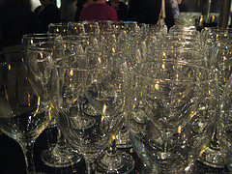
Before wines are tasted there is a need to prepare the tasting area and equipment so the tasting can proceed smoothly and without interruption.
The amount of preparation required for a tasting and the amount of equipment used will vary between properties.
Some businesses will have relatively elaborate facilities, areas and equipment while other businesses will have only the basics such as just glasses for tasting.
Be prepared to accommodate whatever applies in your workplace.
The following is an indication of activities which may need to be addressed as part of the preparation for a wine tasting:
- Notify those who are to participate in the wine tasting well in advance – give them enough notice to enable them to prepare personally for the evaluation. Wine tastings should never be sprung on people, unannounced
- Ensure the wines to be tasted are available – and available in sufficient quantity at the pre-determined temperatures as appropriate for each wine and the requirements of the venue for tasting
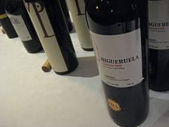
- Prepare the wines in accordance with the tasting protocols used at your venue. This can but will not necessarily include:
- Masking bottles with a napkin/waiter’s cloth
- Opening the wines to allow them to breathe the opening times should be correlated to the tasting time so there is consistency regarding the amount of breathing time the wine has
- Decanting wines
- Ensure appropriate equipment is available, operational and clean – this may involve preparing:
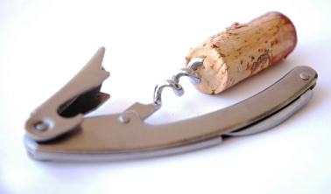
- Bottle openers and corkscrews – checking they are in sufficient quantity and operational
- Spittoons – checking they are in sufficient quantity and placed appropriately for use by tasters
- Glasses – there could be a need to prepare specific types of glasses, in terms of shape and style, for certain wines such as flutes for sparkling wines, port glasses for port or the venue may prefer to use a standard wine tasting glass for all wines
- Checks should include:
- Sufficient numbers
- Clean, not chipped or cracked – glasses must be dry and polished
- Free from odours
- Clear – glasses should not be coloured or tinted in any way in order to allow the colour of the wine to be fully appreciated
- Eliminate distractions – it is preferable to have the wine tasting environment as free as possible from distractions such as interruptions, televisions, visual distractions etc to allow tasters to focus on the wines
- Provide water – to enable people to cleanse their palate. Jugs and glasses should be provided
- Provide water crackers – to help cleanse the palate
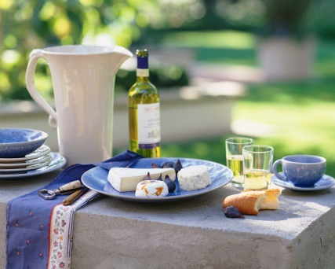
- Distribute printed materials as required by the venue and as appropriate to the wines being tasted – this can include wine maker tasting notes, tasting notes from previous tasting sessions, blank tasting sheets on which tasters can record their evaluations, copies of standards for the wine being tasted to use as a reference when discussions are being undertaken, and pens.
Wine is a food
Always remember wine is a food and its treatment in terms of storage, handling, service etc, should be in accordance with all normal safe food handling procedures that apply in the venue.

3.2 Evaluate wines by sight, taste and smell

Introduction
Now that the wine tasting area has been set up, it is now time to evaluate the wines that make up the wine tasting.
The sequence in which wines are tasted can impact on how they are evaluated.
Standard practice exists in relation to the order in which wines are tasted in order to optimise evaluations.
Tasting order for wines
Basic options
There are several options commonly used by properties when tasting wines.
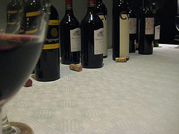
These include:
- Only tasting red table wines at the one tasting
- Only tasting white table wines at the one tasting
- Only tasting sparkling wines at the one tasting
- Only tasting nominated fortified wines at the one tasting – for example, only tasting Sherries or ports.
In some cases the imperatives of the workplace can, of course, dictate reds, whites, fortifieds etc are all tasted at the one tasting session but this is best avoided.
Appropriate order
When deciding which wines should be tasted in which order, attention should be paid to each wine in terms of:
- Colour
- Age
- Sweetness
- Weight/body
- Still or sparkling
- Alcohol content
- Flavour.
The following is a general guide:
- Taste younger wines before older wines
- Taste lighter styles before the more full-bodied ones
- Taste wines with lower alcohol content before those with a higher alcohol content
- Taste still wines before sparkling wines
- Taste white wines before red wines
- Taste dry wines before sweet wines.
Vertical tastings
A vertical tasting is where the same wine is tasted over a number of different vintages.
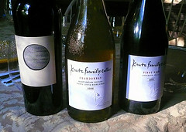
These tastings allow appreciation of how the wine changes over time as it is cellared in terms of colour and taste.
The younger wine should be tasted first.
Horizontal tastings
A horizontal tastings is where wines of the one grape variety from the one vintage from a nominated area are tasted.
This allows appreciation of how wines can differ as a result of micro-climates, soil, weather and wine maker skill.
Blind tastings
A blind tasting is where the tasters do not know anything about the wine they are tasting.
The bottle/label is masked or the wine may be decanted prior to tasting.
Blind tastings eliminate the influence that can be introduced to evaluations by virtue of the taster’s previous knowledge of a wine (or winery, wine maker etc) and by virtue of the look of the bottle or label.
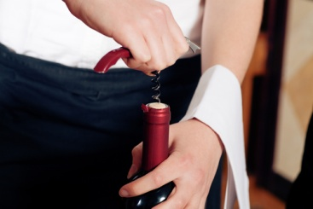
Opening bottles
Still table wines
Where the bottle features a Stelvin cap closure, opening simply requires you to unscrew the cap.
Where the table wine features a cork the basic procedures for opening a wine at the table should be observed:
- Cleanly cut and remove the foil
- Clean the lip of the bottle to make sure it is free from dirt and debris
- Use a corkscrew (the traditional type or a counter-mounted type) to remove the cork the cork cleanly – centre the point of the worm of the corkscrew into the cork and ensure the worm of the corkscrew does not penetrate the bottom of the cork and cause cork to fall into the wine. Care must also be taken to avoid disintegration of the cork.
Sparkling wines
The ‘ritual’ for opening champagne or sparkling wines is:
- Remove the foil around the cork of the bottle
- Untwist the wire cage around the cork and remove it
- Hold the bottle firmly at an angle of 45º to help reduce the likelihood of wine escaping from the bottle by increasing the surface area from which the wine can escape and twist the bottle to loosen the cork, keeping the pressure on the cork to ensure it does not inadvertently blow out. Do not twist the cork, twist the bottle
- Allow the cork to come out slowly – you may need to use your thumb to work the cork out of a stubborn bottle.
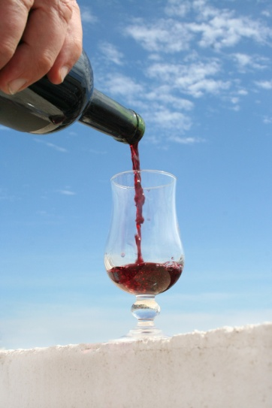
Pouring the wine
The following should be observed when pouring wine for tasting:
- Pour the wine in equal quantities into each glass – table and sparkling wine volume should be in the order of 60mls – 90mls depending on standard practice at the venue
- Ensure there are no drips down the outside of the glasses
- Table wines should be poured into the centre of the glass
- Sparkling wines should be poured down the side of the glass to help preserve the bubbles.
Evaluation wine
To develop competency in evaluating wines, you have to taste wines.
You cannot become skilled in wine evaluation just by reading books, visiting wineries and reading labels.
The use of tastes
The senses of sight, smell and taste are used when evaluating wines and they are used in that order.
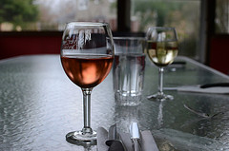
You first look at the wine and assess, you then smell the wine and assess it and finally you taste and assess it.
In most cases you then spit the wine out into a spittoon rather than drink it.
The use of the senses to evaluate a wine is sometimes referred to as ‘organoleptic perception’ (perception using the organs) or ‘sensory evaluation’.
Wine judges use their sense to compare and judge a wine against a pre-determined standard. In the industry, you will most likely be using your senses to:
- Determine if a wine is suitable for inclusion on the shelf or in the wine list
- Work out if the wine is suitable for cellaring for a few years
- Assess if the wine might be suitable for accompanying a certain menu item or set of menu items
- Judging whether or not the wine represents good value-for-money.

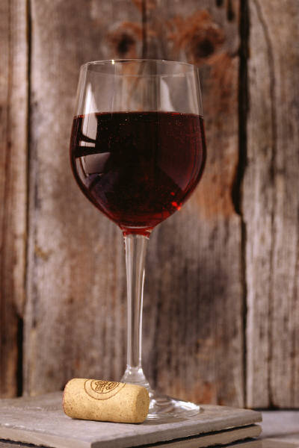
Sight
The eyes are used to determine:
- Intensity and type of colour of the wine - which may be described through using a series of colour-related terms such as green, straw, dark, golden, deep purple, garnet, cherry red, black etc
- Clarity of the wine – by identifying if there is anything in solution, if the wine is clear or cloudy and if it has sediment. Wine should be clear and not hazy
- The ‘legs’ of the wine – also called ‘tears’ and ‘fingers’ these are the streaks of wine that stick to the inside of the glass after swirling it or drinking from it. The more legs, the more alcohol content in the wine. Legs can rarely be used as any significant indicator in relation to wine quality. Viscosity relates to ‘legs’: higher viscosity equals stronger alcohol in the wine.
When evaluating the colour of wine it is important to use a constant background of event colour. White is the most commonly used background. For example, white table cloths on tasting tables or use of a white card held up behind the wine.
Smell
Your sense of smell should be used in wine evaluation to look for:
- Aroma –is the individual smell that is imparted to the wine from the grape varieties that are used to make the wine. Smelling the wine can help identify the grapes it has been made form and give an impression of the intensity of the wine
- Bouquet – which are the range of characteristics imparted to the wine as a result of the wine makers art, barrel ageing, bottle ageing and the general wine making process
- ‘Off’ odours – these are smells which indicate there is a problem with the wine. Off odours are wine faults and ‘nosing’ the wine can help detect these.
Many people use the term ‘nose’ to refer to the combined qualities identified from both the aroma and the bouquet of a wine.
Specific terminology is used to describe the smell of wines such as fruity, vegetable, and spicy.
Using your nose to assess the wine, called ‘olfactory analysis’, can also help determine the age of the wine.

Taste
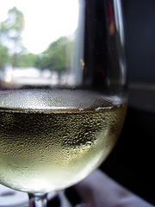
Your tasting of the wine involves assessing the wine on the palate and should be used to identify:
- The flavours of the wine and their intensity, harmony and balance
- Acidity and sweetness
- The in-mouth feel or body of the wine
- The level and balance of fruit, wood, alcohol, tannin and other characteristics
- How the wine feels in the mouth, on the tongue and at the back of the throat
- Length, finish and aftertaste of the wine.
Everyone’s taste is different
The evaluation of wine seeks to use standard terminology to describe how a wine looks, smells and tastes. The use of standard terms enables tasters to make meaningful comment about what they believe the wine to be like.
Obviously this process is very subjective even though tasters strive for objectivity.
Regardless, however, of the terminology used and the objectivity or subjectivity of the individual the fact remains that there is often disagreement about wines. A wine that one person likes can be a wine another person intensely dislikes.
The use of standard wine tasting terms should enable people to adequately describe and differentiate their opposing interpretations and evaluations.
Tasting procedures
The following is a guide as to how to go about the actual; tasting process for a wine. Remember the process is to visually look at the wine, then to smell it and then to taste it. Most tastings also require you spit out the tasting.
Looking at the wine
- Hold the tasting glass by the stem
- Tilt it slightly
- Examine the contents against a white background – looking for clarity and colour as well as anything which may be suspended in it
- Consider how brilliant or dull the colour is
- Swirl the glass a little and look at the legs – how strong are they?
- If you are comparing the wine to a given set of criteria, to what extent does it meet the criterion for appearance?

Nosing the wine
- Still holding the glass by the stem, swirl the glass – some prefer to hold their hand over the top of the glass while they do this to tarp the aromas etc, that are released
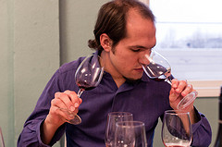
- Nose, sniff or smell the wine – take one or two sniffs. Don’t be afraid to put your nose well into the glass
- What can you smell?
- What fruit smells or characteristics can you discern?
- What characteristics of the wine making process itself are you able to identify?
- Are then any smells that smell unpleasant, bad or off?
- If you are comparing the wine to a given set of criteria, to what extent does it meet the criterion for aroma and bouquet?
Tasting the wine
Tasting wine can be a noisy business!
- Still holding the glass by the stem take about 10 – 15mls of wine into the mouth sucking in air over and swirling wine over all the taste buds and tongue. This will create quite a deal of noise. It is also known as ‘aspirating the wine’ and helps release volatile compounds from the wine
- Roll the wine around your mouth
- Hold the wine in your mouth for approximately 10 – 15 seconds
- Form an impression of what you can taste – what key taste sensations can you detect?
- Spit the wine out into a spittoon.
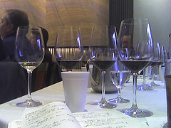
Recording impressions
It should be standard procedure to record all your thoughts on the appearance, smell and taste of the wine.
This may be done on a pad, or on pro forma tasting sheets.
Your thought should be recorded independently of other people to avoid their comments influencing your perceptions.
Refresh the palate
Follow the standard procedures that apply in relation to cleansing the palate after tastings.
This may involve eating a water cracker between tastings or at some stage of an extended tasting.
3.3 Identify wines by style and grape variety

Introduction
Wine characteristics help identify and relate different wines to each other. Since over 250,000 different wines are released every year around the world, it’s helpful to think about wine characteristics in terms of the varietal and where they’re from.
Most people do not have the fortune to be able to try the wines before they are purchased and therefore they will be guided by the advice and descriptions provided by the staff.
It is essential that staff are able to provide terms that help customers understand the different characteristics in reference to a wine.
This explanation of wines normally involves describing wines by specific characteristics or terms.
Aroma and flavour descriptors
Using an aroma wheel and a taste wheel can be a good idea in the first instance to help you describe and identify what you are experiencing.
As you gain more experience you will start to identify aromas and flavours from memory and begin to associate various wines with some of the many terms that are used to describe them.
Many wine terms used to describe the wine can seem strange (and almost incorrect or inappropriate) but they can all have their place and are in common use by people such as wine judges and those who seek to evaluate and appreciate their wine.
Use of wine wheels
Wine wheels have emerged over time as a tool that can be used by wine drinkers and tasters to assist them describe the wines they are drinking and tasting.
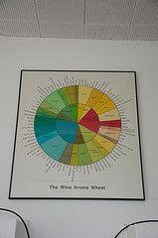
Wheels are available in the following types:
- Colour wheels
- Flavour wheels
- Aroma wheels
- Mouth-feel wheels
- Food and wine matches.
Some wine wheels focus on the wines of certain countries or regions.
Using a wine wheel is a simple and effective way to begin to learn and train yourself about wine.
The wheels contain descriptions of wines you can use to stimulate your responses and help describe the sensations you are experiencing. They can help put a name to what it is you are seeing, smelling and tasting.

Primary characteristics
Wine grape varieties have certain common characteristics and it is these characteristics that tasters can use to identify the wine. These are referred to as ‘primary characteristics’.
The characteristics of the wine are influenced by the degree of ripeness of the grapes when they are harvested meaning wine made from grapes that are picked at an early stage of maturity will differ to a wine mad with grapes that are picked late in their ripening stage.
Most customers are better able to identify a wine that they like by understanding the fruit flavours that dominate the wine. Luckily wines are often characterised by their main fruit flavours.
In this section we will explore the complexity of flavours, starting with simple easy to remember points, through to more varied flavours and the influence of other impacting qualities.
In its simplest form, fruit flavours for wines include:
White wines
GRAPE VARIETY | CHARACTERISTICS
Riesling | Pineapple
Sauvignon Blanc | Asparagus
Semillon | Grass
Chardonnay | Cucumber
Sweet/ dessert wines | Honey
Red wines
GRAPE VARIETY | CHARACTERISTICS
Pinot Noir | Strawberry
Merlot | Cherry
Cabernet Sauvignon | Olive
Shiraz | Pepper
Sparkling wines and Champagne
GRAPE VARIETY | CHARACTERISTICS
Sparkling Wine | Apple
Champagne | Yeast

Wine characteristics through harvesting
The following gives a sample of terms that can be used to describe these primary characteristics moving from grapes that are harvested early to grapes that are harvested later.
- Cabernet sauvignon – herbaceous; tea leafy; capsicum; minty; dusty; black olive; blackcurrant; jammy; aniseed
- Chardonnay – cucumber; tobacco; grapefruit; gooseberry; melon; lime; peach; rockmelon; fruit salad; fig; tropical fruit
- Merlot – herbaceous; earthy; leafy; violets; cherry; raspberry; plum; fruit cake; coffee; chocolate
- Pinot noir – truffle; cherry; black currant; violets; raspberry; plum; beetroot; rhubarb
- Riesling – floral; rose petal; citrus; lime; passionfruit, tropical fruit
- Shiraz – herbs; tea leaf; mint; black pepper; blackberry; raspberry; coffee; chocolate; jammy.
Mature wine characteristics
As a wine matures the characteristics of the wine will change as a result of this process to reflect how the wine has been aged and its length of maturation.
The following indicates a selection of these influences and the characteristics they may produce:
Chardonnay
Characteristics of aged chardonnays can include toast, honey, cashew, almond and vanilla if wood aged.
If the wines are aged in stainless steel tanks the taste will be fresh and crisp.
Riesling
With ageing the most recognisable characteristic is petrol or kerosene. Toast and honey are also common.
Sauvignon Blanc
With age this can develop characteristics of spice, vanilla and honey.
Pinot Noir
With age the characteristics change to reveal earthy, leather, gamey and ‘forest floor’ tones.
Cabernet Sauvignon
Probably the most common characteristic of aged cab-sauvs is ‘cigar box’.
Shiraz
This wine has arguable one of the biggest sets of terms that may be able to be applied to a wine.
Favourites are prune, beefy/gamey, cigar box, leather, and iodine.
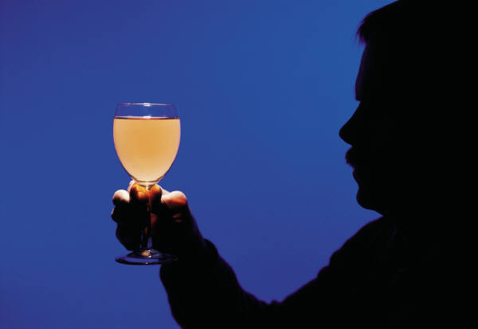
Malo-lactic fermentation
A chardonnay (for example) subjected to malo-lactic fermentation will evidence different characters than one which has not (giving rise to terms such as buttery, creamy, caramelly).
Wood ageing
Where the chardonnay has been aged in wood it will give rise to terms such as vanilla, cashew, burned caramel, charred.
Appearance descriptors
The look of a wine will depend on whether it is a red or white wine.
Appearance of a wine relates to hue, clarity and depth of colour.
White wines
White wines should be assessed against the following descriptors:
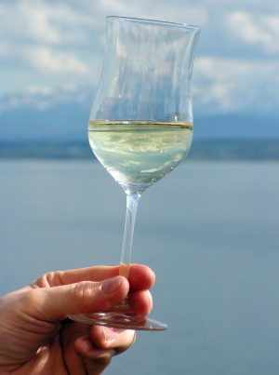
- Pale straw
- Straw
- Deep straw
- Yellow
- Gold
- Other – enables identification of off and other colours (such as ‘green tinges’).
The appearance should also be examined to identify if it is:
- Brilliant
- Clear
- Opaque.

Red wines
Appearance of red wines relates to the hue and depth of colour and is rated against the following descriptive words:
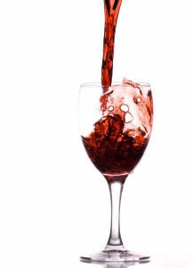
- Purple
- Crimson
- Brick red
- Tawny
- Brown
- Other.
The appearance should also be examined to identify if it is:
- Opaque
- Deep
- Mid
- Pale.

Body of wine
Light to full body wines
Body of the wine is derived from a number of factors including:
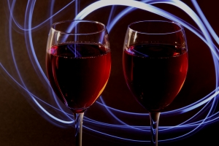
- Wine variety
- Regional origin
- Vintage
- Alcohol level
- Production method.
Body is a snapshot of the overall impression of a wine.


Wine Descriptions Glossary
Following is a comprehensive list of characteristics that can be used to explain certain aspects of a wine to the customer.
Acidity
General term for the fresh, tart or sour taste produced by the natural organic acids present in wine; contributes flavour and freshness to wine when it is in proper balance.
Appearance
Refers to clarity of a wine; wines should usually be free of cloudy and suspended particles when evaluated in a glass.
Aroma
Smells associated with young wines and sometimes varietal characteristics.
Astringency
Tactile, bitter sensation that makes the mouth pucker. Wines with high levels of astringency may be described as course, harsh, and rough or too much tannin.
Austere
Refers to wine that is very acidic and unpleasant.
Balance
Pleasant harmony of the elements and components of a wine; a balanced wine is one whose components of sugar, fruit, tannin, acid, alcohol, wood and extract are evident, but do not mask or dominate each other.
Body
Tasting term for the perceived ‘weight’ - the sensation of fullness, resulting from density or viscosity - of a wine on the palate; wines at either end of the scale are described as full bodied and light bodied.
Big
Big describes a wine with plenty of flavour in your mouth, often resulting from fruit or tannins.
Body
The apparent weight of a wine in your mouth (light, medium, or full)
Bouquet
Complex aromatic compounds which result from wines of extended bottle age.
Bright
Bright wines are higher in acidity.
Buttery
A wine with buttery characteristics has traditionally been placed in oak. It has a richer taste and is smoother than un-oaked wines that have a clearer and crisper taste.

Complex
A complex wine simply means that when you taste it, the flavour changes from the moment you taste it to the moment you swallow.
Creamy
Creamy is a popular term for white wines and sparkling wines fermented or aged in oak.
Crisp
The word Crisp with wine is more often used to describe a white wine, and is normally related to contact with steel containers instead of oak - a wine with refreshing acidity
Dry
Adjective often used to describe wines in which there is no perceptible sweetness.
Fat
Wide, Big, Massive, Deep and complex wine
Finish
The impression a wine leaves as you swallow it
Flavour
Most of what is described as flavour in wine is actually aroma. Flavour is used to describe the overall sensory impression of both aroma and the taste components.
Flavour intensity
How strong or weak a wine's flavour is
Food friendly
The wine does not have overpowering flavour that will spoil a meal.
Fruit Driven
A tasting term used to convey the fact that a wine has a dominance of grape derived fruit flavour. For a wine to merit this description, the dominance of fruit overrides flavours in the wine that originate from other processes or treatments which the wine has undergone.
Fruity
A wine whose aromas and flavours suggest fruit; doesn't imply sweetness
Full Bodied
Description of a wine that is high in alcohol and viscosity.
Green
Tasting term for a wine made from grapes that did not reach full ripeness.
Hard
Tasting term applied to wine that is high in astringent tannins and apparently lacking in fruit.
Herbaceous
Tasting term for the leafy or grassy aroma of crushed green leaves or freshly cut grass.

Lees
Sediment comprising dead yeast cells, grape seeds, pulp, stem and skin fragments that settle at the bottom of the container in the wine making process. Red wine is racked off this sediment. Some whites are left on their lees to add flavour and complexity.
Lifted
Tasting term for a wine with a high but not excessive level of volatile acidity
Long
Tasting term referring to the persistence of wine impact on the palate; a wine that is long is usually considered of high quality.
Mature
Tasting term for a fine wine that seems to have enjoyed sufficient ageing for it to have reached the peak of its potential
Mouthfeel (Texture)
Non-specific tasting term, used particularly for red wines, to indicate those textural attributes, such as smoothness, that produce tactile sensations on the surface of the oral cavity.
Non-vintage (NV)
A blended wine, particularly champagne or sparkling wine, which may contain the produce of several different vintages
Nose
Used as a synonym for the smell, aroma, or bouquet of a wine.
Oaky
A wine that has flavours that have derived from contact with oak including butter, vanilla and caramel
Oxidation
Chemical reaction of wine to oxygen in the air; if a wine is described as being oxidised, it has gone stale and flat from excessive contact with air.
Palate
Sense of taste in the mouth
Short
The tasting term for a wine whose impact on the palate is not persistent; the opposite of long
Silky
Silky is the red-wine equivalent word to creamy with white wines.
Soft
A wine that has a smooth finish
Smoky
This is where the wine has smoky characteristics due to exposure to oak.
Tannins
A compound naturally found in grapes and therefore wine. The tannins in grapes are predominantly in the skins and seeds of each berry
Texture (Mouthfeel)
Non-specific tasting term, used particularly for red wines, to indicate those textural attributes, such as smoothness, that produce tactile sensations on the surface of the oral cavity.
Unoaked
A wine that is unoaked is crisp with citrus tones.
This glossary is a great example of the many words that can be used to describe a wine to the customer.
It is important to remember that when choosing words, to keep in mind the customer’s understanding and trying to put it in a way in which they will understand.

3.4 Determine wine quality and characteristics

Introduction
Wine is a commercial product, which can vary greatly in aroma and flavour according to the innumerable possible variations in its production. Over time, wines made by a certain winery or from a certain region or vineyard can develop a reputation as being better, and be more sought after and thus more costly, than those from other sources. This reputation for quality for a particular wine brand or provenance, and the price a consumer is willing to pay, can be enhanced or degraded over time. Can we capture this elusive character of ‘quality’ in an objective measure?
Quality vs. Value
The terms ‘quality’ and ‘value’ are consequently widely used in reference to wine. The International Standards Organisation defines quality as the ‘degree to which a set of inherent characteristics fulfils requirements’ and it is worthwhile considering the meaning of this definition in relation to different elements involved in the wine production chain.
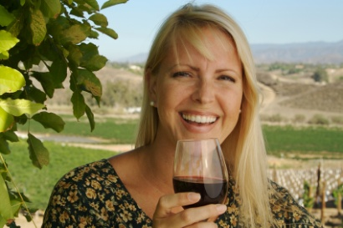
To the consumer who considers whether to purchase a wine, fulfilling requirements is associated with the ‘intrinsic’ sensory quality of the wine, i.e. how the wine tastes, as well as perceived value.
Value is related to both intrinsic quality and image - the latter derived from many aspects such as how the wine is marketed, show awards, or winery environmental sustainability record - and cost.
Thus, a wine with moderate intrinsic quality, but with a high concept of image, at a relatively low price compared with alternatives, would be considered by a consumer as high in perceived value.
Identifying wine quality
In essence, each customer will have their own preferences in relation to the wines they enjoy hence what they consider to be ‘quality’ will differ to the opinion of another.
There are some considerations when identifying quality within a wine.
Wine quality and characteristics (wine evaluation) must include:
- Comparison and rating of wines against set criteria – the most noted is awards given at wine shows. This will be explained in more detail in Section 4.6 of this manual
- Assessing acceptability of wines against identified preferences of target markets – again it is the end consumed who will indicate whether a wine is of quality and value to them
- Consideration and evaluation of wine clarity, colour, type, alcohol, aroma, flavour, sweetness, acidity, body, weight, mouth feel, tannin, balance and length
- Consideration of the suitability of wines for ageing/cellaring.

3.5 Identify wine faults

Introduction
Not all wines are perfect.
Some are slightly flawed or ‘less than perfect’ while others have problems that make them undrinkable.
Regardless of the problem wines may have, it is imperative that they are identified and changed in a timely manner.
This section will explore the different faults that are commonly found in wine and how to identify them.
In Section 5.6, techniques when responding to patron complaints about wine will be discussed.
Faults and flaws
A major problem with a wine that makes it undrinkable is referred to as a fault.
A minor problem that decreases the pleasure of drinking the wine but does not make it undrinkable is called a flaw.
Types of wine faults
Faults in wine can be related to their appearance, their smell or their taste.
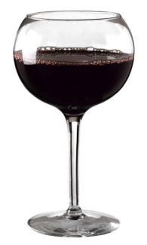
While there are a number of wine faults, the basic wines are as follows:
Oxidation
Oxidation is caused when wine is exposed to air for too long causing the wine to absorb air and oxidise and essentially turn into vinegar.
Oxidised wine can smell stale or vinegary, and have a metallic signature to them.
They look darker in colour with white wines turning towards a brown colour.
Wines that have oxidised are described as being ‘off’ and tasting ‘flat’.
Where corks have dried out they allow air into the bottle and can cause oxidation.
Left over wine in a bottle runs the risk of oxidising.
Tartrates
Some wines, usually whites and roses, throw tartaric acid crystals, also known as ‘tartrate precipitation’ which are referred to as ‘tartrates’ or ‘wine diamonds’.
While this is called a fault in the wine it is more an aesthetic problem than anything else. The crystals impair the look of the wine but do not affect its taste and are not harmful to the drinker.

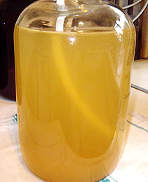
Cloudiness
Where the wine looks cloudy this can be caused by the presence of yeast or bacteria in the wine which is growing and causing the problem.
This may be caused initially by a processing fault.
Corked wine
When a wine is referred as a ‘corked’ wine this relates to it being contaminated by a chemical called Trichloroanisole’ (TCA) which is caused by a fungus found in cork bark.
The chemical imparts a distinct musty, damp smell to the wine.
This was the most common fault with wines sealed using a cork. It was partially responsible, along with the high cost of cork, for the development of Stelvin closures, also known as screw caps.
Wineries will admit that between 1 in 12 to 1 in 20 bottles of wine they bottle will suffer from this. It is the single most common wine fault.
It is also known as ‘cork taint’.
Note: a ‘corked’ wine is not a glass of wine or bottle of wine with bits of cork floating in it because the corkscrew has penetrated through the bottom of the cork and caused bits of cork to fall into the bottle and float in/on the wine.
Excessive sulphur
Sulphur dioxide is used in wine making for various reasons such as to kill the naturally occurring yeasts on grapes so the cultured yeast can be used to ferment the grape juice.
Its incorrect or excessive use can impart a most unpleasant smell reminiscent of ‘struck matches’.
Hydrogen sulphide
The presence of hydrogen sulphide in wine gives a smell of rotten egg gas.
Monitor wine quality and recognise impaired quality during service
When serving wine to customers there is a need for constant attention and watchfulness
Your aims should be to:
- Avoid serving bad wine
- Be alert to signs that customers have a problem with the wine they have been served.
In all situations where you notice a problem it is vital to take appropriate action to address the situation.
Monitoring wine prior to service
To help avoid the service of sub-standard wine the following practices should be followed:
- Visually inspect the bottle and cap/cork for signs that the integrity of the product has been compromised – be alert to leaking corks/seals, cracked bottles, corks protruding from the neck of the bottle
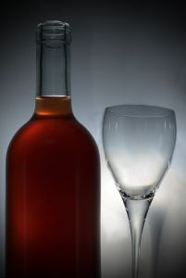
- Visually inspect wines that are opened – look for cloudiness and anything floating in solution
- Check the temperature of the wine – to ensure it is being served at the right temperature
- Be alert to ‘off’ smells – such as volatile acidity, corked wine, sulphur etc.
Always double-check to ensure the wine being served is, in fact, the wine the customer ordered to avoid wasting wine or causing dissatisfaction.
Giving the customer a taste of the wine
It is standard practice in most dining room/restaurant situations when serving wine to include the following as part of the service ritual:
- Present and announce the wine at the table – this means showing the wine bottle and label to the customer and announcing it by maker, grape variety/varieties, vintage, style. This gives the customer an opportunity to verify the wine they are to be served is the one they ordered – this reduces the chance of the wrong wine being open
- Taste Pour a small tasting amount into the glass of the person who ordered the wine – to allow them to evaluate it for themselves by looking at it, smelling it and tasting it before accepting it
- Present the cork of the wine – this allows the customer to visually inspect and smell the cork and builds confidence in the customer that the bottle has been freshly opened and that the wine they are drinking is in reality the wine they have ordered.
Using this ritual helps avoid situations where customers are served sub-standard wines. If the person tasting the wine believes it is ‘off’ they can refuse the wine at this point thereby avoiding their guests having to drink bad wine.
Standard practice in most establishments is for the waiter to offer another bottle of wine to replace the one that has been rejected. This may be another bottle of the same type such as the same grapes, same winemaker, same vintage, or a completely different wine may be offered or selected.
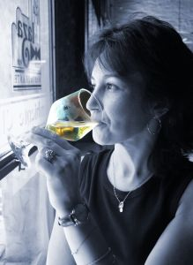
Monitoring the room
During service or after wine has been served there is a need to monitor customers to identify if and when they have a problem with the wine they have been served.
Techniques include:
- Watching for body language that indicates there is an issue – such as customers looking around for help; facial expressions indicative of dissatisfaction
- Asking the customers if they are satisfied with their wine
- Monitoring how much wine is left in glasses or the bottle – if a customer leaves a significant amount then it can be useful to ask them if there is a problem.
Work Projects
It is a requirement of this Unit you complete Work Projects as advised by your Trainer. You must submit documentation, suitable evidence or other relevant proof of completion of the project to your Trainer by the agreed date.
3.1 To fulfil the requirements of this Work Project you are asked to identify how to create the conditions for wine tasting and appraisal.
3.2. To fulfil the requirements of this Work Project you are asked to explain how to evaluate wines by sight, taste and smell.
3.3. To fulfil the requirements of this Work Project you are asked to explain how to identify wines by style and grape variety.
3.4. To fulfil the requirements of this Work Project you are asked to explain how to determine wine quality and characteristics.
3.5 To fulfil the requirements of this Work Project you are asked to explain how to identify wine faults.

Summary

Undertake sensory appraisal of wines
Create the conditions for wine tasting and appraisal
Creating favourable conditions for wine tasting
Temperatures
Standard Operating Procedures
Prepare tasting area and equipment.
Evaluate wines by sight, taste and smell
Tasting order for wines
Opening bottles
Pouring the wine
Evaluation wine
Tasting procedures.
Identify wines by style and grape variety
Aroma and flavour descriptors
Primary characteristics
Wine characteristics through harvesting
Mature wine characteristics
Appearance descriptors
Body of wine
Wine Descriptions Glossary.
Determine wine quality and characteristics
Quality vs. Value
Identifying wine quality.
Identify wine faults
Faults and flaws
Types of wine faults
Monitor wine quality and recognise impaired quality during service.

Element 4:
Provide advice to patrons

4.1 Present wine list/lists to patrons

Introduction
To date, we have looked at how to develop one’s knowledge of wine and how to correctly store and handle wine.
This section explores the steps associated with sharing wine knowledge with customers including providing information and making recommendations to suit the needs and preferences of customers.
Presenting wine lists
When distributing wine lists to customers there are a number of tips to remember:
- Ensure there are adequate menus for customers to read. Whilst you do not need to hand out as menu wine lists in relation to food lists, it is important that anyone who would like to look, has the opportunity to do so
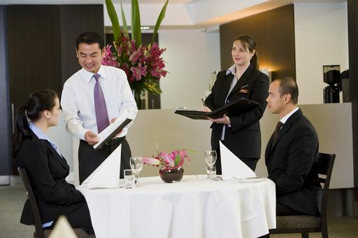
- Provide menus suitable for the customers. For example you may wish to provide menus in different languages
- It is normal to leave the wine list with the host or place in the centre of the table.
- The wine list is often presented after guests have decided what they want to eat, but many establishments present the menu and the wine list together so that guests can better match their food and wine combinations
- Point of direct customers to other menus that may be applicable. This can include fixed menus on walls, daily specials or tent card displays on tables
- You may tell customers you will be back in a minute to discuss the wine list.
Explaining the wine list
Many wine lists can be quite complex leaving customers unsure where to start looking.
It is the role of the beverage server to help identify and explain important aspects of the wine list.
This next section will explore the contents of a wine list and how it is presented in most food and beverage outlets.
There are many ways in which to set out a wine list. The style of the restaurant may go some way to dictating its layout. Imaginative and informative wine lists welcome the customer into a comfort zone that is all too often missing in the process of selecting a wine.
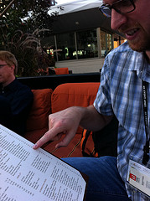
Wine list categories
Most restaurants wine lists break down into the following categories:
- Champagne and Sparkling Wines
- White Wines
- Red Wines
- Sweet and Fortified Wines
- Digestifs (after dinner drinks).
Quite often there are further sections within these headings, such as country, region, sub-region, village, commune, vintage and producer. However, these headings should only be used if there are sufficient wines in each section to make it worthwhile.
Vintage and Price
Some lists are set out in price order. This can be a restrictive style of listing as the customer will slide their finger down the prices until they get to their cut-off price limit, stop there, and not read any further.
Some establishments set out shorter wine lists in vintage/price order. They place the youngest vintage first and then within that group, say 2002s, list them in price order least expensive to most expensive. Then move to the 2001s, put them in price order cheapest to dearest, then 2000s etc. This will split up the list in terms of price and encourage the reader to read to the bottom of the selection before deciding on a wine.
Different styles
Instead of the traditional wine list separating countries, wine may be listed by grape variety, or indeed by the following broad style parameters:
Whites
- Light, dry, refreshing
- Pungent, aromatic
- Spicier, fruitier and more floral
- Medium dry very fruity
- Medium bodied, light to moderately oaked
- Richly textured, full bodied, oaky
Red
- Light, soft, fruity, easy drinking
- Medium bodied no oak
- Medium bodied - moderate oak
- Medium - full bodied, spicy oak and tannins
- Rich, complex, oak and power.

You can design your own headings if you want. This will help the customer to get straight to the correct style and from there; perhaps the waiter could direct the customer to the exact wine.
Keeping information updated
Make sure that the wine lists are updated regularly to keep them clean and free from wines that are out of stock. If a wine is out of stock then make a mark in the margin next to the wine so that the customer avoids any disappointment.
Printed wine lists can be expensive. In some cases suppliers offer list-writing and designing facilities free of charge. If this service is not available, it can be useful to set up your wine list on a computer at the restaurant - this will save on printing expenses and will mean that changes can be made quickly and easily.
A wine list can be used to convey a lot of information about the wines available for purchase. The addition of tasting notes to the wine list can help customers find out more about the wines and enable them to make up their own minds about their choice. Not every restaurant has a wine waiter to wheel out to talk the customers through the list.

4.2 Identify patron preferences and food that has been ordered

Introduction
A fundamental requirement when assisting guests to buy a product is to determine their needs, wants and preferences and to attempt to match what you have to these identified factors.
The keys to determining customer wants etc are to:
- Listen to what they tell you
- Ask questions to find out more information to enable you to make an intelligent and appropriate recommendation.
Give the customer time
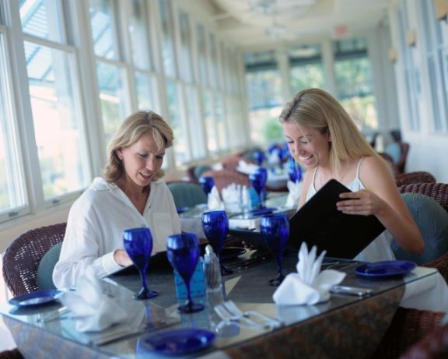
Many customers, whether in a bar or sitting at a table in the dining room prefer to spend some time ‘browsing’ the menu.
We have to be sensitive to allowing them sufficient time to look at what is on offer and make their own selection.
Importantly we need to make them aware we are available if they want help and are willing to provide whatever assistance we can.
It is very much a balancing act. On the one hand we don’t want to pressure, rush or hassle them but we also don’t want them to feel they are being ignored or overlooked.

Asking questions
If the customer does not specify a particular wine, chances are they are looking for some help in making a selection.
The following are questions which could be asked to help you to determine what wine to suggest:
- Do they prefer, or are they looking for, a red or a white?
- Do they want a wine from a selected country?
- If they are looking for a white wine, do they prefer or want a sweet or dry one?
- If they are after a red wine, do they want a full- or light-bodied one?
- Do they have a preference for a particular grape variety, growing region, or winery?
- How much do they wish to spend?
- What is the wine to be consumed with?
When you have these sorts of details you should then use your product knowledge and your own personal experience to make an appropriate recommendation.
When to offer advice
Advice about wines to accompany food can be offered in response to enquiries, or offered as part of service provision without being asked.
Typical occasions that provide an opportunity to advise customers in this regard include:

- Serving a customer at the bar who is thinking about having a wine
- Serving the customer at a table who has ordered, or is about to order, their food and are considering ordering a wine to accompany that meal
- Greeting and seating the customer – by advising them of any Specials that may be available
- In public areas – where customers approach you and ask a question
- Taking a reservation or enquiry over the telephone – where customers make enquiries wine lists
- Responding to requests for room service to guest rooms
- When helping customers in the retail alcohol shop – who are choosing a wine to accompany a meal or as a gift.

4.3 Recommend suitable wine and food combinations to meet identified needs and preferences

Introduction
Once you have identified some customer preferences, it is now time to use your knowledge and selling skills to recommend wines that the customer may enjoy.
Advise customers on appropriate wine and food choices

Offer specific advice on the compatibility of different wines with menu or food items
Customers are likely to ask you for advice when selecting a wine to accompany food.
Suggesting wines to accompany food is a somewhat imprecise art due to the very subjective nature of people’s tastes but there are several techniques that can help you make an appropriate recommendation.
Use of winemakers
Many winemakers and wine merchants are prepared, on request, to help venues develop a ‘suggestion list’.
This suggestion list lists the wines available and pairs them with different types of food or the dishes available on the menu.
This is an obvious aid and where they exist you should try to memorise them as part of developing your product knowledge.
Where they do not exist, consider involving wineries to prepare one.
Reading wine labels
Many wines will list on their label the types of foods that the wine will be compatible with.
While this is a useful starting point when your level of wine knowledge is relatively low, care should be exercises as some wines will indicate the wine will be suitable with almost everything from spicy food and curries through steak and roasts to poached salmon and other delicate dishes!
Wine literature
Most wine books will contain a section on matching food and wine and these can also be a useful reference.
Wine magazines can also be of help, as can a wide variety of websites such as:
- http://www.winespectator.com/Wine/Wine_Basics/Wine_Basics_Template/0,1199,17,00.html
- http://www.tasteoftx.com/bevs/winenfood.html.

Pairing Food and Wine
The following article ‘Restaurants – Pairing Food and Wine’ is taken from the Australian Wine and Brandy Corporation website at http://www.wineaustralia.com/australia/Default. aspx?tabid=827 (accessed 10/5/09).
The world of food and wine offers more freedom and diversity than perhaps that of any other nation on the planet. Many international travellers have had incredible exposure to various cuisines from all corners of the globe. Whilst their knowledge of wines may be more regionally based, this does not mean that they are not open to exploring and trying new wines.
The Basics
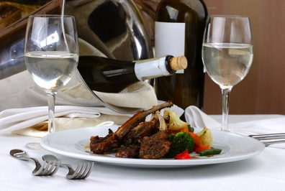
The close relationship between food and wine may, in part, closely parallel the evolution of great cooking and great wine making. It’s no surprise that some of the best cuisine in the world happens in some of the finest wine-growing regions, where wine is often just as prevalent in the cooking process as it is in the glass. Australia is fortunate in terms of availability of excellent fresh, clean, green produce and has developed wines to match food from all around the world.
It is important to understand the basic tastes of wine: sweet, bitter and sour. Much of what we perceive as taste is actually aromas, including floral, fruit, spice, and alcohol aromas. Apart from the basic taste of wine, the weight and intensity, or texture, of a wine is an important factor in food and wine pairing.
Marriages and Contrasts
Broadly speaking there are two approaches to food and wine matching, wherever in the world you may be – marriages and contrasts. The marriage approach is all about like with like, striking harmony between flavours and textures on the plate and in the glass or matching the weight of a wine, whether full, medium or light-bodied, should match the weight of the dish. An example of this approach is to match a ripe, full-bodied Shiraz with a grilled fillet of beef served with a red wine reduction.
The contrasts approach is about pitching wine and food at opposite ends and striking a balance of flavour intensity and texture through their interaction. An example of this is to match a zesty young Riesling with pan roasted sea scallops in a rich butter sauce.
One other tip is don’t get hung up on colour. The diverse array of wine on offer beckons you to break free of convention and experiment. Each wine is unique, regardless of variety and region, and each vintage has its own character plus subtle shifts in wine style can make big differences in the way wines interact with food.

Food and wine combinations
The most common request for advice regarding matching a beverage with food relates to wine.
Some basic suggestions include:
Food | Wine
Salads | Chenin blanc, Verdelho, Chardonnay, Riesling
Antipasto | Chardonnay, Rosé
Seafood | Semillon, Sauvignon Blanc, Riesling
Game | Cabernet Sauvignon, Shiraz, Chardonnay, Semillon
Red meat | Cabernet Merlot, Cabernet Sauvignon, Shiraz, Malbec
Poultry | Chardonnay, Chenin Blanc, Verdelho
Pasta | Chardonnay, Riesling, Shiraz
Cheese platters | Cabernet Merlot
Desserts | Dessert wines
You should also be sufficiently familiar with the wines on the drink list to make intelligent recommendations to compliment the food.
One way of choosing wines to go with food is the ‘Complement or contrast’ approach as follows.
Wine to complement food
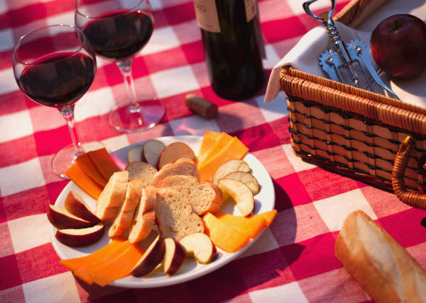
When complementing food with wine, try to select wines that will harmonise well with the dishes and their ingredients general guidelines are:
- Whites with fish, chicken, veal and pork
- Reds with dark meat
- Reds with cheese
- Delicate wines with delicate food
- Full-bodied wines with full-bodied food
- Sweet wines with sweet food
- Champagne can generally go with anything and with any course.

Wine to contrast food
‘Contrasting’ relates to selecting a wine that stands distinctly on its own when compared to the food being eaten and is viewed as a separate taste experience.
It’s best to stick with the idea that a style of wine goes well with a style of food and then finetune your selection from that point, taste-testing dishes and wines, and taking professional advice from wine experts.
Offer appropriate wines for special occasions and particular seasons

It must always be remembered when it comes to anything served in the hospitality industry – the customer is always right!
With this in mind your employer may require you to promote certain wines on certain occasions, or through particular seasons.
As with recommending wines to individuals, there are no hard and fast rules. There are only options.
It is difficult to recommend with any degree of certainty what wines would be suitable for what occasion or season. The fact that the appreciation of wine is such a personal thing makes it an almost impossible undertaking.
Nonetheless, some general guidelines exist:
- Sparkling wine is generally accepted as a wine to celebrate almost anything – and a wine that can be recommended to help compliment any up-beat occasion
- White wines are generally more suitable for the hotter months because they are served chilled – the same applies to the lighter reds that are gaining in popularity
- Red wines are seen by many as the ideal wine for the winter months.
Special occasions include meals, either at home, or in a restaurant situation, and the following notes provide the basis for further recommendations.
Remember fortified wines
Fortified wines are often overlooked by staff when recommending wines, both in a bottle shop and at the table.
Remember a meal can be set off to a good start by the intelligent recommendation of a chilled dry sherry.
A good meal can also have the final touch given to it by recommending a port, muscat or tokay.
4.4 Explain choice of recommended wine and food combinations


Introduction
In the last section a number of suitable food and wine combination were identified. In addition to the request for these recommendations, customers will often have their own questions in which they need clarification.
When talking about wine with customers there is nearly always a need to respond to questions.
This section looks at how those questions should be dealt with.
Answer wine relation questions from customers
Customers will ask questions when discussing wine with you, often to help them determine your level of knowledge and to help them decide whether or not they can rely on your opinion, and when seeking suggestions about which wine to purchase.
Guidelines for answering questions from customers are:
- Be honest in your responses – never tailor-make a reply deliberately intended to make a sale where you believe the content of your answer to be wrong
- Use terms and descriptions that match the identified level of wine knowledge the person asking the question has shown – do not be a wine snob, do not talk down to the customer, do not exclude them from the conversation by your attitude or the way you speak
- Accompany your responses with additional information – this can be wine maker’s notes, tasting sheets, a look at a web site, a copy of a magazine article or a tasting of the wine
- Don’t rush the answer – avoid giving the customer the impression you have more important things to do than answer their questions
- Smile – use appropriate interpersonal skills
- Provide ‘sufficient’ information – try not to drown the customer with information. Answer their question, perhaps with some sight additional information, but avoid showing off about your depth and breadth of knowledge. Save that for wine clubs, or in-house tasting sessions
- Acknowledge when you don’t know the answer to a question – standard responses to this situation can include:
- Apologising
- Excusing yourself while you go and find the answer – perhaps by looking up a reference book or looking up literature from suppliers and wine makers on the Net
- Referring the customer to a more experienced person in the property who will be better able to assist – it is useful to introduce the customer to this person and listen to what the answer is.

Being proactive to guest requests
Being proactive is the best way to convey willingness, both verbally and non-verbally, to assist any customers you believe have a request.
This requires you to be ‘always on the lookout’ for ways to assist.
Every dining experience presents many opportunities for a customer to seek requests fulfilled. In addition a staff member has many opportunities to recognise when these requests arise and signs to recognise them.

4.5 Inform patrons of relevant wine production countries, grape varieties, wine production techniques and associated wine industry information, trends and details

Introduction
In Section 1 of this manual, the different types of wine producing countries, regions, wine styles and varietals were explained.
One key aspect of selling wine is being able to identify and explain the special features of particular wines.
Naturally the easiest way to get this information is from the wine bottle itself, however by increasing your knowledge in all aspects of wine, enables you to explain the differences in wine and to highlight the specific and unique characteristics of particular wines, styles, regions or producers themselves.
Different wine trends will be identified in Section 6.2 of this manual.
Explain special features
Individual establishments will have specific wines that they serve to customers. Some establishments will provide a varied and extensive wine list to cater to the needs and tastes of all international guests, whilst other establishments will offer limited but select offerings to accompany regional cuisine and menu items.
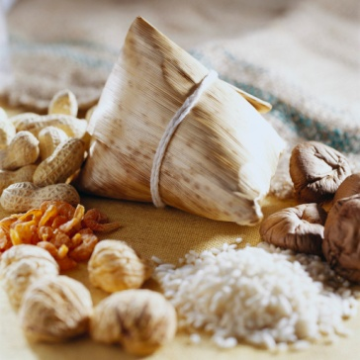
Regardless of the wines on offer at your establishment it is imperative that you understand the features of them.
This is especially true whether the offering originate locally, as many international customers may not have come into contact with local wines.
Even in the ASEAN region, each country has their own unique and authentic dishes which customers may not know about, but are certainly keen to try. In addition, they may not be able to identify a wine to suit a menu item they are interested in.
It is up to the each staff member to not only understand any special features of their wines, but are able to explain and promote it in a way that excites the customer and motivates them to purchase it.

Understanding special features
Given that some local food and wines will come from a specific region, it will be the first time the customer will try it. Not only will they be excited to try it, they will want to know more about it. This may be to:
- Reassure themselves that it is safe to consume
- Help them to prepare for any tastes or smells
- Increase their understanding – this is common as the customer will certainly tell others about the menu item or wine if they either like it or dislike it.
It you are offering a unique wine, most customers would certainly appreciate any information that may accompany or relate to the item. This may relate to:

- History of the wine – some basic background information
- Characteristics of the items – taste, smell etc
- Regions of origin – where it is produced
- How it is prepared – an explanation of any preparation activities
- Any menu accompaniments that are commonly served with the wine
- Its availability to purchase – most customers will welcome the opportunity to take some samples home to family and friends, whether to prepare it themselves or as a possible gift.

4.6 Interpret wine medals and wine judging methodologies

Introduction
One very influential factor that impacts a customer’s perception of a wine is through the awards and medals that they have won. If a wine producer has won an award, there is no doubt it will be shown on the bottle itself, as it is an extremely influential marketing tool.
In some cases, customers may ask you about the background and criteria of these awards. By being able to provide accurate information, it helps the customer to make a calculated judgement in relation to their wine purchase.
This section will discuss the criteria often used in the awarding of wine medals.
Wine shows
Knowing a bit about wine shows can help in offering advice and recommendations. If at all possible, attend a wine show and see what happens.
In addition, keep up-to-date about what wines are winning in the shows. Knowing this can help you when recommending a wine.
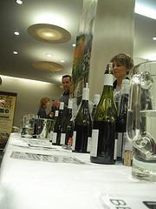
Wine shows are conducted throughout various countries, and these shows are forums that allow wine producers to showcase their product.
Success at these shows can have a big impact on future sales and successful wine companies are not backward in boasting about their awards and successes in the media.
Wine shows provide many categories for companies to exhibit in – covering all types of wine, various periods of ageing, and varietal and generic classifications.
Wines entered into the show must be forwarded in standard, unlabelled bottles so that judges are not influenced by prior knowledge or bottle presentation.
Wine show medals
When wines are exhibited at a wine show they are judged for:
- Colour and clarity
- Bouquet
- Palate.
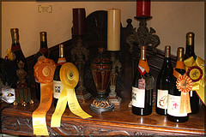
Each wine is judged against a written standard for each type, style and category: this standard stipulates aspects such as taste, colour and smell.
Each wine is judged (by groups of two, three or more judges) out of 20 points:
- 3 points are available for colour and condition
- 7 points are allocated for aroma and bouquet
- 10 points for palate and overall quality.
Medals are awarded as follows:
- 18.5 points and above receives a Gold medal
- Wines scoring 17.0 points to 18.4 points receive a Silver medal
- Those scoring 15.5 to 16.9 points are awarded a Bronze medal.
It is probably fair to say that many wine drinkers are unaware of this scoring system.
In theory every wine can win a gold medal. It’s not like the Olympics where only ‘the winner’ gets gold, the runner-up gets silver and the third place-getter gets bronze. Many customers think a Gold medal winning wine must be the best wine but as you can see it is not.
The above structure or ‘scoring system’ can be used or adapted to suit your workplace needs.
While many industry personnel will not be evaluating wines in the same way as show judges, it is nonetheless useful to have an understanding of the way these judges score the wines they taste.

Work Projects
It is a requirement of this Unit you complete Work Projects as advised by your Trainer. You must submit documentation, suitable evidence or other relevant proof of completion of the project to your Trainer by the agreed date.
4.1 To fulfil the requirements of this Work Project you are asked to explain activities associated with presenting wine lists to patrons.
4.2. To fulfil the requirements of this Work Project you are asked to explain how to identify patron preferences.
4.3. To fulfil the requirements of this Work Project you are asked to identify examples of suitable wine and food combinations to meet identified needs and preferences.
4.4. To fulfil the requirements of this Work Project you are asked to explain ways to answer customer questions in relation to wine.
4.5 To fulfil the requirements of this Work Project you are asked to identify how to explain special features of a wine.
4.6 To fulfil the requirements of this Work Project you are asked to explain how to interpret wine medals and wine judging methodologies.

Summary

Provide advice to patrons
Present wine list/lists to patrons
Presenting wine lists
Explaining the wine list
Wine list categories
Vintage and Price
Different styles
Keeping information updated.
Identify patron preferences and food that has been ordered
Give the customer time
Asking questions
When to offer advice.
Recommend suitable wine and food combinations to meet identified needs and preferences
Advise customers on appropriate wine and food choices
Pairing Food and Wine
Food and wine combinations
Offer appropriate wines for special occasions and particular seasons
Remember fortified wines.
Explain choice of recommended wine and food combinations
Answer wine relation questions from customers
Being proactive to guest requests.
Inform patrons of relevant wine production countries, grape varieties, wine production techniques and associated wine industry information, trends and details
Explain special features
Understanding special features.
Interpret wine medals and wine judging methodologies
Wine shows
Wine show medals.

Element 5:
Serve wines

5.1 Present and serve red table wines

5.2 Present and serve white table wines

5.5 Serve house wines

Introduction
In many establishments some style of wine is served before, during or after a course. In all bars wines are served either by themselves or with a snack or meal of some sort.
The next few sections will explore the procedures used to serve different styles of wine.
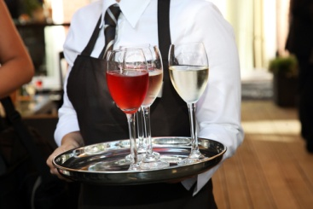
This section will focus on the service of red, white and house wine. As the service of this wine is similar, they have been grouped together into one section, as to avoid unnecessary repetition.
Section wine is commonly served accompany a meal include sparkling and table wine.
This section will look at the steps associated with the service of wine at the table, so that it is done in a professional manner.
Section 5.3 will explore the service of sparkling wine with Section 5.4 focused on fortified wines.
Naturally the style of service and the wines served may vary from the procedures explained, but in most establishments these procedures are common.

Select glassware
It is essential to stock the correct glassware in a restaurant, as it is the medium through which the wine is transferred from the bottle to your mouth.
There are many different styles of glassware on the market today and while it is possible to have a different glass-shape for every wine imaginable, it is more sensible to have a:
- White wine glass
- Red wine glass
- Water glass - can be the same as the red wine glass
- Champagne glass
- Smaller glass - to accommodate sherry, port, sweet wines and digestifs.
While your glassware cannot change the fundamental nature of the wine it contains, it can radically alter your perception of it.
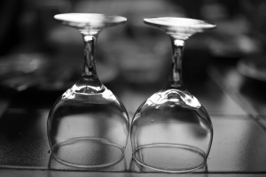
The right glass will emphasise the balance and harmony of your wine and considerably enhance your overall drinking experience. The teardrop or tulip shaped bowl design allows swirling to release aromas which are concentrated at the rim and direct the essence of wine straight to your receptors.
Each establishment will have its own glasses selected from an enormous range of commercially available options.
Waiting staff must ensure that the correct glass is used for the correct wine, and that uniformity throughout the dining room is maintained.
In general terms, a larger glass is used for the service of red wines than for whites.
This is due to the fact that white wines need to be consumed chilled, and a smaller glass will help keep the wine colder than a bigger one would.
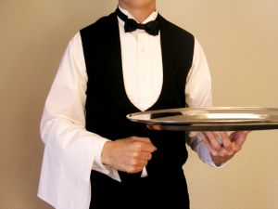
Also, the aromas of a red will be more easily appreciated by the extra volume that a larger glass gives.

Select appropriate equipment
Drink trays
These come in a variety of shapes and are usually made out of stainless steel.
Many trays have non-slip tray mats or non-slip surfaces.
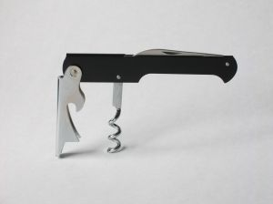
Waiter’s friend
The main purpose of a waiter’s friend is to assist in opening wine bottles and extracting corks at the table.
The waiter’s friend has three parts. These are a:
- Blade
- Corkscrew (worm)
- Lever.
All bar staff and waiters should carry a waiter’s friend. It is really an industry pre-requisite.
Make sure you have one, check it to make sure the blade is sharp, the corkscrew (or ‘worm’) is sharp and not bent, that it opens easily, and operates safely.
There is no need for a waiter’s friend where all the wines are Stelvin seals.
Ice bucket
An ice bucket is used for chilling wine and may be presented in a tripod stand.
The stand may be located beside the guest’s table, however some venues prefer not to do this as is can get in the way when waiters try to serve or clear a table. In these cases the stand is kept at the waiter’s station, requiring the waiter to keep a keen eye on the glasses to make sure guests don’t run out!
Fill the bucket with about one-quarter of cold water, then add half to two-thirds full of ice. The combination of ice and water enables the bottle to settle fully among the ice. Trying to push a bottle into a bucket with ice only, can be difficult to impossible.
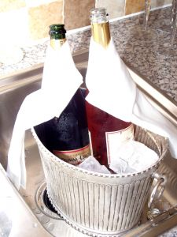
Ice buckets can also be table-top models made from transparent plastic. Ice is not required for this style of bucket but may be added if house practice demands.
Ice buckets should always be kept clean and well maintained.
Service cloth
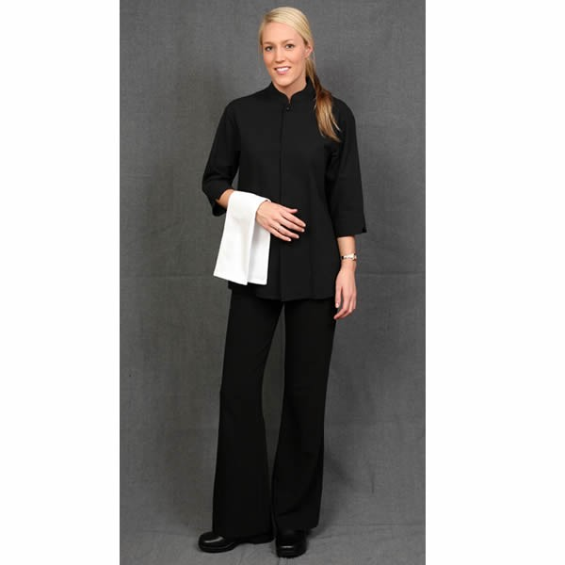
A service cloth (a folded linen serviette), also known as a waiter’s cloth, is used in the table service of wine.
They are used to present wine at the table. The cloth is folded behind the bottle to provide a background, while the wine is announced.
They are also folded lengthwise to a quarter their area and draped over the left arm and used to wipe drips from bottle necks, and to wipe moisture off white wine bottles, as necessary.
Additionally, some establishments fold a napkin around the neck of wine bottles as a decoration and to catch any drips of wine which may run down the neck of the bottle.
Some establishments only use this fold for red wines, inserting the cork from the wine into the folded napkin as a method of presenting the wine and the cork.
Carafes
These are used for the service of house wines to table, and for the service of decanted wines.
They come in a variety of sizes such as 500 mls, 1 litre and 2 litres.
Decanting equipment
Where there is a need to decant wine for genuine service reasons such as to remove sediment or simply to enhance presentation, the venue may use specialist decanting equipment.
This can include a candle, a carafe and a basket or container to contain the wine bottle
Wine baskets

Wine baskets are usually cane baskets used to present wine, and in some cases, to assist in service of the wine at the table.

Check bottle condition
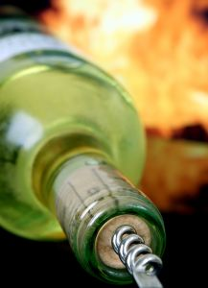
When selecting wine for service, it must be checked to ensure it is presentable and that it is at the correct temperature.
All bottles should be checked to ensure they are in good condition before being served to a guest.
This may include checking:
- Label – legible and intact
- Top near the cork or seal – intact and entire
- Bottle top - clean and not leaking
- Nothing floating in solution – as best as can be identified
- Overall condition of the glass – not cracked, not leaking.
Checking wine temperature
Temperature plays a large part in customer satisfaction with wine.
Some beverages may have to be stored in different conditions to achieve optimum temperature for service.
The exact same wine, white or red, poured at fridge, cellar and room temperature will taste completely different. This is well known by regular wine drinkers. In a restaurant atmosphere serving a wine at the wrong temperature can ruin the first few glasses. Customers often mistakenly feel that the wine is opening up and thus getting better in the glass. This is not always the case. If a fine white wine is served too cold, fruit flavours may be inhibited, and it can take half an hour for the bottle to warm a little. Serious whites do not need to be constantly immersed in an ice bucket. The opposite is often true about red wines. A room temperature red can taste too soupy and lose its definition. A quick dunk in an ice bucket can return the red to its tighter more balanced state. Restaurateurs should try hard to make sure that wines are all sold at their optimum temperature. Be prepared to leave a white out of the ice bucket, and use ice for warm reds.
Suggested temperatures are:
- Red wines are usually stored in a Dry and dark storeroom with racks to store red wine bottles on their sides –: arguably the idea of serving reds at room temperature is a concern because the actual temperature of rooms can vary so much however many venues serve their reds ‘off the shelf’ at whatever the ambient temperature is. Therefore the most desirable temperature is 16ºC
- A refrigerated environment for white wines so they can achieve the required service temperature – many venues will refrigerate their whites to around the 2ºC – 5ºC mark and serve them at this temperature even though they should be served around 10ºC – 12ºC to highlight their unique characteristics. The reality can often be that if we serve white wines at 10ºC – 12ºC we receive complaints the wine is not cold enough
- Fortified wines are generally served at room temperature, unless otherwise requested – the only common exception to this is dry sherry which may be refrigerated and served chilled.

Presenting wine
Bottles of wine are traditionally presented to customers prior to service.
Where this part of the traditional wine service process, known as ‘the ritual of wine service’, is required by your employer it should be adhered to for both red and white wines.
Why present the bottle?
Presenting wine is done for three reasons:
- It provides an opportunity for the guest to check the wine they have ordered to ensure it is the one they really want. Sometimes guests will see the bottle or wine label and realise they have made a mistake with their selection
- It allows the guest to check that the waiter has brought the bottle that was ordered. This helps avoids situations where the waiter may have misheard the order
- It is part of the service ritual for wine that many guests expect.
Presenting wine
When the bar attendant has given you the bottle of wine that has been ordered, check it to see that it is in fact what has been ordered and then take it to the table.
You should, depending on house policy, place a waiter’s cloth, folded and draped over the left forearm and carry the bottle in the right hand.
The wine may be wrapped in a service cloth that acts as a background to it, or it may be carried in a wine basket.

On reaching the guests’ table the procedure is to:
- Excuse yourself
- Present the unopened bottle of wine, label first, to the person who ordered it. Note that this may not necessarily be the host for the party
- ‘Announce’ the wine - by describing it as follows “Madam, your 1997 Wolf Blass Grey Label Cabernet Sauvignon, Shiraz”
- Wait for the customer to confirm it is the right product.
When the guest agrees that it is the bottle that has been ordered, it is then opened.
You never present a wine that has already been opened.
If a guest wants you to open a bottle of wine prior to their meal to allow it to breathe, the bottle is presented before it is opened and not before it is poured.
Decant wines where appropriate, according to variety, style and vintage of wine
Decanting wines is part of the wine service ritual in many fine dining restaurants, but is not a common activity in pubs and clubs. The reason for this is fine dining venues tend to offer wines that require decanting, while pubs and clubs tend not to.

‘Throwing a crust’
Some reds ‘throw a crust’ (produce gritty sediment) during bottle maturation.
This is why bottles should be left alone, quiet and untouched, so that the sediment can settle along one side of the bottle. This is also another reason why bottles with a Stelvin cap may be stored lying down.
When opening wines that have or are suspected of having a crust they should be treated very carefully and gently so as not to stir up this grit and put it back in solution.
Guests do not want to drink this sediment as it is most unpleasant to taste.
Wines are therefore decanted – that is, the clear, bright wine is poured off the sediment – to prevent this sediment being served along with the wine.
Which wines to decant
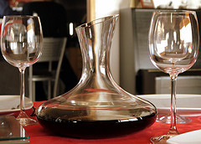
You should always decant a wine where experience has shown you that wine has sediment.
In addition the following guidelines can be useful:
- Decant all red wines over a certain age – a commonly held age is 5 years
- Decant wine where you wish to offer an higher level of service
- Decant wine where you want the wine to breathe prior to consumption.
Note the decanting process should occur in full view of the customer whose wine is being decanted. This is so the customer can verify for themself that the wine in the decanter actually came out of the bottle they ordered.
Decanting
The procedure for doing this varies from a simple, slow and careful pouring of the wine out of the bottle into glasses, through to a ritualistic (in the case of restaurant service) pouring of the wine off the sediment into a carafe using a lighted candle to help identify when the sediment is starting to move out of the bottle.
Where bottles have been decanted for guests in a restaurant situation, the bottle containing the sediment should be presented to the guest so they can see how much was ‘wasted’ in decanting.
Any red that is over five years old should be handled for serving purposes as if it will have a crust. Note that a crust does not itself indicate a fault in the wine.
Movement (vibration, say from motors or machines) during storage will prevent sediment from settling and mean that it will be suspended in solution when dispensed and served.
In addition to the above factors, when storing any beverage commercially, ease of access must be ensured so that staff can quickly obtain the required item, and so that stock may be rotated according to venue cellaring requirements. You may want to lay some stock down for several years while other stock can be sold whenever required.

Open and serve wine
Open and serve beverages correctly, safely and without spillage
Opening of bottles presents a slight danger of cutting yourself so all bottles must be opened carefully and safely.
All beverages must be served at the table without spillage because spills:
- Waste the customer’s valuable drink
- Create a mess on the guest’s table that is visually displeasing.
Opening wine – bottles with corks
In some establishments, after the bottle has been approved by the customer, the cork is drawn at the table
In other venues the waiter withdraws to the waiter’s station and removes the cork there in full view of the table that ordered it.
Yet again, some premises return the bottle to the bar and the bar attendant opens it.
A waiter’s friend should be used to open wines at the table.
Wines should be opened quietly, and no noise should be audible when the cork is withdrawn.
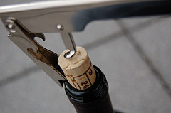
The corks of red wines can be presented on a doilied saucer to the person who ordered the wine, to allow them to inspect it for signs of soundness or problems. This is part of the ritual of wine service.
Corks for white wines are not traditionally presented after having been drawn.
Any wine that smells obviously ‘off’ must not be served but discarded and another bottle obtained.
Steps to removing a cork
After presenting the bottle:
- Cut the seal with the knife on the waiter’s friend – take care not to cut yourself
- Maintain a firm grip on the bottle while cutting the seal – to make sure you don’t drop the bottle
- Once the top of the seal is cut off, place the loose piece into your pocket
- Place the very tip of the waiter’s friend into the centre of the cork – then apply pressure onto the handle and twist the corkscrew in parallel to the glass neck of the bottle
- Twist the corkscrew until only two twists on the corkscrew are left visible – if you twist the worm too far, the point of the corkscrew will push through the cork and send little pieces of cork into the wine
- Secure the lever to the lip of the bottle – support the lever firmly using pressure from your wrist with your index finger or thumb
- Pull the body of the waiter’s friend towards you, ensuring your thumb continues to apply pressure to the hooked lever against the bottle
- Keep pulling until the cork is 3/4 way out of the bottle
- Using your index finger and thumb, twist the cork out of the bottle – make sure you do not ‘pop’ the cork but remove it gently
- Remove the cork from the corkscrew
- Red wine corks may be presented to the guest – white wine corks may be put in the pocket of your trousers or jacket
- The waiter’s friend can be likewise placed in the pocket of your trousers or jacket – or left at the waiter’s station or bar.
Pouring wine
Pouring table wine
There are a number of points to remember when pouring wine:
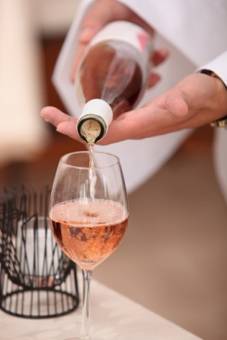
- Always pour about 60mls into the glass of the guest who ordered the wine for them to taste it. Once the guest gives their approval, move on to the next person’s glass, which would be to the orderer’s right-hand side. This enables the wine waiter to work anti-clockwise around the table
- Remember that the person who ordered the wine gets the first taste, but their glass is not filled until all the other guests at the table have had their glasses filled
- Pour the wine slowly so there is no ‘glug-glug’ sound as the wine and air meet in the bottle’s neck – hold the bottle so that the label of the bottle is visible to the person whose glass is being filled. This allows them to read the bottle while their glass is being filled
- Fill white wine glasses 2/3 full
- Fill red wine glasses to the halfway mark – extra room is left in red wine glasses to allow the development of the bouquet from the red wine
- Always serve customers from the right
- Never let the bottle touch the rim of the glass while pouring
- Lift and twist the bottle on completion of the pour – to eliminate drips from the bottle. A waiter’s cloth should also be held in the left hand to wipe the neck of the bottle between servings
- White wine should rest in an iced ice bucket in a stand on the floor, or in a cooler on the table
- Red wine should remain on the table – a napkin may be wrapped around the neck for presentation purposes: the bottle can be left standing on the table or resting in a wine basket
- Some establishments have a ‘high tide’ line on their glasses, and others have a policy of 100 – 120 mls only.

Refill glasses where appropriate
Filling and re-filling glasses is all part of the customer service experience.
Beverage waiters are expected to re-fill guest glasses after they have been served with a bottle or can. It is not good service to simply serve the bottle and then abandon the customers to their own devices in terms of re-filling their own glasses.
Re-filling glasses also:
- Provides an opportunity to develop rapport with customers
- Gives an opportunity to check out the level of intoxication of customers
- Provides an opportunity to sell extra drinks – either alcoholic or non-alcoholic.
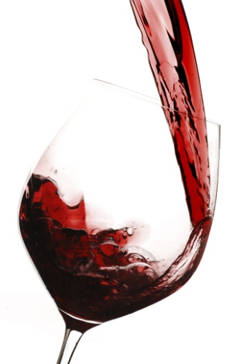
All service of liquor, including re-filling customer glasses, must occur within RSA principles and reflect any RSA agreements or accords that exist.
Refilling glasses
Drink waiters must realise that their job is not finished when they have completed the initial pouring of the wine.
They must pay constant attention to the state of the glasses and refill them as necessary, offering more wine or the wine list when a bottle is emptied – within RSA principles.
When providing this refilling service, staff should make sure they do not interrupt conversation between guests, and excuse themselves whenever they pour.
The technique to be used when re-filling glasses is:
- Take the wine from the table, wine stand etc. and hold in your right hand
- A waiter’s cloth may be held in the left hand – to assist in service by wiping drips from the neck of the bottle in between pours
- Approach drinkers individually from their right-hand side
- Enquire if they would like more wine – in some cases it may be appropriate to provide this service without asking this question
- Top up the glass as per previous directions: red wine – half full; white wine 2/3 full
- Twist and lift the bottle on completing the pour
- Work anti-clockwise around the table
- Don’t knock the bottle on the glass.
If the bottle is emptied during, or at the end of, the re-filling process, another bottle of wine or the wine list may be offered.
Where another bottle of wine is purchased, fresh glasses should be offered and laid.

Clear wine glasses and items
Similar to the service and refilling of wine, the timely clearance of both used and unused glasses and other wine items such as bottles is important.
When a glass is empty on a table it should either be refilled or removed.
In theory and practice, there should never be an empty glass on a table in front of a guest.
No customer likes to have dirty or unused glasses on the table if they can help it. Not only does it look unpleasant, especially when used glasses remain on the table, but it takes up space, which is already limited.
Removing unused glassware
Where the cover has included glassware, these glasses must be cleared when guests indicate they will not be using those glasses.
For example, if a red and white wine glass were set on the cover and the guests ordered only white wine, the red wine glasses must be removed.
Where guests order a drink that is not catered for by the glasses that have been set, the glasses that have been set must be removed and exchanged for the correct glasses.
For example, if glasses for still table wines were set and the guests ordered champagne the wine glasses would have to be swapped for champagne flutes.
Removing used glassware
Where there is wine still in the bottle, this should be offered before glasses are cleared.
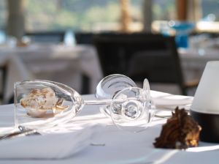
Where a guest refuses the offer of the drink that is left in the bottle, staff should ask if the customer would like the bottle and their glasses taken.
If you unsure whether or not a guest has finished with their glass, be it empty or with some drink still in it, then politely ask the guest whether or not they have finished.
Where a table orders a second bottle of wine of the same brand, type, style and year, fresh glasses should be offered, although this offer may well be refused, or guests may wonder why it is being done.
Where a table orders another bottle of wine different to what they have previously been served, fresh glassware must be set before the wine is presented, even though this may add to the glassware already on the table.
All glassware taken from the table, used or unused, must be transported on a drinks tray. Glasses must be held by their stem or base. Never put fingers inside glasses, whether it is used or unused.
Timing of clearing
Constant observation of guests’ tables will indicate when clearing of glasses and bottles is required.
Drink waiting staff should remember that their job does not finish after the initial service and pouring of a bottle. As mentioned attention should be paid to topping up glasses as required, and clearing empty bottles and glasses.
When a bottle is emptied it should be removed, and the guests offered the drink list to encourage a further sale. Staff must guard against being ‘pushy’, but must also try to provide service and maximise sales.

5.3 Present and serve sparkling wines

Introduction
Whilst some of the techniques explained when opening table wines will also apply when serving sparkling wine, there are some differences.
These will be explained below.
Opening sparkling wine
The ‘ritual’ for opening champagne or sparkling wines is:
- Present the bottle to the host - using a service cloth
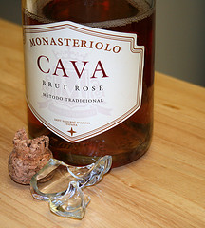
- Announce the wine – by brand, style and vintage to the host to confirm the correct selection of the bottle
- Remove the foil around the cork of the bottle – place the foil into your pocket
- Untwist the wire cage around the cork and remove it – place the wire cage into your pocket. From this point on keep your thumb on the cork, just in case it pops out unexpectedly
- Hold the bottle firmly
- Twist the bottle to loosen the cork, keeping the pressure on the cork to ensure it does not pop. Do not twist the cork, twist the bottle
- Allow the cork to come out slowly without a large pop sound – you may need to use your thumb to work the cork out of a stubborn bottle
- Hold the now open bottle at an angle of 45º to help reduce the likelihood of wine escaping or foaming from the bottle – holding the bottle at a 45º angle creates a much larger wine surface area at the top of the bottle providing more space for gas and wine to escape.
Pouring sparkling wine
After the sparkling wine has been opened, the following tips apply to pouring it at the table:
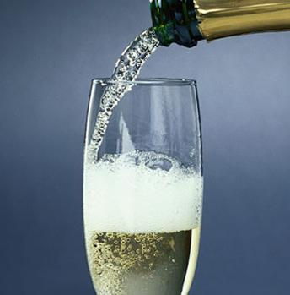
- Always pour about 60mls into the flute of the guest who ordered the wine - for them to taste it
- Once the guest gives their approval, move straight onto the next person’s glass, which would be to the orderer’s right. Remember that the person who ordered the wine gets the first taste, but their glass is not filled to the required level until all the other guests at the table have had their glasses filled
- Pour the wine slowly to avoid foaming the wine in the glass - hold the bottle so that the label of the bottle is visible to the person whose glass is being filled
- Fill champagne flute to the 2/3 level
- Always serve customers from their right-hand side
- Never let the bottle hit the glass
- Sparkling wine should rest in an iced ice bucket or a cooler.

5.4 Present and serve fortified wines

Introduction
The service of fortified wines normally takes place at the end of a meal or to accompany dessert.
As a reminder fortified wines are base wines which are strengthened or ‘fortified’ by the addition of grape spirit or brandy.
The addition of the grape spirit stops fermentation, increases alcoholic strength, adds sweetness, imparts keeping qualities, and in the case of port provides the brandy character.
Serving fortified wines
Ports
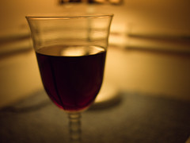
Ports are an after-dinner drink: serve size is 60 mls.
Different types of port include:
- White port
- Ruby port
- Tawny port
- Vintage port
- Liqueur port.
Muscat
Muscat is an after-dinner drink: serve size = 60 mls.
The name can refer to either grapes, or to the wine they make.
Tokay
Tokay is an after-dinner drink: serve size = 60 mls.

5.6 Respond to patron complaints about wine

Introduction
In Section 3.5 a number of common wine faults and flaws were identified.
Due to the very nature of wine, at times wine will not be to the expected standard.
When faced with a customer complaint in relation to wines, the fundamental advice is to implement the house policy as it applies where you work.
If you don’t know what the policy is, or are unsure about any aspects of it, then you must clarify things as soon as possible with your supervisor.
Responding to complaints
Given the appreciation of wine is very much a personal thing, it is always possible that what one person sees as grounds for a complaint, is really not a wine fault, but simply a difference of opinions between people.
This makes it very difficult to determine ‘who is right, and who is wrong’.
Indeed, many drinkers will consume a wine and enjoy it, whilst another drinker will refuse to accept it because of some fault.
It is for this reason that your house policy must be adhered to. Certainly, the last thing you want to do is become engaged in an argument with a customer over wine.
Nonetheless, it is useful for you to evaluate the wine in order to form your own opinion. The objective should be to assess the wine independently to see if it is ‘acceptable’ from your own point of view, and to identify what the customer sees as a fault, or as unacceptable.
The evaluation should take into account the appearance, smell and taste of the wine.
Where obvious legitimate complaints are identified, the standard procedure is to:
- Apologise
- Replace the wine – if that is what the customer wants, or
- Refund the purchase price.
House policy may indicate additional or alternative courses of action.
Where possible, when the wine has been returned, it should be sent back to the winery or supplier for a credit or replacement.

Work Projects
It is a requirement of this Unit you complete Work Projects as advised by your Trainer. You must submit documentation, suitable evidence or other relevant proof of completion of the project to your Trainer by the agreed date.
5.1 To fulfil the requirements of this Work Project you are asked to identify the steps associated with preparing wine for service to customers.
5.2 To fulfil the requirements of this Work Project you are asked to identify steps associated presenting wine to the customer.
5.3 To fulfil the requirements of this Work Project you are asked to identify steps associated with serving sparkling wine.
5.4 To fulfil the requirements of this Work Project you are asked to identify different types of fortified wines and the steps associated with serving them.
5.5 To fulfil the requirements of this Work Project you are asked to identify steps associated with opening and pouring wine to the customer.
5.6 To fulfil the requirements of this Work Project you are asked to identify how to respond to patron complaints about wine.

Summary

Serve wines
Present and serve red table wines; Present and serve white table wines; Serve house wines
Select glassware
Select appropriate equipment
Check bottle condition
Checking wine temperature
Presenting wine
Decant wines where appropriate, according to variety, style and vintage of wine
Open and serve wine
Pouring wine
Refill glasses where appropriate
Clear wine glasses and items
Removing unused glassware
Removing used glassware
Timing of clearing.
Present and serve sparkling wines
Opening sparkling wine
Pouring sparkling wine.
Present and serve fortified wine
Serving fortified wines.
Respond to patron complaints about wine
Responding to complaints.

Element 6:
Maintain wine knowledge

6.1 Implement formal and informal research to update knowledge about wine

Introduction

The wine industry is having an ever growing presence in food and beverage service and therefore it is expected that any professional staff member working in any capacity involving wine must have a sound understanding of the industry in general and more specifically the wines that are available to the customer.
Not only is it important to identify different wine regions, styles and varietals, but a competent staff member must also be able to explain it in detail and provide advice and suggestions that may benefit the customer in their drinking experience.
This section will explore the ways a wine server can improve their range of wine knowledge.
Whilst at a minimum beverage attendant must understand the specific wines relating to their establishment, it is certainly beneficial to have a sound understanding of the wine industry as a whole, with a particular focus on being able to match wines with different cuisines and understanding wine related trends that may be present in this exciting and ever changing industry.

Benefits of product knowledge
Having a sound understanding of the wine industry enables the server to:
- Demonstrate professionalism
- Inform the customer of the various wines offered in your establishment
- Explain wine styles, varietals and characteristics
- Provide background information about wines
- Promote wines
- Recommend food items to match wines
- Generally assist customers with any enquiries in which they may have.

General information
At a minimum, wine servers should be a sound understanding of:
- The wines that are available from the bar
- The ways they can be served – by the bottle, glass, cask etc
- The brand names and types of table wines, sparkling wines and fortified wines available
- Information about individual wines
- Prices
- Knowledge about matching wine to menu items
- Glassware for the service of all drinks
- How to present and pour wine.
Sources of wine information
The wine industry is a constantly changing landscape.
New products, tastes, trends are constantly emerging and some products lose popularity and fade away.
Professional staff should use informal and formal research techniques to keep pace with these changes especially as they relate to their venue.
There are endless ways in which wine servers can improve their understanding of the wine industry.
Following are just some of these ways.
Organisational sources
Within the property you can obtain product knowledge information from:
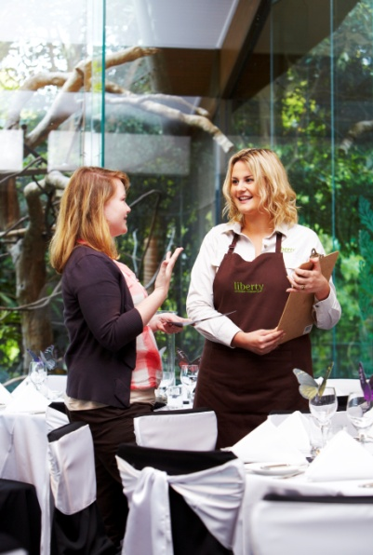
- Wine lists – many of these contain descriptions about wines on offer
- Taste the products – subject to whatever workplace restrictions apply, one of the best ways to really learn about wines is to ‘experience’ them – as mentioned wine tasting is the most appropriate method
- Experienced staff – such as senior wine servers, purchasing officers, wine shop sales assistants, managers and owners
- Operational manuals – for details relating to the way things should be done
- Policies and procedures manuals – for background information about handling wine
- Information found on the bottle itself – this is a great source of information
- Doing a tour of the wine storage area or wine shop – to understand the different types of wine available

- Workplace observations - This information can also be used to evaluate products, services and promotional incentives offered by the establishment. Observation in the workplace may include:
- Being aware of new products and services offered
- Being aware of product returns
- Familiarising yourself with promotional displays and printed materials
- Speaking with other team members about the services and products they appear familiar with
- Observing customers’ reactions to a particular product or service.
Note that for any research, questioning or observation to be successful it must be done with a purpose in mind. You must have a definite idea of what you want to find out about
- Own experiences – as a wine server, you can recall and reflect on your own experiences in restaurants and bars and evaluate them in a more critical manner than the average customer. By looking back at both positive and negative experiences has as a customer, is a great starting tool in being able to see what can be implemented in the workplace.

External sources
There are endless sources of information in which wine knowledge can be extracted. That said, there are a number of good reliable sources in which to start from, including:
- Trade magazines – these specialist publications are a great source of all information and trends that are specific to the wine industry. Whilst the focus of these magazines may focus on wine the range of topics are endless. These can include management tips, operational strategies, trends, new products etc
- Feature newspaper articles – most newspapers will have a section dedicated to hospitality and tourism, with many having dedicated space for interesting wine related stories, creations or industry events
- Television programs – in recent times there has been a rapid rise in the popularity of wine shows, and in directly cooking shows featuring wine and matching with food. This enables more people, many of whom do not work in the industry, to improve their culinary and wine awareness
- Food and beverage reference books – these specific information tools traditionally contain detailed content in a variety of food and beverage operational and management disciplines. They are normally an invaluable resource for students and anyone seeking to improve their knowledge and understanding
- Internet – no doubt, the greatest source of industry knowledge at one’s fingertips

- Wine/food tasting events and other promotional activities – these are a great opportunity to not only understand and taste new product, but it allows you to meet with industry leaders and to get a first hand appreciation of current offerings in the market place.
Along with tastings, it is common for winemakers to provide an informational seminar or question and answer session, which provides tremendous insight into different types of wines
- Trade shows, exhibitions, and food and beverage festivals – provide a great opportunity to not only understand the latest offerings to the industry, but allows you to speak with a wide variety of suppliers. Keep an eye on the media and invitations sent to your employer. Make the time to go as many shows/exhibitions are free to industry personnel and they are a great way to establish industry networks and keep abreast of what’s happening in the business
- Winemakers – these experts in the industry have specific knowledge, skills and experiences which is beneficial to help wine servers understand and expand their industry knowledge
- Visit wineries – no doubt the best way to get a great understanding of the detailed activities involved in wine production
- Tasting notes written by others – both ‘professional’ people such as wine judges, magazine reviewers, wine makers and other staff at your workplace
- Sales representatives – all suppliers are a great source of information, not only of their own range of products but what the industry as a whole is seeking and to identify items and trends that are in demand. Information can be obtained by asking direct or by asking them to send you product information sheets
- DVDs – these are a great visual resource that can be used over and over again
- Belonging to wine clubs – these are an excellent way to develop in depth wine knowledge
- Customers, e.g. customer opinion and feedback – given the customer is the most important aspect of a business, it is no point conducting large amounts of research, unless the customer is happy with the end result. Therefore their feedback is invaluable either to get reassurance for items that are successful, but to see where items or preparation methods can be replaced or improved.
Customer feedback may involve:
- Asking a customer for their comments after they have bought, eaten or consumed an item
- Providing comment cards for the customer – and encouraging them to complete them
- Talking to customers
- Observing customer reactions.
Whilst this section has identified a number of good informational resources, all wine professionals can strive to seek information, whether it be a trip to a supermarket, wine shop, looking up the internet, discussions with friends or simply watching the news, opportunities to develop your understanding are right before your eyes.

6.2 Identify emerging trends in the consumption of wine and changes in patron preferences

Introduction
As a professional in the wine business you must realise the industry is a constantly changing one and there is a need for you to stay up-to-date with what is happening in it.
Research of this nature needs to be on-going.
You must be able to keep in touch with the latest trends in the wine industry, both on an international and local level.
Not only does this help when designing wine lists, but being able to impart useful information to customers who wine and dine at your establishment.
Ways to research general wine trends
As part of your ongoing efforts to remain up-to-date with happenings in the wine industry, you will need to engage in formal and informal research. Some of these were identified in the previous section, but research may include:
- Doing a wine course
- Subscribing to wine magazines
- Reading the wine pages of industry journals and the general media
- Visiting wineries and talking to the people there – try to get an introduction from the sales rep who calls on you

- Visiting the web sites of wineries and wine merchants
- Attend wine shows and exhibitions
- Read wine books, guides and reference material
- Read the tasting notes and wine labels
- Talk to others who are interested in wine and get their opinions
- Visiting the opposition to see what is happening there
- Tasting new wines and making your own tasting notes
- Listen to the feedback that customers give you.
Once you have begun to actively search out information about wine, you will be amazed where you find it.
Set up a book as your reference book and write down the names and contact details of people and organisations that may be of use to you.

Identify trends in customer tastes based on direct contact and workplace experience
As mentioned, wine trends are a difficult thing to interpret and they are in a constant state of change.
There is definitely a need to be aware of what is happening in the general marketplace, as identified above, but this does not necessarily translate into sales at your venue.
To maximise revenue from wine the key is to be able to cater for demand as it relates to your property and the needs and preferences of your customers.
The factor that underpins this ability is first-hand knowledge about customer preferences and up-to-date, venue-specific information on wine sales.
Ways to identify ‘your customer’ trends

Simple and effective ways to determine workplace trends in relation to wine are:
- Talk to your customers – and ask them about what they are drinking now, what they want you to stock and how their wine drinking habits are changing
- Monitor your wine sales statistics – this can be done by checking stock movements via stock takes and stock sheets, customer accounts and register audit rolls
- Talk to the staff – keep in touch with wine waiters, wine shop attendants and anyone else involved in the in-house service of wine to identify what people are drinking and what they have been asking for. It is vital to enquire about what they have been asking for as this helps identify wine that should be stocked. The analysis of your wine sales statistics is useful but will only tell you what has been sold and not indicate sales you may have missed out on, or wines customers now want that they did not want, say, six months ago.
Identify general trends in the wine market
General information
As mentioned, it is important for venues to maintain currency of market knowledge regarding general wine trends and use this knowledge in the venue in a practical way.
Industry magazines contain regular information about trends in the wine industry detailing popular brands and varieties as well as production in terms of litres and sales in terms of dollars.
Most of these reports will compare latest figures with previous years to indicate whatever trend is emerging. This knowledge may have implications for the wines you stock, or simply be a conversation point with those who share your interest in wines.
Figures are available in some reports that will detail trends in bottle wine and casks, as well as from various outlets, such as on-premises, and off-premises sales.
The reports will provide you with details such as which minority varieties are experiencing strong sales growth – albeit from, say, a fairly small initial sales base – and which traditionally popular varieties are maintaining their position or improving it, or suffering at the expense of something else.
Other reports will focus less on table wines but drill down into the emerging figures as they relate to fortified wines or sparkling wines.
Still other reports will investigate imported wines, and look at domestic exports.
Types of wine trends
Whilst different countries, regions and producers will have their own trends and influences, in general terms wine industry trends include:
- The consumption of wine is increasing worldwide
- The production of wine is increasing worldwide
- There is a glut of wine in Europe – it was once referred to as the ‘wine lake’ but has been more recently referred to as the ‘wine ocean’
- Producers are seeking alternatives to the traditional wines – such as the introduction of ‘cooler-style’ options
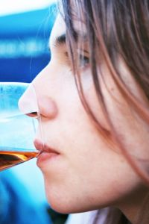
- More countries are importing wine today than ever before – even when they are producing more than they can sell domestically (or export), and even when they are producing their own outstanding wines
- There is a growing demand for truth-in-labelling so that consumers can drink confident in the knowledge that what’s on the label is what’s in the bottle
- There is a growing popularity in wines from boutique wineries
- Customers are eager to try wine made from new grape varieties
- Wine consumers are becoming more knowledgeable about wine and more sophisticated in their wine choices.
- Increase in wine on tap – this enables costs to be reduced as ‘kegs’ can be refilled and are eco-friendly. Servers don’t need to store large amounts of bottles and don’t need to open as many corks
- Increase popularity of rose wines
- Increased popularity for unoaked chardonnay instead of the oaked variety
- Wine and chocolate pairings
- Exploring new and interesting varietals
- People may drink less but are willing to pay more

6.3 Share updated wine knowledge with others

Introduction
As can be seen from the last two sections, there are many ways and pieces of information relating to the wine industry that should be shared with others.
It is critical for your product knowledge to remain up-to-date and accurate as this will be one of your most powerful selling tools. When you have managed to gather updated information, knowledge or skills you must be prepared to share that information.
As you gain and share product knowledge it will help you and your colleagues to sell the wine better. Knowledge is a powerful tool and is the best selling tool you can have.
Sharing knowledge with customers
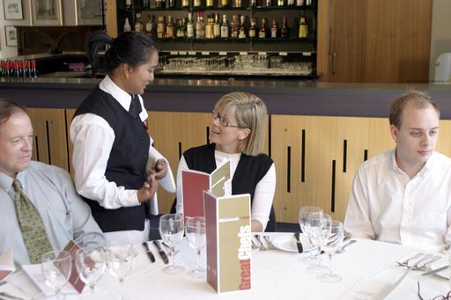
Naturally the best way to use the knowledge you have gained, is to help customers in their wine selection.
There are three basic ways in which information about wines can be used to assist customers:
- Tell them verbally of the information you have found
- Give them a copy of the relevant information – tasting sheets, product information, winemakers notes
- Direct them to additional information – a website, a magazine, the winery, a tasting.
Sharing knowledge with staff

It is important for all staff to share new product knowledge they become aware of.
This can be done in an informal fashion which would commonly be information that you ‘just pick up around the place’ in a random manner, or it can be structured through organised staff meetings that have a pre-set focus.
Opportunities for knowledge sharing include:
- Discussions in any sort of staff meetings
- Before or after service – at briefing and de-briefing sessions
- During breaks
- E-mail co-workers with the information you have discovered
- Prepare a short handout – put this on the notice board or photocopy and distribute it
- Present it is meetings.

Making practical use of the knowledge gained
As you improve your knowledge about the wine industry and the trends that affect the, this knowledge can be used to help improve operations.
This can be done by:
- Add wines to your wine list – by buying in new stock
- Remove wines from your wine list – by moving wine to the wine shop for sale; discounting unpopular wines to clear them. Note ‘removing wines’ may also involve reducing the level of stock on hand while still keeping some of the wines available
- Buy additional stocks of wines that are proving popular – to ensure you do not run out
- Buy wines and cellar them for later sale – capitalising on the extra money that can be made from ageing the wine yourself, in-house
- Develop new menu items to accompany the emerging wine trend
- Obtain point-of-sale promotional material to assist in optimising sales of new wines. Increasing profit margins – new products, used as alternatives to current products, may be more cost-effective, enabling better returns which can translate into larger portion sizes
- Reducing selling prices – where the premises is in an extremely competitive environment, the new products may mean you can compete more effectively on the basis of price and be in a position to offer the same portion size or larger at a lower price than the opposition
- Generating a new target market – the new food item that is now available to you may mean you can now attract a fresh demographic, or rejuvenate an existing one.
Summary
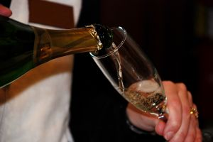
As you can see in this manual, the wine industry is varied and complex but of great interest to customers and staff alike. Its impact in the food and beverage industry will become ever greater and those staff who can embrace and become knowledgeable in it, can identify and take advantage of unique selling points, to not only help expand your customer base, but more importantly, to help enhance each and every customer experience.

Work Projects
It is a requirement of this Unit you complete Work Projects as advised by your Trainer. You must submit documentation, suitable evidence or other relevant proof of completion of the project to your Trainer by the agreed date.
6.1 To fulfil the requirements of this Work Project you are asked to identify different types of research that can be undertaken to update knowledge about wine.
6.2 To fulfil the requirements of this Work Project you are asked to explain how to identify emerging wine and customer trends.
6.3 To fulfil the requirements of this Work Project you are asked to identify how to share and make use of updated wine knowledge.

Summary

Maintain wine knowledge
Implement formal and informal research to update knowledge about wine
Benefits of product knowledge
General information
Sources of wine information.
Identify emerging trends in the consumption of wine and changes in patron preferences
Ways to research general wine trends
Identify trends in customer tastes based on direct contact and workplace experience
Identify general trends in the wine market
Types of wine trends.
Share updated wine knowledge with others
Sharing knowledge with customers
Sharing knowledge with staff
Making practical use of the knowledge gained.

Presentation of written work

1. Introduction
It is important for students to present carefully prepared written work. Written presentation in industry must be professional in appearance and accurate in content. If students develop good writing skills whilst studying, they are able to easily transfer those skills to the workplace.

2. Style

Students should write in a style that is simple and concise. Short sentences and paragraphs are easier to read and understand. It helps to write a plan and at least one draft of the written work so that the final product will be well organised. The points presented will then follow a logical sequence and be relevant. Students should frequently refer to the question asked, to keep ‘on track’. Teachers recognise and are critical of work that does not answer the question, or is ‘padded’ with irrelevant material. In summary, remember to:
- Plan ahead
- Be clear and concise
- Answer the question
- Proofread the final draft.

3. Presenting Written Work
Types of written work
Students may be asked to write:
- Short and long reports
- Essays
- Records of interviews
- Questionnaires
- Business letters
- Resumes.
Format
All written work should be presented on A4 paper, single-sided with a left-hand margin. If work is word-processed, one-and-a-half or double spacing should be used. Handwritten work must be legible and should also be well spaced to allow for ease of reading. New paragraphs should not be indented but should be separated by a space. Pages must be numbered. If headings are also to be numbered, students should use a logical and sequential system of numbering.
Cover Sheet
All written work should be submitted with a cover sheet stapled to the front that contains:
- The student’s name and student number
- The name of the class/unit
- The due date of the work
- The title of the work
- The teacher’s name
- A signed declaration that the work does not involve plagiarism.
Keeping a Copy
Students must keep a copy of the written work in case it is lost. This rarely happens but it can be disastrous if a copy has not been kept.
Inclusive language
This means language that includes every section of the population. For instance, if a student were to write ‘A nurse is responsible for the patients in her care at all times’ it would be implying that all nurses are female and would be excluding male nurses.
Examples of appropriate language are shown on the right:
Mankind | Humankind
Barman/maid | Bar attendant
Host/hostess | Host
Waiter/waitress | Waiter or waiting staff

Recommended reading
Arduser, Lora and Brown, Douglas R; 2004 (1st edition); The Waiter & Waitress and Waitstaff Training Handbook: A Complete Guide to the Proper Steps in Service for Food & Beverage Employees; Atlantic Publishing Group Inc.
Dahmer, Sondra & Kahl, Kurt; 2008 (2nd edition); Restaurant Service Basics; Wiley
Johnson, Hugh; 2007 (6th edition); World Atlas of Wine; MITCH
Katsigris, Costas; 2012 (5th edition); The Bar and Beverage Book; Wiley
Lillicrap, Dennis & Cousins, John; 2010 (1st edition); Essential Food and Beverage Service: Levels 1 & 2; Hodder Arnold
Robinson, Jancis; 2006 (3rd edition): The Oxford Companion to Wine; Oxford University Press
Robinson, Andrea; 2005 (2nd edition); Great Wine Made Simple: Straight Talk from a Master Sommelier: Clarkson Potter
Robinson, Jancis; 2008 (Revised edition); How to Taste: A Guide to Enjoying Wine; Simon & Schuster
In addition
The following is sourced from ‘Trove: National Library of Australia’ at http://trove.nla.gov.au/.
2013. The 2013 restaurant, food & beverage market research handbook, Richard k miller & associates, Loganville, ga
Hayes, David K 2014, The professional restaurant manager
Fallowfield, Giles & Cooper, W. Craig 2014, Champagne, First edition, New York Princeton Architectural Press
National Restaurant Association (U.S.). ManageFirst Program (sponsoring body.) 2013, Bar and beverage management, Prentice hall, Upper saddle river

Trainee evaluation sheet

Serve a range of wine products
The following statements are about the competency you have just completed.
Please tick the appropriate box | Agree | Don’t Know | Do Not Agree | Does Not Apply
There was too much in this competency to cover without rushing.
Most of the competency seemed relevant to me.
The competency was at the right level for me.
I got enough help from my trainer.
The amount of activities was sufficient.
The competency allowed me to use my own initiative.
My training was well-organised.
My trainer had time to answer my questions.
I understood how I was going to be assessed.
I was given enough time to practice.
My trainer feedback was useful.
Enough equipment was available and it worked well.
The activities were too hard for me.

The best things about this unit were:

The worst things about this unit were:

The things you should change in this unit are:

Trainee self-assessment checklist
As an indicator to your Trainer/Assessor of your readiness for assessment in this unit please complete the following and hand to your Trainer/Assessor.

Serve a range of wine products
 |  | Yes | No*
Element 1: Develop wine knowledge
1.1 | Identify and differentiate between wine styles
1.2 | Identify and differentiate between the major grape varieties used in wine production
1.3 | Identify major wine producing countries and the wines they produce
1.4 | Identify the steps in basic wine production
1.5 | Describe variations in grape growing and wine production techniques
1.6 | Interpret wine labels to identify and make assessment of wine contained within bottles
Element 2: Store and retrieve wines
2.1 | Develop in-house wine storage facilities
2.2 | Create floor wine displays and self-service stands
2.3 | Store wines in established wine storage facilities
2.4 | Retrieve wines for service/sale
Element 3: Undertake sensory appraisal of wines
3.1 | Create the conditions for wine tasting and appraisal
3.2 | Evaluate wines by sight, taste and smell
3.3 | Identify wines by style and grape variety
3.4 | Determine wine quality and characteristics
3.5 | Identify wine faults
Element 4: Provide advice to patrons
4.1 | Present wine list/lists to patrons
4.2 | Identify patron preferences and food that has been ordered
4.3 | Recommend suitable wine and food combinations to meet identified needs and preferences
4.4 | Explain choice of recommended wine and food combinations
4.5 | Inform patrons of relevant wine production countries, grape varieties, wine production techniques and associated wine industry information, trends and details
4.6 | Interpret wine medals and wine judging methodologies
Element 5: Serve wines
5.1 | Present and serve red table wines
5.2 | Present and serve white table wines
5.3 | Present and serve sparkling wines
5.4 | Present and serve fortified wines
5.5 | Serve house wines
5.6 | Respond to patron complaints about wine
Element 6: Maintain wine knowledge
6.1 | Implement formal and informal research to update knowledge about wine
6.2 | Identify emerging trends in the consumption of wine and changes in patron preferences
6.3 | Share updated wine knowledge with others

Statement by Trainee:
I believe I am ready to be assessed on the following as indicated above:
Signed: _____________________________ | Date: ____________

Note:
For all boxes where a No* is ticked, please provide details of the extra steps or work you need to do to become ready for assessment.





